Olly Alexander

Releases ’When We Kiss’ - the new single taken from forthcoming album Polari, out February 7th
(Listen / Watch HERE)

Up Close and Polari Tour of UK & Europe starts March 19th

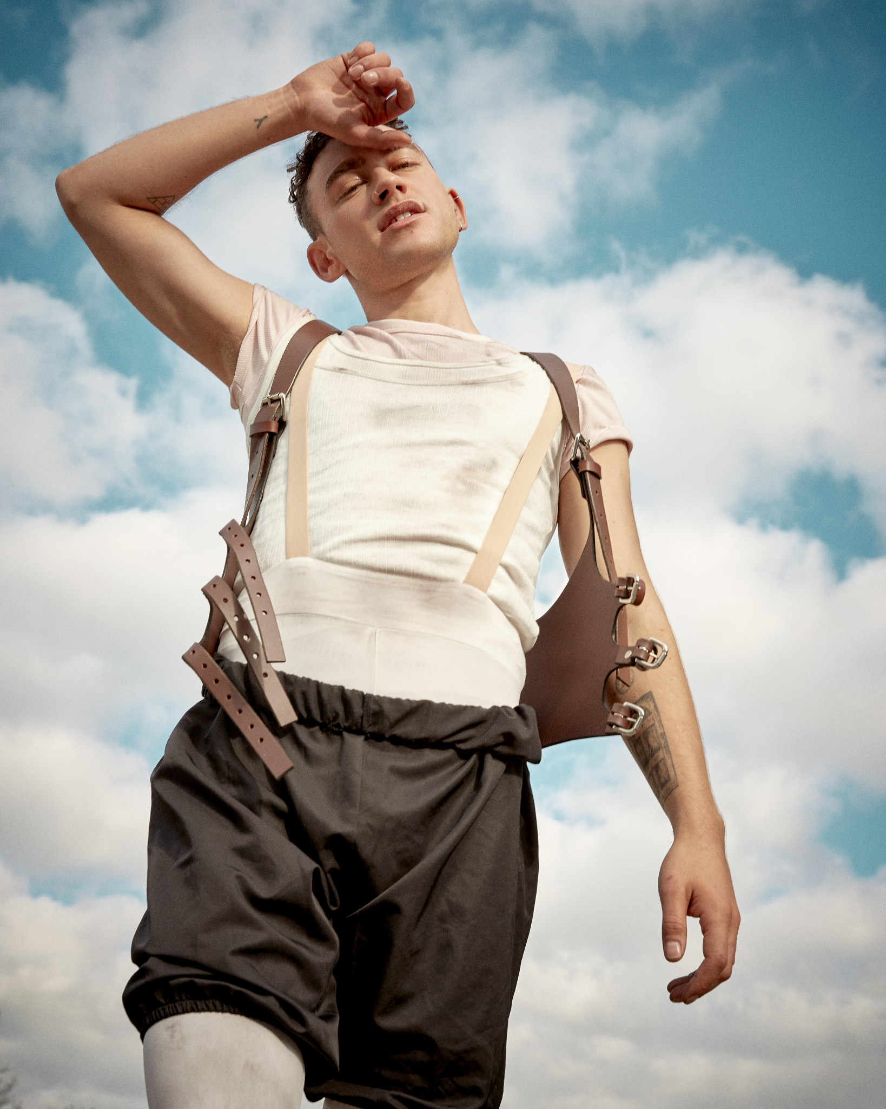

“I believe heartbreak and synthesizers are made for each other” Olly Alexander
British pop icon Olly Alexander hits 2025 hard with a love song for the ages. Taken from his forthcoming new album ‘Polari’, ‘When We Kiss’ drops alongside another visually arresting Colin Solal Cardo directed video - watch HERE.

A song that’s as much about pain as it is about love. The push-pull of a relationship fraught with tension, lust, need, desire and multiple complexities rooted in nagging questions over the future.

“‘When We Kiss’ is an epic love song about a difficult moment in a relationship, when you don’t know whether you should break up or if you should stay together forever. I wanted this song to reflect those conflicted feelings, all the pain and ecstasy of loving someone. I believe heartbreak and synthesizers are made for each other and I had the best time making this with my Polari partner Danny L Harle. Our aim was to take the listener on a rapturous journey of heartfelt emotion, from anguish to euphoria and back again.” Olly Alexander

‘When We Kiss’ is the fourth track release to showcase the upcoming album, Polari, due for release next month. The emotive ‘Cupid’s Bow’ led the charge back in October last year, the album’s punchy title track and opener ‘Polari’ followed before the euphoric ‘Archangel’ closed out the year.

Across ‘Polari’ Olly explores themes of desire, intimacy, voyeurism and fate all wrapped up in a pounding club soundscape. Polari was crafted alongside writer and producer Danny L Harle and is a pop album for the ages. Olly Alexander’s first album under his own name takes as its primary inspiration the (almost) lost art of Polari. Originating around Europe and the Romani community as early as the 1600s, this coded slang became in effect a secret language for homosexuals and the stigmatized during the twentieth century. It’s a concept Olly first came across when coming out, and resonated more deeply with when playing Richie in ‘It’s A Sin’, where he grappled with questions about identity, self-expression and community. The kinds of which have always populated British life, and have long been threaded through the history of pop music - you just had to know where to look.

After a decade releasing music as Years & Years, Polari is literally Olly Alexander talking the talk. He bonded with Danny L Harle over a mutual love of 80s club music, that period of uncompromising, avant-garde pop which nonetheless snuck into the mainstream. Polari remained a north star throughout the creative process, a language likewise lacking widespread recognition but still influential in plain sight (see such colloquialisms as “drag”, “naff” and “trade”). The album arrives alongside audio-visual world-building in which Olly is in complete control, from its anarchic Derek Jarman-inspired aesthetic to Olly even writing a short play accompanying its release, full of cowboys, gods, and the occasional music industry exec. And after a long history of secrets and subtext, Polari is ultimately an open and universal pop record about those needs that transcend time, sexuality, and self: what it means to belong, to be loved, and (Polari literally translates as “to talk”) to connect.

The landmark project will hit the road this year across the UK and Europe with the special intimate, Up Close and Polari tour for Spring 2025.

ABOUT OLLY ALEXANDER: Entering a brand new solo era, Olly Alexander’s influence on pop culture shines bright. As Years & Years, Olly scored 2 #1 UK albums, 10 UK Top 40 singles and was awarded the BRIT Billion Award with 6.5 billion streams globally. He was nominated for Leading Actor at the 2022 BAFTA Television Awards for his role in the hit show ‘It’s A Sin’, which brought the fight against HIV/Aids back into public conversation and challenged perceptions of queer life for good. In 2024 Olly fulfilled a childhood fantasy of representing the UK in the Eurovision Song Contest, flying the flag as only he could in the first preview of Polari, ‘Dizzy’. He also returned to the stage this month with a role in the internationally-acclaimed experimental drama ‘White Rabbit Red Rabbit’, following a rotating cast that includes the likes of Michael Sheen, Minnie Driver and Daisy Edgar-Jones. Having headlined arenas and festivals worldwide - not to mention collaborating with Elton John, Kylie and Pet Shop Boys - it’s an icon-status that even saw him immortalised at Madame Tussauds London. Polari, the album, is set for release in February 2025.

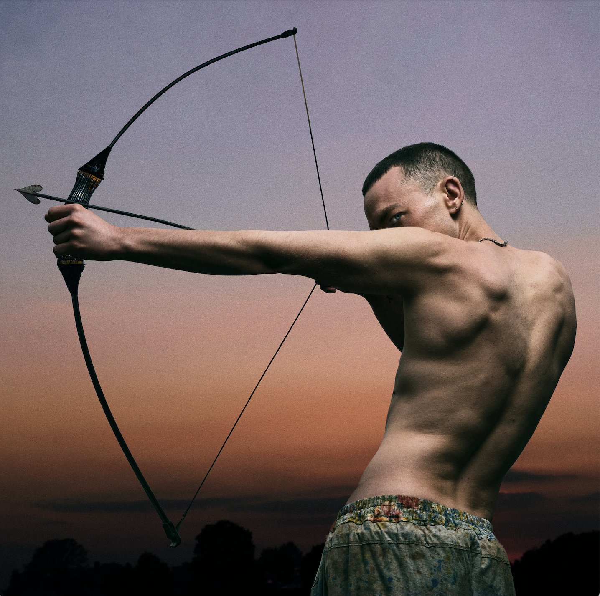

Polari - album artwork

- ‘Polari’
- ‘Cupid’s Bow’
- ‘I Know’
- ‘Shadow Of Love’
- ‘Make Me A Man’
- ‘Dizzy’
- ‘Archangel’
- ‘Miss You So Much’
- ‘When We Kiss’
- ‘Whisper In The Waves’
- ‘Beautiful’
- ‘Heal You’
- ‘Language’

Up Close and Polari Tour UK & Europe

19.03.25 || Luxembourg || den Atelier
20.03.25 || Frankfurt || Zoom
21.03.25 || Cologne || Live Music Hall
23.03.25 || Paris || La Cigale
24.03.25 || Brussels || Cirque Royal
26.03.25 || Berlin || Metropol
27.03.25 || Warsaw || Palladium
29.03.25 || Zurich || Komplex 457
30.03.25 || Utrecht || TivoliVredenburg
01.04.25 || Dublin || 3Olympia Theatre
02.04.25 || Birmingham || Town Hall
03.04.25 || Glasgow || Glasgow Barrowland Ballroom
04.04.25 || Manchester || Manchester Factory International, Aviva Studios
06.04.25 || Bristol || Bristol Beacon
07.04.25 || London || The London Palladium

For more information and press enquiries please contact

Jenny Entwistle
Jenny@chuffmedia.com

