Olly Alexander

Shares video for his new album’s title track, ‘Polari’
(Watch HERE /Listen HERE)

Polari out February 7th
(Pre-order HERE)
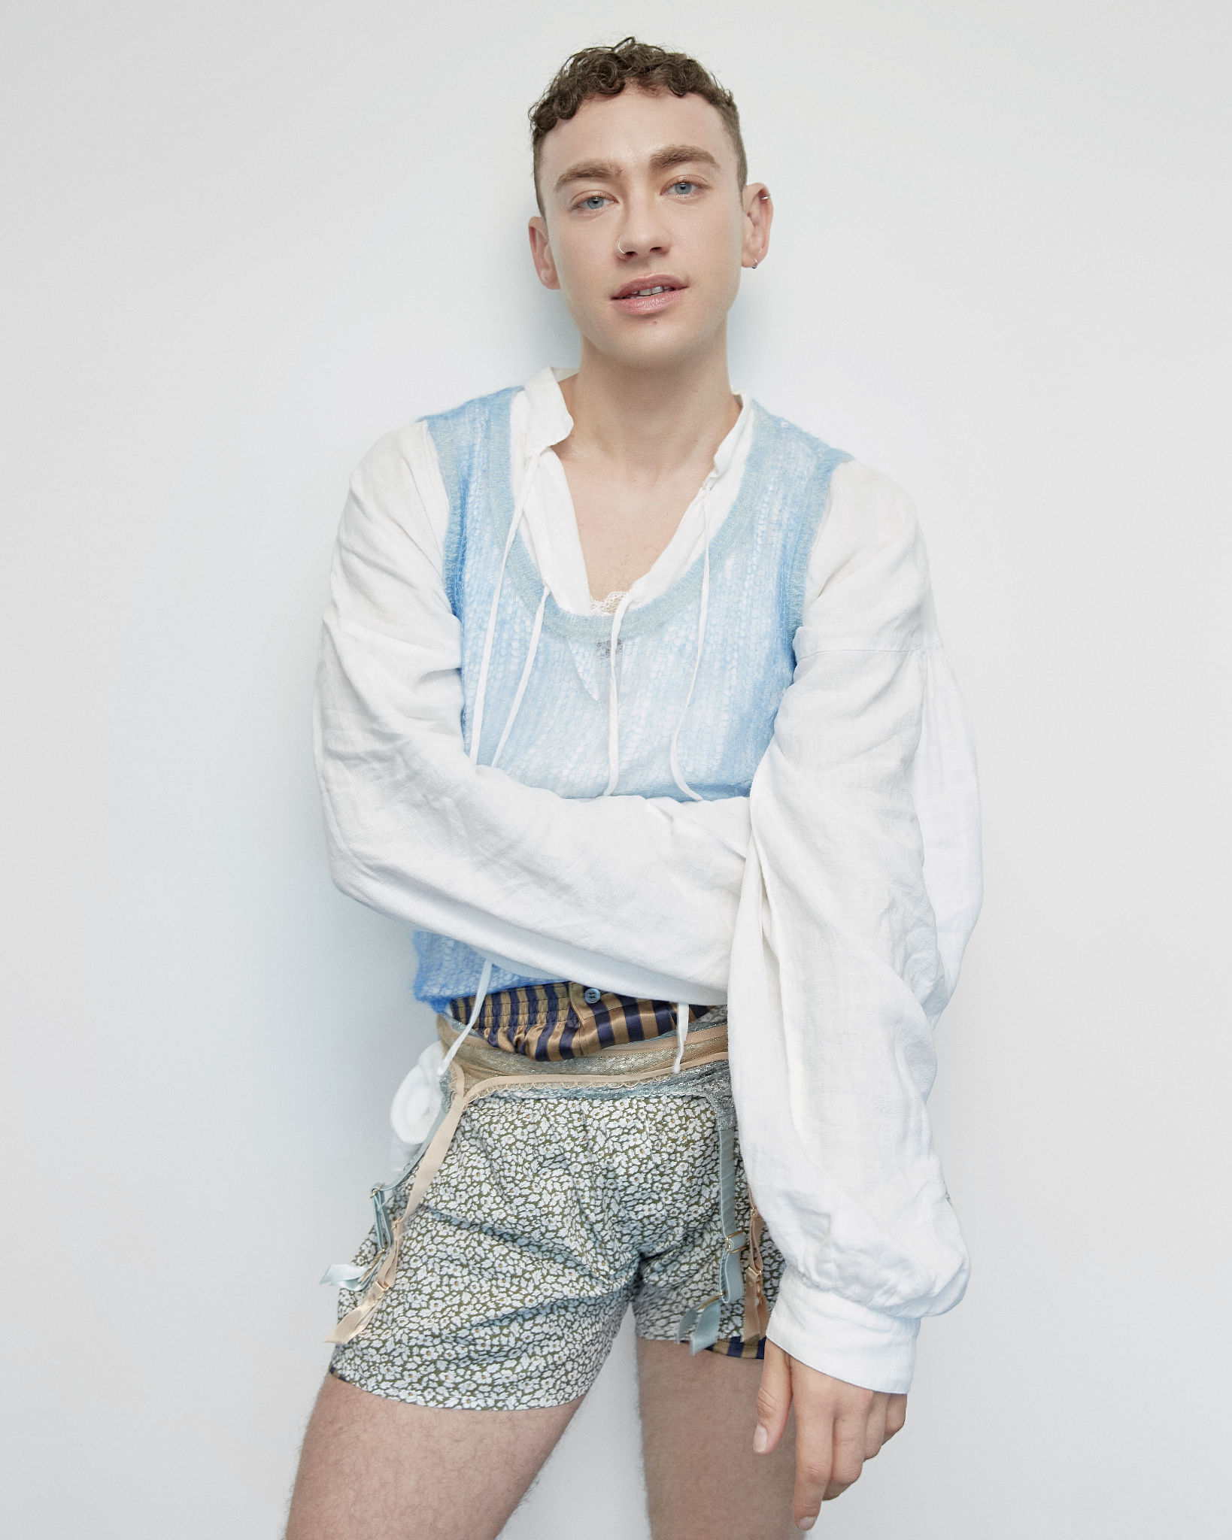

Today Olly Alexander has shared a second teaser for his forthcoming new album with a visual for title track ‘Polari’ available now on Polydor Records. This bracing, punch in the gut album opener comes alongside another dynamic video from director Colin Solal Cardo (Charli XCX, Robyn). Watch HERE.

As Olly explains, “This is track 1 on the album and is intended as a shot of adrenaline and jumpstart the car kind of introduction because I’m about to take you for a ride - it’s also a bit of an audio collage of all the music that follows so I’m very excited to put this out!”

‘Polari’ follows the album launch single ‘Cupid’s Bow’ which was released last month and introduced Olly’s new era as a fully fledged solo artist. Across the new album he explores themes of desire, intimacy, voyeurism and fate all wrapped up in a pounding club soundscape which title track ‘Polari’ has in spades. Polari was crafted alongside writer and producer Danny L Harle and is a pop album for the ages. Olly Alexander’s first album under his own name takes as its primary inspiration the (almost) lost art of Polari. Originating around Europe and the Romani community as early as the 1600s, this coded slang became in effect a secret language for homosexuals and the stigmatized during the twentieth century. It’s a concept Olly first came across when coming out, and resonated more deeply with when playing Richie in ‘It’s A Sin’, where he grappled with questions about identity, self-expression and community. The kinds of which have always populated British life, and have long been threaded through the history of pop music - you just had to know where to look.

“In the ‘lost gay language’ of Polari, “Polari” means ‘to speak’. I was very inspired by how we communicate with each other and what it means to speak a secret language, something I think we all do in some form or another with the people we’re close to. In our hyper connected world of fractured communication it’s not easy to trust that anything is what it seems, I felt that a song about vernacular should be as wild and unpredictable as the history of Polari itself. I had such a great time making this bijou song with Danny and taking musical inspiration from the past, the present and the distant future. Please enjoy and thank you for listening!”
Olly Alexander

After a decade releasing music as Years & Years, Polari is literally Olly Alexander talking the talk. He bonded with Danny L Harle over a mutual love of 80s club music, that period of uncompromising, avant-garde pop which nonetheless snuck into the mainstream. Polari remained a north star throughout the creative process, a language likewise lacking widespread recognition but still influential in plain sight (see such colloquialisms as “drag”, “naff” and “trade”). The album arrives alongside audio-visual world-building in which Olly is in complete control, from its anarchic Derek Jarman-inspired aesthetic to Olly even writing a short play accompanying its release, full of cowboys, gods, and the occasional music industry exec. And after a long history of secrets and subtext, Polari is ultimately an open and universal pop record about those needs that transcend time, sexuality, and self: what it means to belong, to be loved, and (Polari literally translates as “to talk”) to connect.

The landmark project will hit the road next year across the UK and Europe with the special intimate, Up Close and Polari tour for Spring 2025.

ABOUT OLLY ALEXANDER: Entering a brand new solo era, Olly Alexander’s influence on pop culture shines bright. As Years & Years, Olly scored 2 #1 UK albums, 10 UK Top 40 singles and was awarded the BRIT Billion Award with 6.5 billion streams globally. He was nominated for Leading Actor at the 2022 BAFTA Television Awards for his role in the hit show ‘It’s A Sin’, which brought the fight against HIV/Aids back into public conversation and challenged perceptions of queer life for good. In 2024 Olly fulfilled a childhood fantasy of representing the UK in the Eurovision Song Contest, flying the flag as only he could in the first preview of Polari, ‘Dizzy’. He also returned to the stage this month with a role in the internationally-acclaimed experimental drama ‘White Rabbit Red Rabbit’, following a rotating cast that includes the likes of Michael Sheen, Minnie Driver and Daisy Edgar-Jones. Having headlined arenas and festivals worldwide - not to mention collaborating with Elton John, Kylie and Pet Shop Boys - it’s an icon-status that even saw him immortalised at Madame Tussauds London. Polari, the album, is set for release in February 2025.

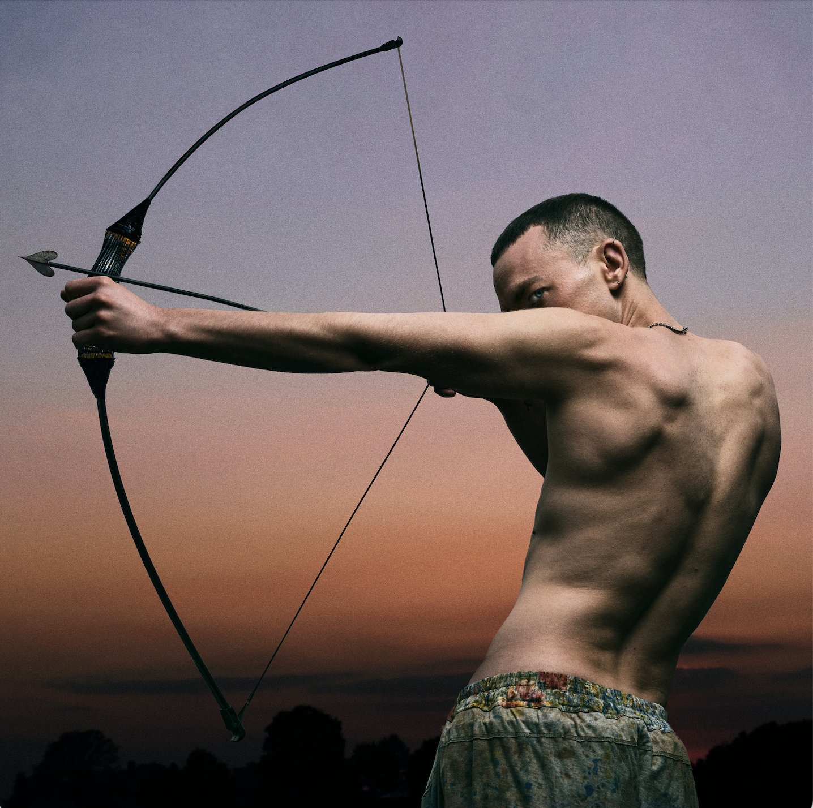

Polari - album artwork

1. ‘Polari’
2. ‘Cupid’s Bow’
3. ‘I Know’
4. ‘Shadow Of Love’
5. ‘Make Me A Man’
6. ‘Dizzy’
7. ‘Archangel’
8. ‘Miss You So Much’
9. ‘When We Kiss’
10. ‘Whisper’
11. ‘Beautiful’
12. ‘Heal You’
13. ‘Language’

Up Close and Polari Tour UK & Europe

19.03.25 || Luxembourg || den Atelier
20.03.25 || Frankfurt || Zoom
21.03.25 || Cologne || Live Music Hall
23.03.25 || Paris || La Cigale
24.03.25 || Brussels || Cirque Royal
26.03.25 || Berlin || Metropol
27.03.25 || Warsaw || Palladium
29.03.25 || Zurich || Komplex 457
30.03.25 || Utrecht || TivoliVredenburg
01.04.25 || Dublin || 3Olympia Theatre
02.04.25 || Birmingham || Town Hall
03.04.25 || Glasgow || Glasgow Barrowland Ballroom
04.04.25 || Manchester || Manchester Factory International, Aviva Studios
06.04.25 || Bristol || Bristol Beacon
07.04.25 || London || The London Palladium

For more information and press enquiries please contact

Jenny Entwistle
Jenny@chuffmedia.com

