

**OLIVIA DEAN RETURNS WITH FRESH NEW SOUND ON BRAND NEW SINGLE ‘TIME’**

[**LISTEN HERE**](https://oliviadean.lnk.to/Time)



Following the success of her debut album *Messy,* multi-BRIT and Mercury-nominated singer-songwriter **Olivia Dean** today releases her brand-new single, **‘Time’**, via **EMI Records**.

Premiered at her triple-sold out London Hammersmith Apollo headline show, and released nearly a year after her breakout album, **Olivia** continues to showcase her effortless versatility. Opening with an acoustic guitar and drum melody which is a mainstay throughout the track, **‘Time’** was produced by **Zac Nahome** and co-written by **Max Wolfgang**, **Bastian Langebaek**,and **Matt Hales** and introduces us to a bold new sound for the singer, diverging from her previous more mellow, neo-soul tracks.

Recorded in a single take, a new method for the 25-year-old Londoner, the song draws inspiration from the melodic styles of British superstars such as David Bowie and The Beatles, and lyrically hones in on subjects Olivia has touched upon before - love, growth and change. Emulating the rock sound of music legend Tina Turner, **‘Time’** infuses a fresh rock element into her music, with a heavy electric guitar component which can be seen as a departure from previous tracks such as **'Ok Love You Bye'**, from her debut 2021 EP, *Love Songs 2021*.

Of **‘Time’** **Olivia** said: "*Time was born out of the frustrating feeling of not having enough of it. It's about wanting to be ambitious, experience the world, and do everything while still feeling connected to the ones you love. It's a real balancing act, especially as a woman. So, the song moves between these two worlds, dreamy and serene, then wild and chaotic, as life often is!*

*It's pretty much a completely live, one-take of me and my band just playing in a room together as we have been on tour. It feels so different from what I've made before, sonically of course, but also in its energy. I'm really excited about that."*

Showcasing **Dean**'s ever-sultry vocals and her skill in crafting evocative lyrics, set against a backdrop of high-energy instrumentation, the result is a track that feels new, yet with a warm nostalgia to it, likely to resonate with **Dean**’s already growing fan base, but also new listeners alike. **‘Time’** signifies an evolution for the singer, demonstrating her range as an artist and her willingness to explore new musical territory. Following the success of *Messy*, she continues to push boundaries and develop her sound, securing her place as one of today's most exciting artists in the music industry.

2024 has started on an incredible note for **Olivia**, with three **BRIT Award** nominations, a cover on **POP Magazine**, a feature in **British Vogue**’s July issue, a debut performance at **Coachella Festival**, a European and UK tour including three **sold-out** dates at London’s Hammersmith Apollo (with 35,000 people on the waitlist), a performance at **Radio 1’s Big Weekend**, and upcoming performances at **Glastonbury** and Japan’s **Summer Sonic**, as well as her first festival headline slot at **Love Supreme** Festival. Her demand and pace show no sign of slowing.

With over **3.5M+** monthly listeners on **Spotify**, **Olivia's** sound and talent have established her as one of the UK's most exciting artists. **‘Time’** only goes to further showcase her musical aptitude and introduces a refreshing sound to her repertoire. She embodies rawness, energy, and truth, crafting relatable tracks about love, self, and identity.

**Stream ‘Time’**:

[https://OliviaDean.lnk.to/Time](https://oliviadean.lnk.to/Time)

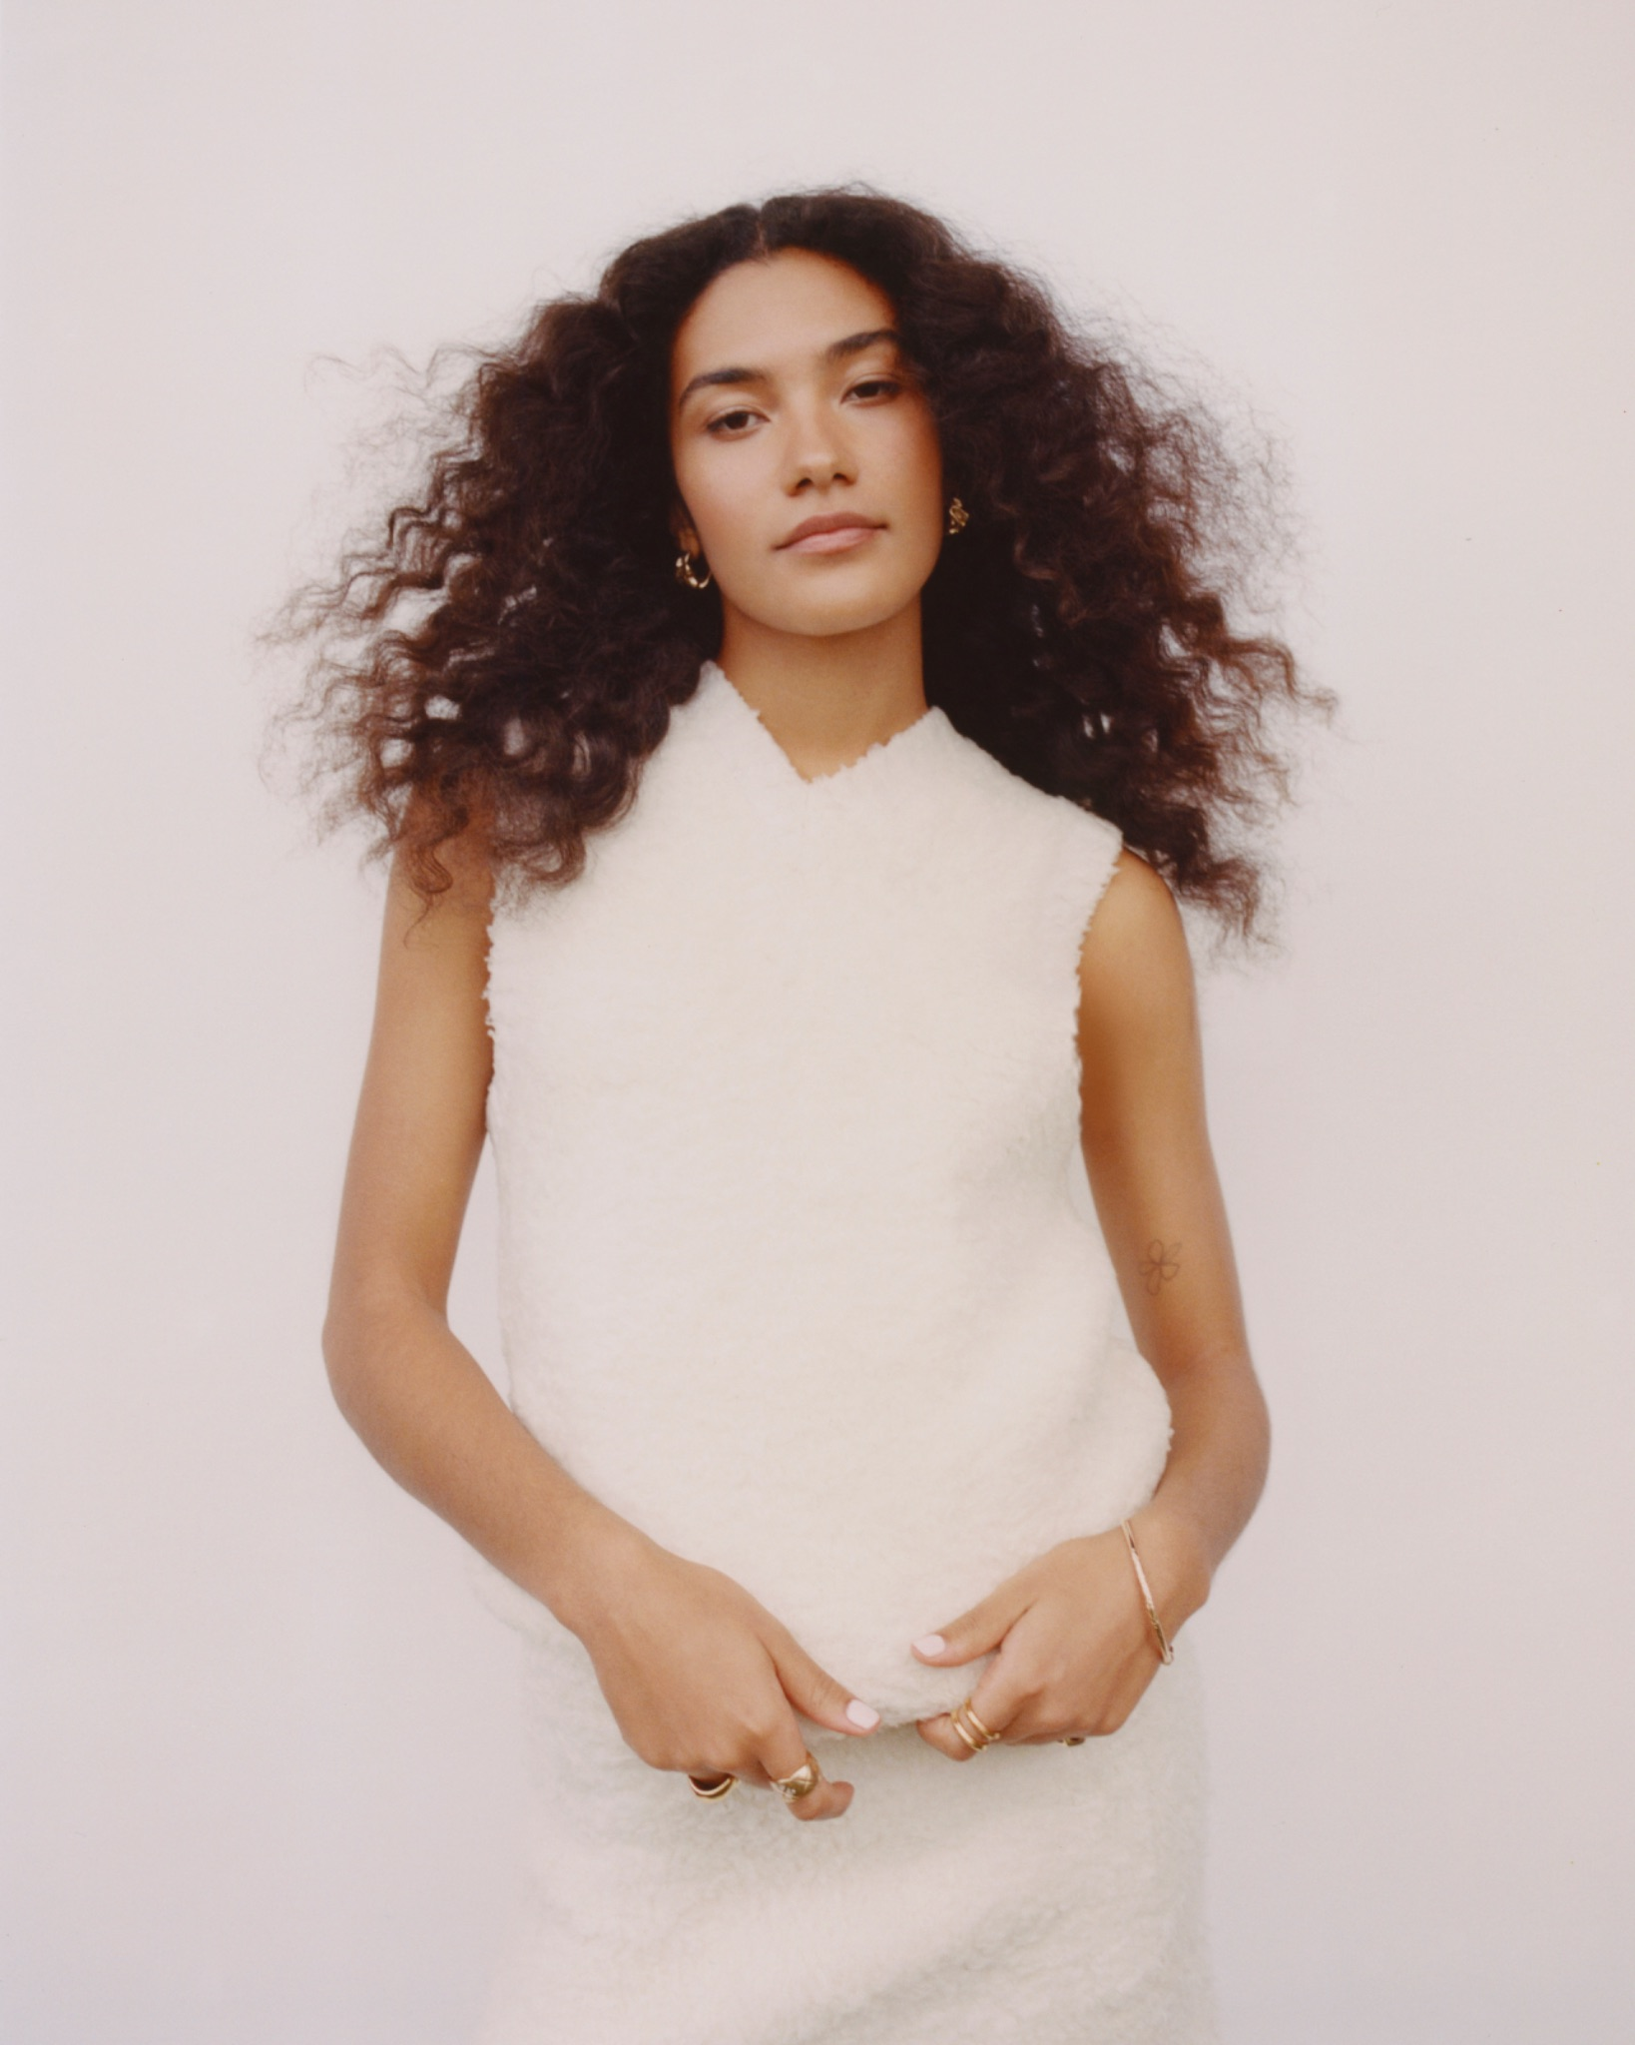

**Photo Credit**: Elliot James Kennedy

**FOLLOW OLIVIA DEAN:**

[Instagram](https://www.instagram.com/oliviadeano/) | [Spotify](https://open.spotify.com/artist/00x1fYSGhdqScXBRpSj3DW?si=9buqD0cfQ5iGQNPN0jaUMA) | [TikTok](https://www.tiktok.com/@oliviadeano_?lang=en)

**For more information and press enquiries please contact:**

**Jenny Entwistle**[**jenny@chuffmedia.com**](mailto:jenny@chuffmedia.com)