

**ANNOUNCES UK HEADLINE TOUR THIS SEPTEMBER**

**INCLUDES A LONDON SHOW AT THE ISLINGTON ASSEMBLY HALL**

**LISTEN TO HIS NEW ALBUM ‘LOJA’** [**HERE**](https://orlandoweeksuk.lnk.to/LojaPR)

**PHYSICAL FORMATS FOLLOW ON AUGUST 23RD**

**PRAISE FOR ‘LOJA’:**

*“A refreshing, entertaining, and ever-emotive cycle of personal development that takes his work into new spaces.”* **- Clash**

*‘’Weeks is clearly evolving beyond anything his audience may have imagined.’’* **- FAR OUT**

*“Feels like Weeks’ most fully formed solo album to date.”* **- Music OMH**

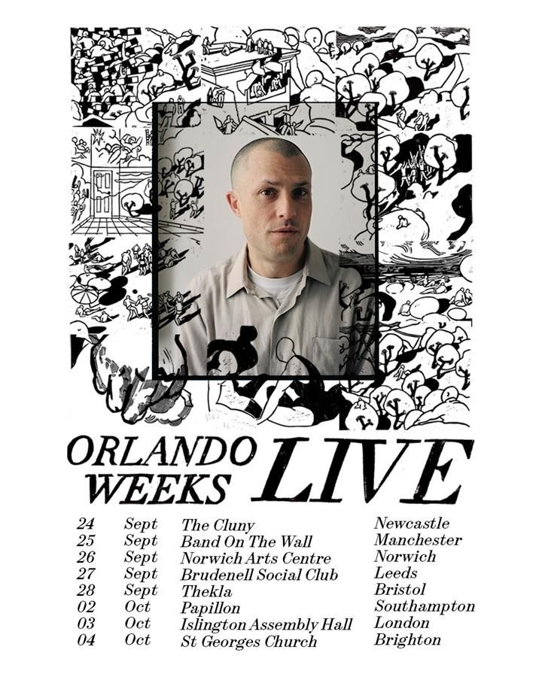

Having launched his acclaimed new album **‘LOJA’** with three inspiring sold-out performance /art exhibition events at the **Copeland Gallery**, **Orlando Weeks** now announces details of a full **UK** tour which starts in **September**.

The tour will see **Orlando** supported by a live band which features several of the key musicians on the album. Tickets for the tour, which includes a London show at the **Islington Assembly Hall**, go on sale at **https://www.orlandoweeks.co.uk** from **10am** this **Friday, July 12th**.

**Orlando** says, *“LOJA has been out for a few weeks now and after the joy and privilege of the Copeland Gallery residency, I’m very excited to be taking LOJA’s music on the road. I’ll also be playing songs from all sorts of long-ago and not so long-ago chapters. Can’t wait.’’*

The dates are:

**SEPTEMBER**

**24th - Newcastle, The Cluny**

**25th - Manchester, Band on the Wall**

**26th - Norwich, Arts Centre**

**27th - Leeds, Brudenell Social Club**

**28th - Bristol, Thekla**

**OCTOBER**

**2nd - Southampton, Papillon**

**3rd - London, Islington Assembly Hall**

**4th - Brighton, St. George’s Church**

**‘LOJA’** is available to stream [**HERE**](https://orlandoweeksuk.lnk.to/LojaPR), while Orlando’s official store offers a range of physical products which will be released on **August 23rd**: signed transparent green vinyl, black vinyl and a CD.

**‘LOJA’** is a record informed by **Orlando** and his family’s move from **London** to **Lisbon**. It was a change that stirred the waters of inspiration, instigating reflection on things which have passed, optimism for the future, and the contentment that comes with finding your place. Its warm, organic feel feels like a reflection of his new home city: an atmosphere conjured equally by his poetic yet heartfelt lyricism as it is by the organic instrumentation provided by his live band. The bulk of the album was recorded during thirteen days of sessions in **Chale Abbey Studios** on the **Isle of Wight** with producer **Sergio Maschetzko** (**Black Country New Road**) and his collaborator **David Granshaw**, before **Orlando** teamed up with **Nathan Jenkins (Bullion)** to add the final fine nuances.

The album’s lead single[**‘Dig’**](https://orlandoweeksuk.lnk.to/DigPR) featured **Rhian Teasdale** of **Wet Leg** and landed on the **6 Music** playlist. Meanwhile, strong reviews were complemented with news coverage spanning **Clash**, **DIY**, **Dork**, **Far Out**, **NME**, **So Young**, **The Line of Best Fit**, **whynow** and more, plus an in-depth conversation on the **101 Part Time Jobs** podcast.

**Follow Orlando Weeks:**

[**Website**](http://www.orlandoweeks.co.uk) **|** [**Spotify**](https://open.spotify.com/artist/5K9Px0eeCuYatmBGFfhSOA) **|** [**Apple Music**](https://itunes.apple.com/gb/artist/orlando-weeks/201628833) **|** [**YouTube**](https://www.youtube.com/channel/UC2N065Sur6IbRdw-IwjMbrw) **|** [**Instagram**](https://www.instagram.com/orlandoweeks/)

**For more on info contact** [**warren@chuffmedia.com**](mailto:warren@chuffmedia.com)