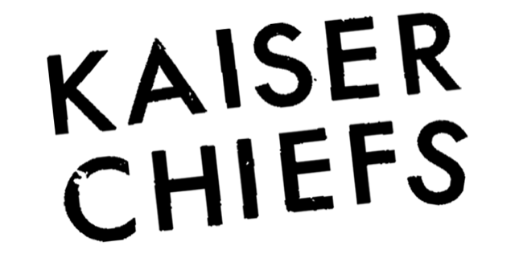

HEADLINE SUMMER SATURDAY LIVE
SATURDAY 22ND AUGUST – NEWMARKET RACECOURSES

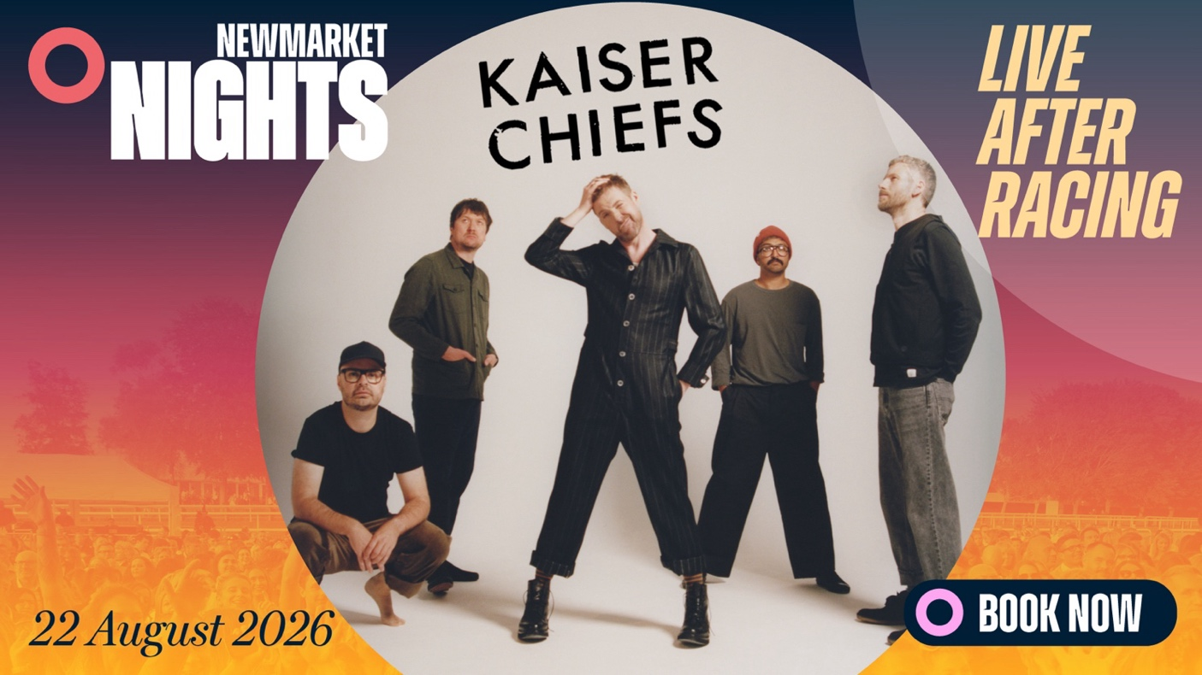
DOWNLOAD MEDIA ASSETS HERE

Newmarket Racecourses are thrilled to welcome the return of KAISER CHIEFS to the July Course, marking their first appearance since their blistering headline in 2019. The announcement also completes the music line-up for the summer season, with the Brit Award-winning band taking to the stage in the afternoon on Summer Saturday Live, 22nd August.

Formed in Leeds in 2000, Kaiser Chiefs are one of the leading bands of their generation. Fronted by the charismatic Ricky Wilson with Simon Rix on bass, Andrew ‘Whitey’ White on guitar, Nick ‘Peanut’ Baines on keyboards and drummer Vijay Mistry, the band have had a string of anthemic hits such as “Oh My God,” “I Predict A Riot,” “Everyday I Love You Less and Less,” “Never Miss A Beat” and “Hole In My Soul”.

The band have released 8 original studio albums which includes their Mercury nominated debut, Employment which sold over 2 million copies, its number 1 follow up, Yours Truly, Angry Mob, which went twice-platinum in the UK alone and Education Education Education and War which entered the UK Album Charts at number 1. They have achieved, top ten singles including the infamous number 1 hit “Ruby,” 3 Brit Awards, an Ivor Novello award for Album of the Year, toured with U2, Foo Fighters and Green Day and sold 8 million albums.

Sophie Able, Newmarket Racecourses and International Director, said
“Kaiser Chiefs are a firm favourite here at Newmarket. As 2025 marks the 20th anniversary of their debut album Employment, you can be sure to hear all your favourite hits when they headline Summer Saturday Live on 22nd August. The line-up for Newmarket Nights in 2026 is now complete and incredibly strong, offering something for everyone, with headliners spanning a wide range of genres. We can’t wait to welcome many of you this summer for some remarkable evenings of music and racing.”

The Newmarket Nights series continues to set the standard for value-packed entertainment in the East, combining thrilling afternoon racing with full headline performances from some of the nation’s biggest music stars. With a single ticket granting access to both world-class racing and live music, fans enjoy an unforgettable afternoon (and night out) at exceptional value. The experience is further enhanced by a diverse range of food options, from vibrant street food offerings to Newmarket’s renowned selection of outstanding restaurants.

Tickets for KAISER CHIEFS will be on sale at 10am on Friday 30th January via thejockeyclub.co.uk/newmarket, priced starting from £36. There will be a presale at 10am on Thursday 29th January for those on the Newmarket Racecourses mailing list, register here.

Tickets for all shows in the Newmarket Nights season are now on sale.

2026 Newmarket Nights Season
Friday 19th June – FIVE
Friday 26th June – BASEMENT JAXX
Friday 17th July – MADNESS
Friday 31st July – AITCH
Friday 7th August – JESSIE J
Friday 14th August – CRAIG DAVID’S TS5
Saturday 22nd August – KAISER CHIEFS – Summer Saturday Live

FOR MORE INFORMATION AND ALL MEDIA ENQUIRIES FOR
NEWMARKET NIGHTS, PLEASE CONTACT

Jenny Entwistle at Chuff Media
jenny@chuffmedia.com

FIVE – FRIDAY 19TH JUNE
The iconic British boyband comprised of Ritchie Neville, Scott Robinson, Sean Conlon, Abz Love and J Brown are one of the UK’s most beloved pop acts. Bursting onto the scene in the late 1990s, they scored multiple UK and international hits - including “Keep On Movin” and “Everybody Get Up” - and sold millions of records worldwide during their original run. The lineup reunited for the first time in over two decades last year for a huge arena tour, including 3 sold-out shows at London’s The O2.

BASEMENT JAXX – FRIDAY 26TH JUNE
Basement Jaxx are the innovative British electronic music duo behind some of the most influential dance-punk and house tracks of the last three decades. Known for singles including “Red Alert,” “Romeo,” “Do Your Thing” and “Where’s Your Head At,” their debut album Remedy helped define late-90s house music and introduced genre-bending energy to a global audience. They continue to deliver dynamic full live band shows, including having headlined both the Pyramid Stage and the Other Stage at Glastonbury Festival, that blend electronic, funk, soul and pop in unforgettable performances.

MADNESS – FRIDAY 17TH JULY
Madness’s energetic blend of ska, pop and reggae had made them one of the UK’s defining bands. With a rich catalogue of classics including “Our House,” “Baggy Trousers,” “It Must Be Love” and “House of Fun,” the band have amassed more than three decades of chart success, with 12 UK Top 10 albums and numerous singles that remain staples of British music culture. In recent years, they released a career-spanning hits compilation Hit Parade, hit UK No.1 with studio album Theatre Of The Absurd Presents C’est la Vie, and continue to perform live to thousands of fans, bringing their spirited shows to arenas and outdoor festivals across the UK.

AITCH – FRIDAY 31ST JULY
The 26-year-old Mancunian rapper has rapidly risen from his YouTube beginnings to become one of the UK’s most successful contemporary hip-hop artists. A BRIT Award winner for Best Hip-Hop, Grime and Rap Act, Aitch is a platinum-selling artist with 9 UK Top 10 singles and 4 Top 10 albums. His sharp lyricism, chart-dominating collaborations and crossover appeal have cemented his place at the forefront of British rap. A firm fan favourite, he recently finished fourth in the 25th series of I'm a Celebrity...Get Me Out of Here!

JESSIE J – FRIDAY 7TH AUGUST
Jessie J first rose to global prominence with chart-topping hits such as “Price Tag,” “Bang Bang” and “Domino”. With multiple number one singles, she is celebrated for her powerhouse vocals, dynamic live performances and her role as a coach on The Voice. In 2025, she released her sixth studio album Don’t Tease Me With a Good Time, her first full-length project in nearly eight years, showcasing deeply personal songwriting and marking a powerful new chapter in her artistic evolution.

CRAIG DAVID’S TS5 – FRIDAY 14TH AUGUST
26 years since the critically acclaimed album, Born To Do It changed his life, Craig David has clocked up an astounding 26 UK top 40 singles, 11 UK top 40 albums and over 5 billion streams worldwide, achieving multi-platinum status in more than 20 countries around the world. With two UK Number 1 albums under his belt, he has also received multiple BRIT Award and Grammy nominations. Alongside his solo catalogue, Craig created TS5 - a world-renowned DJ and party brand blending UK garage, house and R&B - which has played major festivals and club residencies worldwide, becoming a defining live experience in its own right.

KASIER CHIEFS – SATURDAY 22ND AUGUST
Formed in Leeds in 2000, Kaiser Chiefs are one of the leading bands of their generation. Fronted by the charismatic Ricky Wilson with Simon Rix on bass, Andrew ‘Whitey’ White on guitar, Nick ‘Peanut’ Baines on keyboards and drummer Vijay Mistry, the band have had a string of anthemic hits such as “Oh My God,” “I Predict A Riot,” “Everyday I Love You Less and Less,” “Never Miss A Beat” and “Hole In My Soul”.

The band have released 8 original studio albums which includes their Mercury nominated debut, Employment which sold over 2 million copies, its number 1 follow up, Yours Truly, Angry Mob, which went twice-platinum in the UK alone and Education Education Education and War which entered the UK Album Charts at number 1. They have achieved, top ten singles including the infamous number 1 hit “Ruby,” 3 Brit Awards, an Ivor Novello award for Album of the Year, toured with U2, Foo Fighters and Green Day and sold 8 million albums.

ABOUT NEWMARKET RACECOURSES
Newmarket’s two magical racecourses, the Rowley Mile and the July Course, together form the greatest venue in the East of England. Hosting exhilarating world class Flat racing, pulsating music nights, great value family days, award-winning restaurants and exceptional conferences, in 2016 Newmarket Racecourses proudly celebrated 350 years of extraordinary royal patronage.

Newmarket Racecourses are part of The Jockey Club which stages thrilling sporting occasions including the Randox Grand National, The Cheltenham Festival and The Cazoo Derby. Millions of people every year enjoy the special experiences on offer through racing, music, food and entertainment. Governed by Royal Charter, every penny made goes back into British Racing to help the sport thrive. The Jockey Club was founded in 1750 and today is the largest commercial group in Britain’s second-biggest spectator sport (2018 turnover: £214.6 million), operating 15 racecourses nationwide, The National Stud, Jockey Club Estates, Jockey Club Catering, Jockey Club Live and the charity, Racing Welfare. For more information visit thejockeyclub.co.uk.

