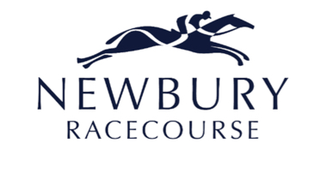
Announces

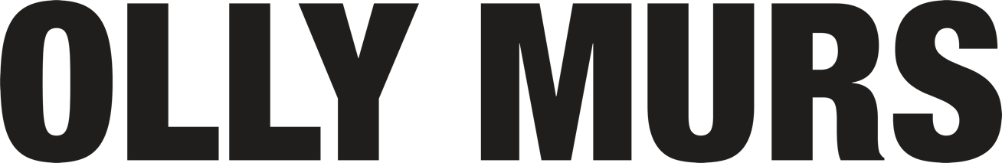

PARTY IN THE PADDOCK
SATURDAY 19TH AUGUST 2023

After a storming set in 2021, OLLY MURS is set to make his triumphant return to Newbury Racecourse on Saturday 19th August 2023, for a full headline set after racing.

The singer, songwriter and solid-gold pop star has been all over our screens recently. He’s been front and centre as host of ITV’s Starstruck, then, he returned to the big swivelly chair on The Voice. But in the artist world – the world that forged him, Olly has been off the radar for over four years. Now, the musician who had four Number One singles and four Number One albums in a near-back-to-back run after bursting onto the scene with his double-platinum self-titled debut in 2010, is well and truly back. He released new single ‘Die of a Broken Heart’ last month, his first taste of new music in four years, taken from his forthcoming album ‘Marry Me’ out 2nd December.
Olly’s previous six albums and subsequent sold-out tours have all been enormously successful. The stats speak for themselves: 6 multi-platinum albums, 4 #1 UK albums, 4 #1 UK singles, 6 million Spotify monthly listeners, 800 million YouTube views & 1.8 million tour tickets sold.

Olly Murs said: “I had a such a good time at Newbury in 2021, I’m absolutely delighted to be returning next year. I can’t wait to play my new music and all my most-loved tracks for you all!”

Harriet Collins, Marketing Director for Newbury Racecourse said: “We are extremely excited to announce Olly Murs as our first artist for the 2023 live music season. We love having Olly at the racecourse as he always puts on such a fantastic show for his fans. See you on Saturday 19th August!”

Tickets for OLLY MURS at Newbury Racecourse will be on sale at 10am on Friday 25th November via newburyracecourse.co.uk, with a presale available to customers at 10am on Wednesday 23rd November. Tickets start from £45 general sale, with an early bird offer price available for presale. There will be a range of exciting new hospitality & dining packages available to suit everyone.

For more details and tickets visit newburyracecourse.co.uk or call 01635 40015.

FOR MORE INFORMATION AND ALL MEDIA ENQUIRIES FOR
OLLY MURS AT NEWBURY RACECOURSE PLEASE CONTACT

Jenny Entwistle & Warren Higgins at Chuff Media
jenny@chuffmedia.com / warren@chuffmedia.com

About Newbury Racecourse
Newbury Racecourse PLC is the parent of a Group of companies which own Newbury Racecourse and supporting businesses.

Newbury Racecourse held its first race in 1905 and has long been one of Britain's leading tracks, staging up to 30 days of top class Jump and Flat racing annually, with at least one raceday in every month of the year. On the Flat, Newbury's high-quality programme includes the Group 1 Al Shaqab Lockinge Stakes worth £350,000. The highlight of Newbury's Jump racing season is the £250,000 Ladbrokes Trophy, a handicap chase over an extended three and a quarter mile.

The racecourse is also a thriving events venue, hosting a huge range of activities including weddings, concerts and conferences for 20 to 1,000 attendees for a wide spectrum of businesses and organisations in stunning surroundings. The addition of a brand new on-site 36-bedroom hotel in 2015, The Lodge supports both the racing and non-racing events.

In addition, Newbury Racecourse PLC runs a successful private nursery, The Rocking Horse, providing a safe, happy and stimulating learning environment for many pre-school children.
Newbury is now home to a major housing development by David Wilson Homes, allowing people to live in a unique location alongside a world-renowned sporting venue, which also benefits from a Nuffield Health Club.

Over the past five years the racecourse has undergone a significant redevelopment which was completed in 2020 and comprises of upgrades to every area of the customer journey including redevelopment of the stables, a dedicated facility for owners on racedays, relandscaped parade ring and winner’s enclosure, as well as a number brand new outdoor bars and seating areas.

For more details and tickets visit https://newburyracecourse.co.uk or call 01635 40015.

