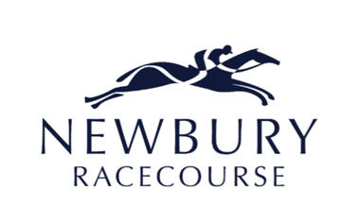
Announces

MINISTRY OF SOUND CLASSICAL
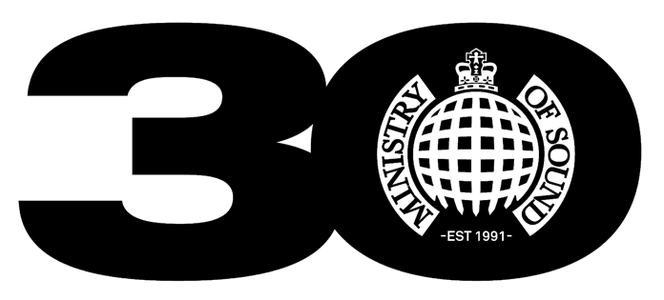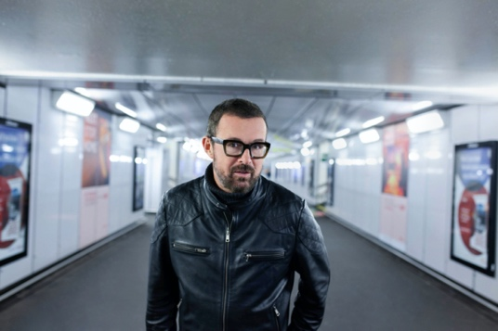

WITH JUDGE JULES
PARTY IN THE PADDOCK
SATURDAY 13TH AUGUST 2022

JUDGE JULES 6-7pm
MINISTRY OF SOUND ORCHESTRA 7-8.30pm

Assets available here.

Newbury Racecourse and MINISTRY OF SOUND CLASSICAL today announce a huge show for the BetVictor Hungerford Day on Saturday 13th August, live after racing.

Having celebrated the 30th anniversary of the world’s most iconic dance brand in 2021, the party is set to continue after the racing action when special guest DJ Judge Jules alongside the 34-piece orchestra take racegoers through some of the biggest dance tracks of the past three decades.

Tickets for the show are on sale now with early bird tickets starting from just £33.75 and include both the live racing and concert available at newburyracecourse.co.uk.

Harriet Collins, Marketing Director for Newbury Racecourse said: “We are extremely excited to announce that Ministry of Sound Classical will be taking to the stage live after racing on 13 August. We are really looking forward to welcoming the 34-piece orchestra to the stage for what promises to be a brilliant evening of classic dance tunes, which for a lot of us will be rolling back the years. To top it off, having Judge Jules provide a warm-up set is sure to get the crowd going after an afternoon of top-quality racing action. We can’t wait.”

Judge Jules said: “I have been a part of Ministry Classical shows before at the Royal Festival Hall and The O2 and I've done some marvellous venues that I’d never imagined. If you add the right records to an orchestration, and the magic of an orchestra to an amazing outdoor venue like Newbury Racecourse, I think it's a really magical combination”.

MINISTRY OF SOUND CLASSICAL is the evolution of their newly created classical arm, which launched in 2018 with the highly acclaimed The Annual Classical live show. It has since gone on to sell out two shows at London’s Royal Festival Hall and its debut UK tour in 2019 along with a huge show at London’s The O2 Arena for the Ministry of Sound’s 30th birthday back in November 2021.

MINISTRY OF SOUND CLASSICAL builds on the success of its previous incarnation and offers an even broader reflection of Ministry of Sound, recreating classical forms of the music that has defined the brand across its three decades with The London Concert Orchestra.

Ministry of Sound opened its doors at its Elephant & Castle site by co-founders James Palumbo and Justin Berkmann in 1991 and immediately made history as the first house music nightclub in the UK. Ministry of Sound have always been at the forefront of dance music and in 1993 the label Ministry of Sound Recordings was launched, marking the birth of the first global electronic label. Swiftly after this in 1996, Ministry of Sound once again made history as The Annual II sold over a million copies making it the best-selling dance music compilation of all time.

Judge Jules is one DJ that has been there, done that and done it all again, and for almost three decades has led the way in the world of dance music. Since hitting the decks in 1987, he has influenced an entire generation as a pioneer of the club scene; passion and persona coupled with crowd connection and unrivalled mixing has earned Judge Jules unforgettable sets at the world’s most iconic clubs and festivals including Gatecrasher, Ministry of Sound, Global Gathering and Creamfields.

Earning his place amongst DJ legends, Judge Jules has received accolades such as #1 DJ (Mixmag), Best International DJ (Dancestar Awards), Best Radio DJ (Smirnoff’s Dancestars), and has consistently featured in the DJ Mag Top 100 poll, peaking at #3 in the world, alongside the industry’s greatest.

Newbury Racecourse on Saturday 13th August looks set to be another monumental moment in Ministry of Sound’s untouchable timeline of success.

Newbury Racecourse has previously announced critically acclaimed, award-winning artist CRAIG DAVID will be headlining Party In The Paddock on Saturday 16th July 2022.

Tickets are on sale via newburyracecourse.co.uk priced at the early bird price from £33.75 with a range of exciting new hospitality & dining packages available to suit everyone.
All T&C’s are available on newburyracecourse.co.uk. There will be hospitality packages available to suit all budgets.

For more details and tickets visit newburyracecourse.co.uk or call 01635 40015.

FOR MORE INFORMATION AND ALL MEDIA ENQUIRIES FOR
MINISTRY OF SOUND CLASSICAL AT NEWBURY RACECOURSE PLEASE CONTACT

Jenny Entwistle & Warren Higgins at Chuff Media
jenny@chuffmedia.com / warren@chuffmedia.com

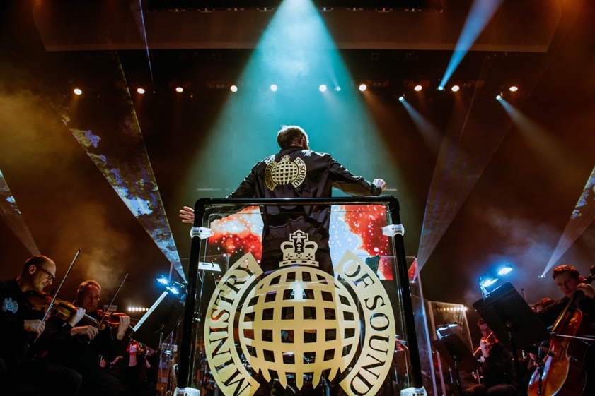

About Newbury Racecourse
Newbury Racecourse PLC is the parent of a Group of companies which own Newbury Racecourse and supporting businesses.

Newbury Racecourse held its first race in 1905 and has long been one of Britain's leading tracks, staging up to 30 days of top class Jump and Flat racing annually, with at least one raceday in every month of the year. On the Flat, Newbury's high-quality programme includes the Group 1 Al Shaqab Lockinge Stakes worth £350,000. The highlight of Newbury's Jump racing season is the £250,000 Ladbrokes Trophy, a handicap chase over an extended three and a quarter mile.

The racecourse is also a thriving events venue, hosting a huge range of activities including weddings, concerts and conferences for 20 to 1,000 attendees for a wide spectrum of businesses and organisations in stunning surroundings. The addition of a brand new on-site 36-bedroom hotel in 2015, The Lodge supports both the racing and non-racing events.

In addition, Newbury Racecourse PLC runs a successful private nursery, The Rocking Horse, providing a safe, happy and stimulating learning environment for many pre-school children.
Newbury is now home to a major housing development by David Wilson Homes, allowing people to live in a unique location alongside a world-renowned sporting venue, which also benefits from a Nuffield Health Club.

Over the past five years the racecourse has undergone a significant redevelopment which was completed in 2020 and comprises of upgrades to every area of the customer journey including redevelopment of the stables, a dedicated facility for owners on racedays, relandscaped parade ring and winner’s enclosure, as well as a number brand new outdoor bars and seating areas.

For more details and tickets visit https://newburyracecourse.co.uk or call 01635 40015.

