AUSTRALIAN COMEDY SENSATION
NAT’S WHAT I RECKON
DEBUT UK STAND-UP TOUR KICKS OFF NEXT MONTH

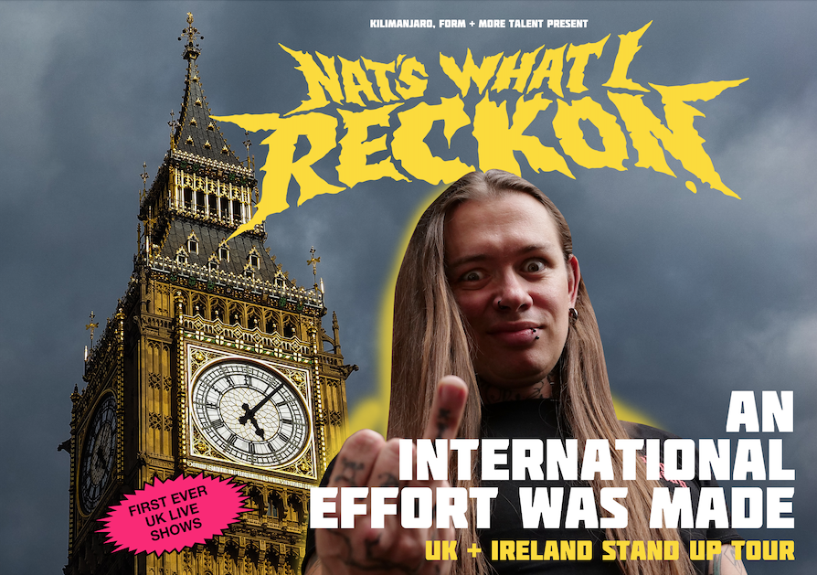

Combining a wild mix of traditional stand-up, video content and music, Nat’s highly anticipated first live stand-up tour in the UK promises to certainly be an experience. Fans will be able to witness his unique blend of humour and openness and encouragement in person as he brings his one-of-a-kind show to cities across the country. With initial shows selling out, further performances in London, Brighton, Bristol and Leeds have been added due to incredible demand.
NAT’S WHAT I RECKON is the phenomenally successful YouTube channel from Nat, a Sydney based stand-up comedian. He has been creating comedic videos online for a decade, but truly rocketed into global prominence in early 2020 with his hilarious isolation cooking content. Capturing the hearts and stomachs of millions, his no-holds-barred approach to cooking and his candid take on the world has earned him a massive and dedicated fanbase. He now has over 4 million social media followers - his YouTube videos have been watched over 275million times, he’s a bestselling author of 3 books with another on the way and has presented his own TEDx talk.
Amongst the no-nonsense recipes featured on his channels and in his books, Nat holds a tongue-in-cheek mirror up to antiquated cultural norms and societal politics. By openly sharing his own battle with anxiety and depression, Nat’s positive impact on the mental health of millions of people cannot be underestimated. In 2022 he took on an ambassadorship role for Australia’s mental health charity, Beyond Blue’s inaugural Big Blue Table alongside ex-Prime Minister Julia Gillard, wildly exceeding campaign expectations, leading to an invitation to continue the role in 2023.
Nat has had shoutouts and collaboration invites from global icons as diverse as Machine Gun Kelly, Courtney Act, Briggs and Dave Grohl. He’s sold-out solo comedy shows all over Australia as well as two sold-out live theatre performances at 6am and 10am in Sydney for viewers in the UK and Canada in the first real-time live-streamed ‘lockdown’ events of their kind globally.
With a message of positivity, kindness and inclusiveness that has resonated across the globe, Nat’s attention to detail in making sure his videos never ‘punch down’ has galvanised his voice as a trailblazer for mental health advocacy. Watching a video from NAT’S WHAT I RECKON leaves people with more than a decent recipe. It makes them feel like a champion.
Tickets available from myticket.co.uk/nats-what-i-reckon
6-Oct-23 Bristol Tobacco Factory – SOLD OUT
6-Oct-23 Bristol Tobacco Factory - 9pm – NEW SHOW
7-Oct-23 London Leicester Square Theatre – SOLD OUT
8-Oct-23 Brighton Komedia - 4.30pm – NEW SHOW
8-Oct-23 Brighton Komedia - 7pm
9-Oct-23 Leeds Wardrobe – SOLD OUT
9-Oct-23 Leeds Wardrobe - 9pm – NEW SHOW
10-Oct-23 Manchester Academy 2 - 7.30pm
11-Oct-23 Glasgow Oran Mor - 6.30pm
16-Oct-23 London Earth - 6.30pm – NEW SHOW

For all media enquiries please contact Warren Higgins @ Chuff Media
warren@chuffmedia.com / 07762 130510

