HI-RES ASSETS HERE
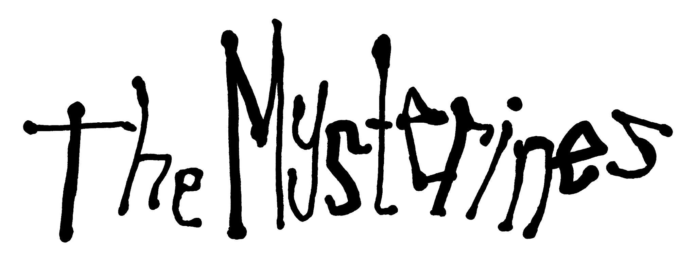

RELEASE ‘BEGIN AGAIN’ (JORDAN NOCTURNE REMIX)
STREAM HERE
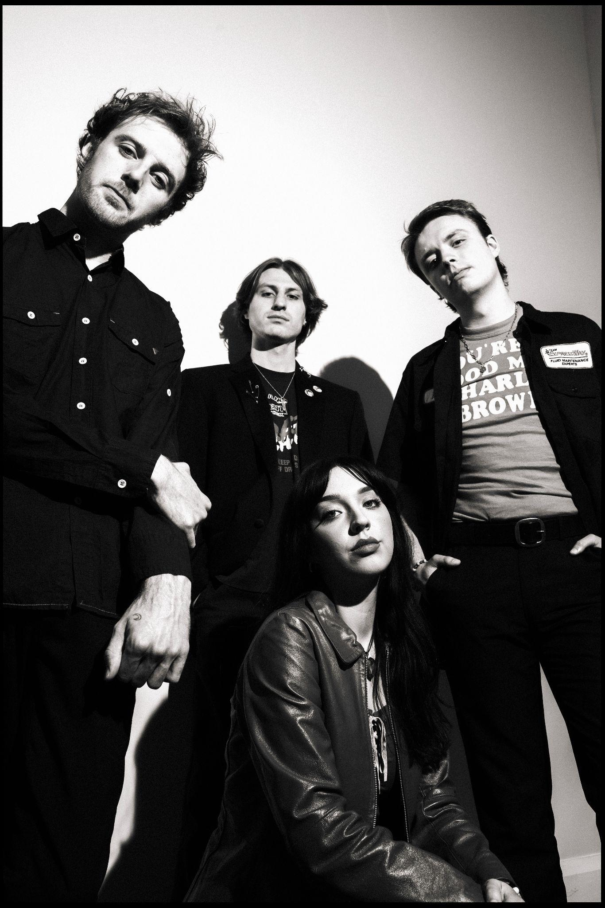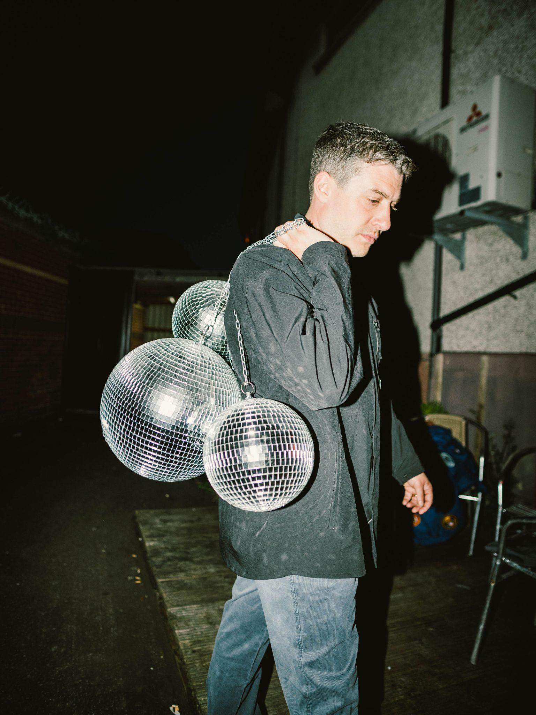
PHOTO CREDIT: CHARLES GALL

“Sounding like an angrier, tougher PJ Harvey, Lia Metcalfe takes on the world, one distorted guitar song after another.”
- The Times

"Metcalfe’s confident attitude is felt at every turn as she opens up on themes of self-destruction and love."- NME

"Few can match the levels of accessibility, seduction and intensity that The Mysterines have.." - The Line of Best Fit

Alt rock wunderkinds The Mysterines have joined forces with producer Jordan Nocturne, releasing a revved up remix to their latest single ‘Begin Again’. Listen here.

Bringing a new lease of life to the rock anthem, the remix delves into the intoxicating world of dance/electronic pop to deliver a whole different feel to the track. The remix develops on the band’s concept of refining their craft and branching into new directions.

Lia Metcalfe says about the remix: “We thought it would be a great idea to get a remix of ‘Begin Again’. The song was released as the start of a new conception of the band and a few months after it came out, Jordan felt like the perfect person to give it extra life and a new direction. We love what he’s done with the remix.”

Riding high on the success of their critically acclaimed, UK Top 10 debut album ‘Reeling’ released March 2022, The Mysterines have been achieving remarkable success since the release, including two tours of the UK, two of North America and one in the EU, and a summer tour with their personal heroes Arctic Monkeys across UK stadiums.

‘Reeling’ saw stellar support across the board on release, from a TV appearance on Jools Holland (which Lia herself predicted as a teenager) to glowing reviews from leading indie tastemakers and national broadsheets. The Line of Best Fit’s 8/10 review said The Mysterines “draw you in with their seething words…mountainous rock tones…and humoured musings on life’s painful inevitabilities over thirteen glorious tracks”, with DIY commenting "their knack for melody is one of their greatest strengths, particularly when combined with frontwoman Lia Metcalfe's husky tones". NME declared ‘Reeling’ an “electrifying debut album” in their 4* review, comparing the powerful guitar ballad ‘On The Run’ to “a Celebrity Skin era Hole classic”, meanwhile The Telegraph commented “The Mysterines' default setting is fast and furious garage punk-rock to which Metcalfe adds a goth grandeur with doomy lyrics and a quality of brazen glee at the rebellious posturing of songs with statement titles.”

The Mysterines are:
Lia Metcalfe (vocals/guitar)
George Favager (bass)
Callum Thompson (guitar)
Paul Crilly (drums)

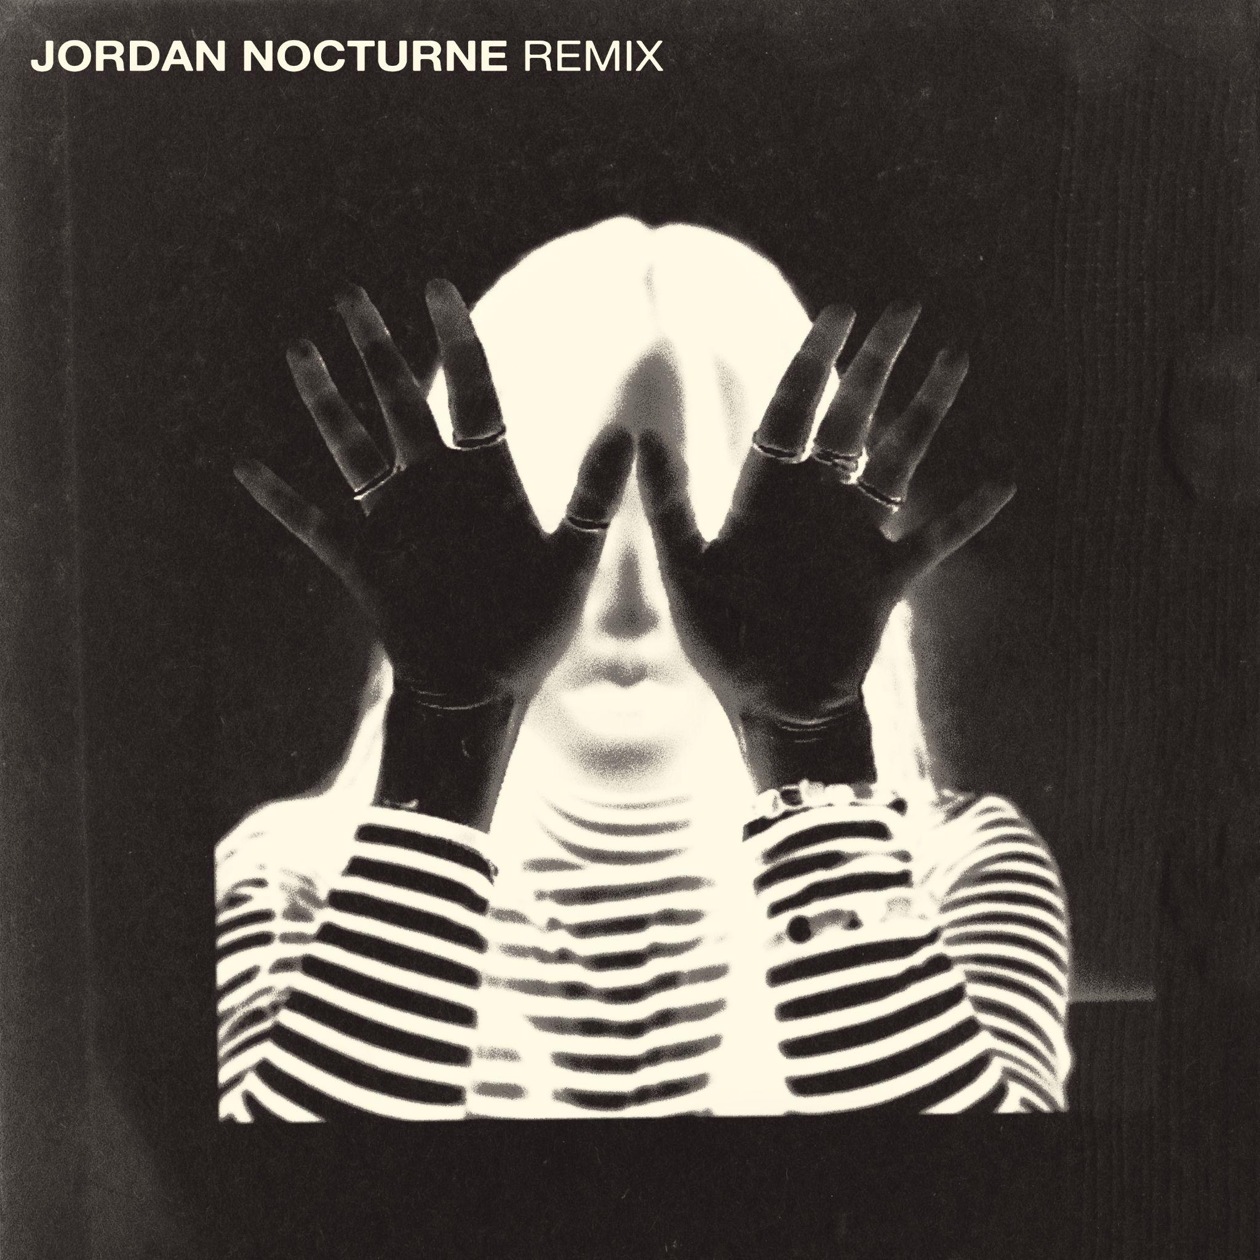
Single artwork

THE MYSTERINES ON SOCIALS
INSTAGRAM | TWITTER | FACEBOOK | SPOTIFY

For more information please contact
Warren@chuffmedia.com on 07762 130 510

