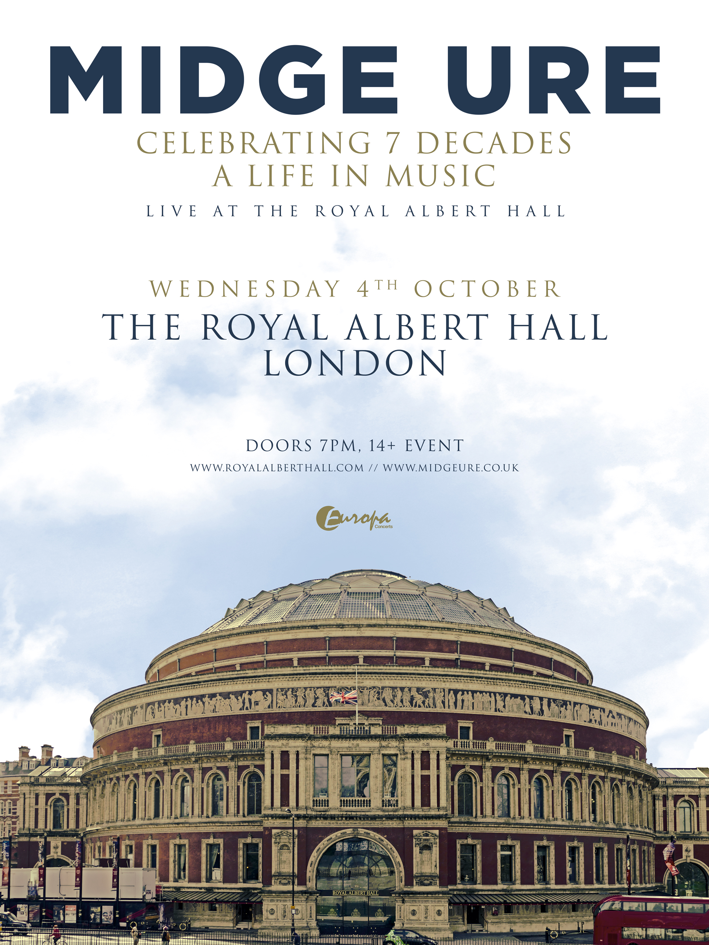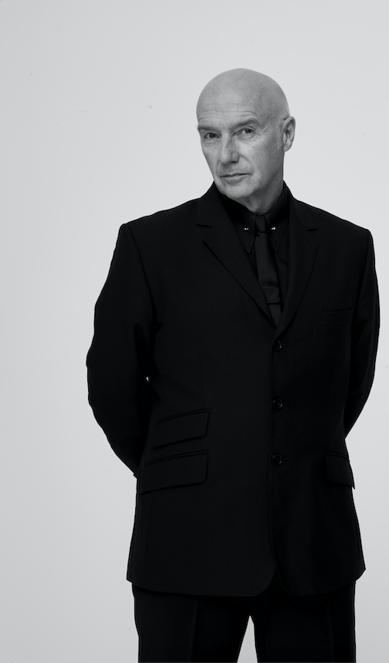

MIDGE URE AT THE ROYAL ALBERT HALL

CELEBRATING 7 DECADES: A LIFE IN MUSIC

WEDNESDAY 4TH OCTOBER 2023
Tickets from £33.50 via royalalberthall.com
On sale Friday 16th June 9am

Media assets here

To mark his 70th birthday and to celebrate a life in music, Midge Ure will headline a one-night-only concert at the Royal Albert Hall on 4th October 2023. The evening will see the incomparable music legend play the hits that have soundtracked lives across generations.

Of the show, Midge Ure says “What do you get as a gift on your significant 70th? A birthday celebration show at the Royal Albert Hall of course. There are prestige venues and globally renowned prestige venues and the RAH falls into the latter. That is the ultimate gift for a musician, one which lasts for the rest of your life”.

A global star who has received multiple Ivor Novello, Grammy and BASCAP awards along with a flotilla of gold and platinum records, really needs very little introduction. Musical success is seldom measured in time spans of more than a few years, if not Andy Warhol's often quoted "fifteen minutes", so the fact that by the time Midge's single ‘If I Was’ went to number one in 1985, he had already crammed several musical lifetimes into a 10 year professional career speaks volumes. Silk, The Rich Kids, Thin Lizzy, Visage, Ultravox and of course the most famous one-off group in musical history, Band Aid, had by then all had the guiding hand of his musical navigation.

A career that started with teen success in the 70’s with Silk, their single ‘Forever And Ever’ took over at number one from Abba’s ‘Mamma Mia’ on Valentine’s Day 1976, Midge was snapped up by ex-Sex Pistol Glen Matlock the following year for his new outfit, The Rich Kids, who charted amid an avalanche of press with a self-titled EMI single early in 1978. By 1979, with his name being added to many musicians' contact book, Ure had been asked to become the new frontman in Ultravox. The band was a major influence on the new romantic and electro-pop movements of the early '80s, tracks like 'Reap the Wild Wind', 'Dancing With Tears in My Eyes', 'Love's Great Adventure' and 1981's timeless 'Vienna' were all massive hits the world over as they charted with awesome regularity, not only on single, but with seven consecutive top ten albums in just six years. Indeed, Vienna has been voted the Nation’s favourite number 2 single of the 80’s, finally granting it a coveted Number 1 position!

He wrote and produced ‘Fade to Grey’ for Visage in 1980, then hit the top 10 in the summer of 1982 with his first release under his own name, 'No Regrets'. Then came November 25, 1984, a historic day for Midge and all of pop music, as 36 artists by the collective name Band Aid gathered at SARM Studios in west London under Ure's production. They recorded 'Do They Know It's Christmas?' a song he had just written with Bob Geldof as the industry's heartfelt and eloquent contribution to Ethiopian famine relief and the unstoppable emotion engendered by the project led to Live Aid, the summer 1985 global concert that, all exaggeration aside, spoke for a generation.

From Silk to Thin Lizzy and The Rich Kids through to Visage and Ultravox and the historic Band Aid & Live Aid in the 80’s, Midge has been a constant in the UK music scene. He continues to record and tour the world as a solo artist, most recently playing to over 40,000 fans on his 2023 Voice & Visions tour.

Midge's services to both music and charity were recognised in the Birthday Honours list in 2005, when Midge was awarded an OBE. He's also received honorary doctorates from Edinburgh, Glasgow Caledonian, Dundee and Bath Universities.

Midge Ure is planning something special for The Royal Albert Hall.

For all media enquiries please contact Warren@chuffmedia.com on 07762 130510

