**JOHNNY VEGAS**

**THE FIELD OF DREAMS**

**GLAMPING BOOKINGS OPEN FOR MELBOURNE HALL**

**FROM APRIL 2023 ONWARDS**

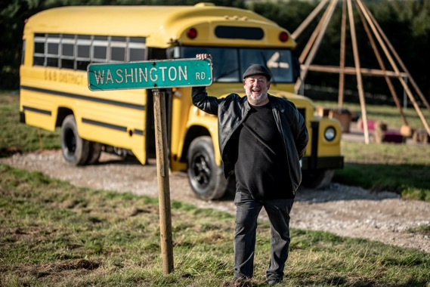

Following the success of the inaugural ***Live at Melbourne Hall*** summer series of events in 2022, JOHNNY VEGAS handpicked the Derbyshire home of Lord & Lady Kerr to permanently host his hugely popular *The Field of Dreams* campsite which will officially open in April 2023 with bookings being taken now.

*The Field of Dreams* at Melbourne Hall will be a unique glamping experience consisting of lovingly restored and converted vehicles. A German fire truck, Patricia the bus**,** an American School Bus anda classic Citroen Camper will take centre stage, with three new additions adding to the unique fleet for 2023. These include a boat set for conversion to a stylish glamping pied-a-terre that will take up a prime place beside the lake, and even a helicopter! The iconic vehicles will be situated across two sites, both within a short walk from the pool and the famous walled gardens which play host to the ***Live at Melbourne Hall*** summer series of events.

Having performed at ***Live at Melbourne Hall*** in May 2022, Johnny approached Lord Kerr with the idea of bringing his *The Field of Dreams* to the grounds of the South Derbyshire Stately home. TheChannel 4 series, *Johnny Vegas: Carry On Glamping*, continues to follow Johnny and his long-suffering assistant Bev with the setting up of the site at Melbourne Hall and will be returning to the screens at some point in 2023. After opening the original Yorkshire glampsite in 2021, it became a roaring success with bookings aplenty, however, ambitions for a bigger site meant Johnny needed to move on. This led Johnny and Bev to undertake a search to find a new home for the eclectic collection of repurposed vehicles that they share with Jim and Claire.

Guest staying at the site will also be able to combine their stay with the 2023 ***Live at Melbourne Hall*** calendar that is currently being planned.

With glamping, top comedians, music, food and more the South Derbyshire stately home is quickly becoming a destination for more than just its iconic gardens,

Bookings via melbournehall.com

***LIVE AT MELBOURNE HALL:***

April – September ***Johnny Vegas’ Field of Dreams Glamping***

Friday 19-May *Just The Tonic presents* **Seann Walsh**

Saturday 20-May *Just The Tonic presents* **Milton Jones**

Sunday 21-May *Just The Tonic presents* **Mark Watson**

Friday 23rd June ***BBC Radio 2: Sounds of the 80s w/ Gary Davies***

Friday 1st September ***Jo Whiley’s 90s Anthems*****SOLD OUT**

**Ticketing and more information at** [**melbournehall.com/events**](https://www.melbournehall.com/events/)

**For all media enquiries please contact**

**Warren (**[**warren@chuffmedia.com**](mailto:warren@chuffmedia.com)**)**

**07762 130510**

***About Live at Melbourne Hall***

Derbyshire’s Melbourne Hall has established itself this summer as one the East Midlands premier venues for summer entertainment.  Eschewing the trend for sprawling festivals catering to thousands, Live at Melbourne Hall felt the boutique approach was more in keeping with the stately home and iconic gardens and welcomed comedic talent such as Julian Clary, Strictly legend Anton Du Beke, celebrity chefs like Gennaro Contaldo to their famed walled garden.

Melbourne Hall stands in an idyllic setting in Derbyshire and is home to one of the most treasured historical gardens in the country and is the best surviving early 18th century English garden in the manner of le Notre.

The house has a chequered and unusually well-documented history, and all centuries from the 16th to the 20th have left their mark on the fabric. This combined with the fact that Melbourne remains a lived-in family home for Lord and Lady Ralph Kerr (Lord Ralph being a direct descendant of Sir John Coke who made Melbourne his home in 1629) accounts for its warm, welcoming and comfortable atmosphere.