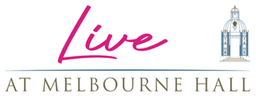

PRESENTS

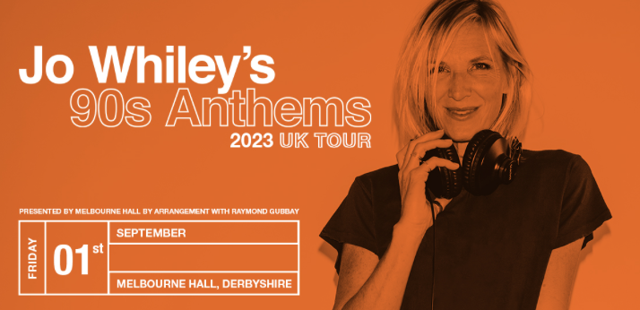

Having previously announced the return of Johnny Vegas to the South Derbyshire stately home with his ‘Field Of Dreams’ glamping site, Live At Melbourne Hall are very happy to reveal the first of the summers entertainment programme. Jo Whiley’s 90s Anthems will headline the hall’s famed walled garden on Friday 1st September for a strictly over 18’s event.

Pre-sale starts at 10am on Thursday 26th January and the general on sale at the same time on Friday 27th January. Tickets start from £30 with limited early bird tickets priced at £19.90 and VIP options are available. Doors for the event will open at 7pm. All tickets available via melbournehall.com/events

Jo Whiley is quite simply the ultimate authority on British music – and the definitive voice and face of a generation is headed to Melbourne Hall with a dazzling new show as she rummages through her record bag to dig out the very best of 90s Anthems.
No-one knows the 90s like Jo – she was right there on the cutting-edge, leading the charge as Britpop blew up, dance music exploded and indie went wild. Introducing us all to so many incredible emerging bands and global superstars through her generational Radio 1 show, no-one is better qualified to take you on an aural retrospective of the 90s than Jo.
She started out in local radio before landing a job as booker for infamous TV show The Word, where she brought Nirvana and Rage Against The Machine to the UK’s screens for the first time. And then the move that created the soundtrack of our lives for so many years – she moved to Radio 1 in 1993 and hosted The Evening Session with Steve Lamacq, a weekday show she maintained for 16 years before moving to weekends.
She will forever remain the iconic face and voice of Glastonbury too, fronting coverage on Radio 1, BBC TV and Channel 4, while she now hosts the 7-9pm weekday slot on Radio 2. Still on the cutting edge of new music she will always be the ultimate authority on the very best of classic sounds of the 90s, Jo is an institution in her own right and a national treasure.
Now, she’s added to the summer line up at Live At Melbourne Hall with a dazzling new show – Jo Whiley’s 90s Anthems. The queen of the decade of mayhem, magic and misty memories delves into her archives to showcase her friends and favourites from that era. She knows it all, she lived it all, she loves it all and you will too! Let Jo take you on a personal tour of her finest musical memories of the decade that defined them all.
With glamping, top comedians, music, food and more planned for 2023, the South Derbyshire stately home is quickly becoming a destination for more than just its iconic gardens.

For all media enquiries please contact
Warren Higgins (warren@chuffmedia.com) 07762 130510

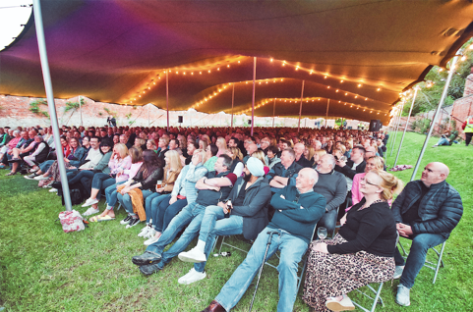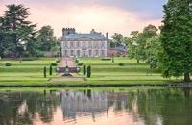

About Live at Melbourne Hall
Derbyshire’s Melbourne Hall has established itself this summer as one the East Midlands premier venues for summer entertainment. Eschewing the trend for sprawling festivals catering to thousands, Live at Melbourne Hall felt the boutique approach was more in keeping with the stately home and iconic gardens and welcomed comedic talent such as Julian Clary, Strictly legend Anton Du Beke, celebrity chefs like Gennaro Contaldo to their famed walled garden.

Melbourne Hall stands in an idyllic setting in Derbyshire and is home to one of the most treasured historical gardens in the country and is the best surviving early 18th century English garden in the manner of le Notre.

The house has a chequered and unusually well-documented history, and all centuries from the 16th to the 20th have left their mark on the fabric. This combined with the fact that Melbourne remains a lived-in family home for Lord and Lady Ralph Kerr (Lord Ralph being a direct descendant of Sir John Coke who made Melbourne his home in 1629) accounts for its warm, welcoming and comfortable atmosphere.

