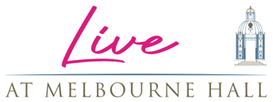

PRESENT

BBC RADIO 2: SOUNDS OF THE 80S

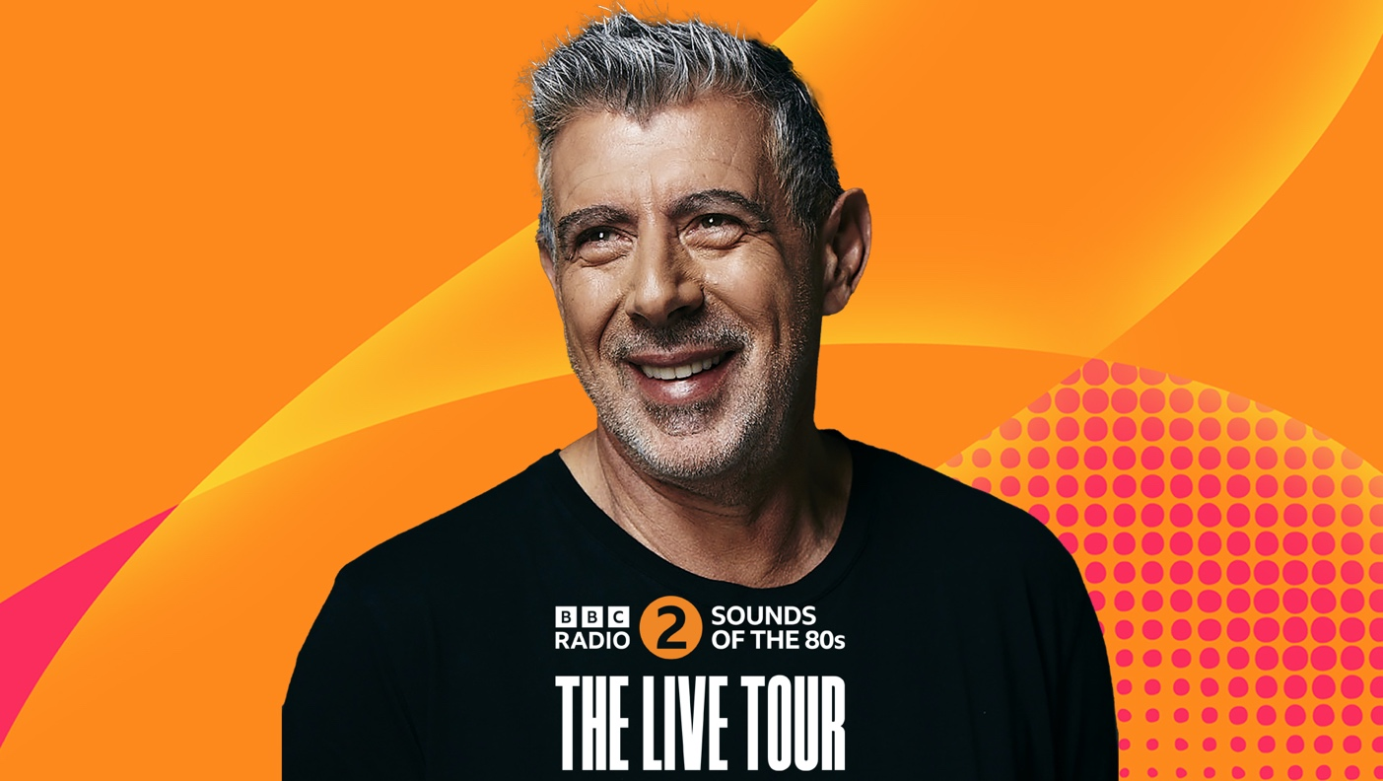

GET READY FOR THE ULTIMATE 80S PARTY
AT MELBOURNE HALL, FRIDAY 23RD JUNE 2023

Gary Davies Takes His Saturday Night Radio Show On Tour
With Mastermixes and Dancers

Pre-sale: Tuesday 31st January, 10am
General On-Sale: Wednesday 1st February, 10am

Legendary DJ Gary Davies will be bringing the UK’s biggest 80s radio show - BBC Radio 2’s Sounds of the 80s to the walled garden for a unique live performance as part of the live at Melbourne Hall summer series. It’s the show that listeners enjoy every Saturday night, but live on stage.

Following on from the previously announced Jo Whiley’s 90s Anthems taking place on the 1st September which has sold out in a matter of days; Gary Davies will be coming to Melbourne Hall on Friday 23rd June with tickets starting from £30 with limited early bird tickets priced at £19.80 and VIP options are available. Doors for the event will open at 7pm. All tickets available via melbournehall.com/events

Celebrating the greatest decade in music, the immersive show will feature Gary, together with his producer Johnny Kalifornia, and some specially curated Mastermixes. The amazing Sounds of the 80s dancers will get you on your feet recreating classic scenes from 80s films and videos. The show also features a fabulous set design from the 80s.

Gary says, “I’m so excited to finally be able to bring the magic of Sounds of the 80s live on tour across the UK - as we all know, the 80s is the best decade. Expect Anthems, Mastermixes, Sloppy Bits, fabulous dancers and the biggest 80s party ever!”

This massive party will feature 80s anthems from artists such as Wham!, Queen, Prince, Madonna, Whitney, and more. The Sounds of the 80s live show debuted at Stoke-on-Trent's Regent Theatre last year to a packed crowd of 80s fans dressed up to the nines in lycra leg warmers, headbands, and Frankie and Wham! statement T-shirts.

The perfect choice to host Radio 2’s Sounds of the 80s (Saturdays from 8-10pm), Davies’ star was at its peak in those heady days as a presenter on BBC Radio 1 and Top of the Pops, when he discovered and championed many of the acts that he now plays out on the programme. He was one of the first to offer mainstream support to the likes of U2, Chris Rea, Deacon Blue, Tears For Fears and Simple Minds. Gary Davies and his show in some ways helped define the sounds of the 80s
With glamping, top comedians, music, food and more planned for 2023, the South Derbyshire stately home is quickly becoming a destination for more than just its iconic gardens.

LIVE AT MELBOURNE HALL
Friday 23rd June BBC Radio 2: Sounds of the 80s
Friday 1st September Jo Whiley’s 90s Anthems SOLD OUT
April – September Johnny Vegas’ Field of Dreams Glamping

Ticketing and more information at melbournehall.com/events

For all media enquiries please contact
Warren Higgins (warren@chuffmedia.com) 07762 130510

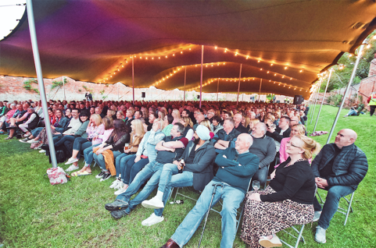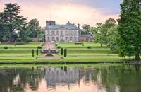

About Live at Melbourne Hall
Derbyshire’s Melbourne Hall has established itself this summer as one the East Midlands premier venues for summer entertainment. Eschewing the trend for sprawling festivals catering to thousands, Live at Melbourne Hall felt the boutique approach was more in keeping with the stately home and iconic gardens and welcomed comedic talent such as Julian Clary, Strictly legend Anton Du Beke, celebrity chefs like Gennaro Contaldo to their famed walled garden.

Melbourne Hall stands in an idyllic setting in Derbyshire and is home to one of the most treasured historical gardens in the country and is the best surviving early 18th century English garden in the manner of le Notre.

The house has a chequered and unusually well-documented history, and all centuries from the 16th to the 20th have left their mark on the fabric. This combined with the fact that Melbourne remains a lived-in family home for Lord and Lady Ralph Kerr (Lord Ralph being a direct descendant of Sir John Coke who made Melbourne his home in 1629) accounts for its warm, welcoming and comfortable atmosphere.

