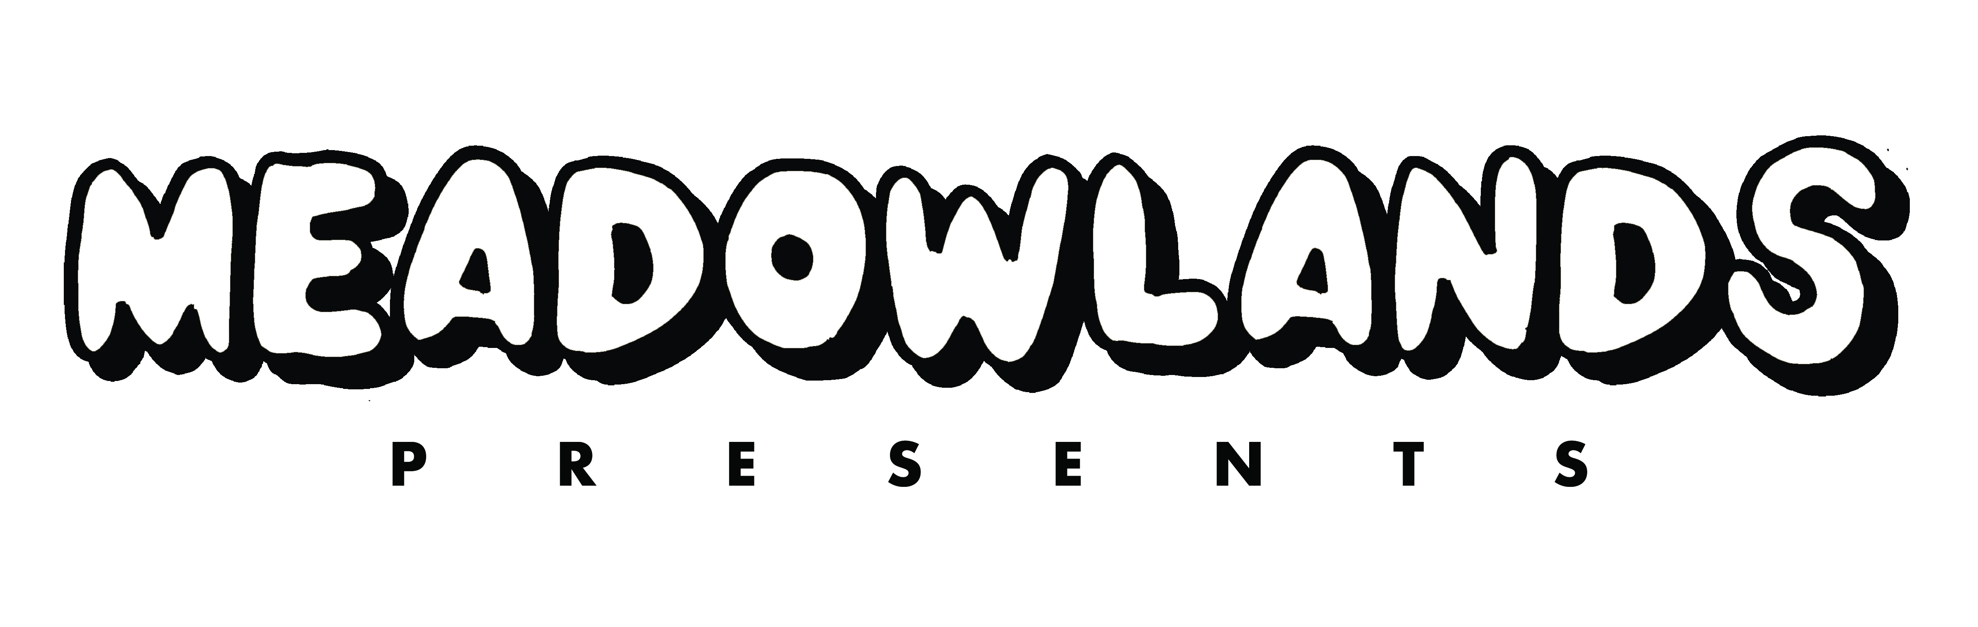

Victoria Embankment, Nottingham
Bank Holiday Friday 3rd June 2022
2pm to 11pm

On sale 10am this Friday 24th September
Tickets from £45 at eventim.co.uk

Stadium and arena-filling GERRY CINNAMON has been revealed as the first headliner of MEADOWLANDS, the new event series from live promoters, FKP Scorpio. Set to take place at Victoria Embankment over the Jubilee Bank Holiday Weekend in June 2022, Meadowlands will feature a variety of music acts across multiple stages with its sights set on becoming one of the biggest music events to ever take place in the city.

Following Gerry’s triumphant penultimate slot at Reading and Leeds Festival attracting one of the biggest crowds of the weekend, the show in Nottingham will be one of only a handful of shows his fans will be able to see him outdoors in the UK in Summer of 2022, with the tour also taking in a sold-out hometown show in Glasgow’s Hampden Park national stadium.

Event promoters Daniel Ealam and Scott O’Neill, FKP Scorpio say: “We are so excited to be announcing Gerry Cinnamon as our first headliner of the inaugural Meadowlands festival series. Meadowlands will bring the finest international, national and local artists to Victoria Embankment in the amazing music city of Nottingham.“

Councillor Eunice Campbell-Clark, Portfolio Holder for Leisure, Culture and Schools at Nottingham City Council said: “We’re delighted to be welcoming a brand-new music festival to Victoria Embankment next summer. Meadowlands promises to bring some of the very best indie artists to Nottingham, along with a significant economic boost for the city’s events and hospitality sectors, which have suffered during the pandemic. We’re happy to be working with FKP Scorpio to ensure this exciting event is a success for everyone.”

The continuing ascent of Gerry Cinnamon is one of contemporary music’s most outstanding stories. As an artist whose revealing and honest songs naturally connect with a huge and devoted audience, he’s achieved it all entirely independently.

In April 2020, Gerry’s second album ‘The Bonny’ shot straight to Number 1 in the Official Album Charts in the UK. Now certified gold, the album went on to become the third biggest selling UK album released that year. Having organically built up a huge following over the past 4 years, Gerry has become the UK‘s biggest independent artists and his last tour was second largest in 2019 UK tickets sales.

An already legendary live performer, his gigs have become folklore – joyous mass fan singalongs inspiring devotion and a dedicated following that has swelled, via word-of-mouth, to epic proportions.

More announcements to follow…

MEADOWLANDS PRESENTS
GERRY CINNAMON

Victoria Embankment, Nottingham
Bank Holiday Friday 3rd June 2022
2pm to 11pm
£45

Tickets at eventim.co.uk
Accessibility tickets at eventim.co.uk

https://www.instagram.com/inmeadowlands/
https://www.facebook.com/InMeadowlands
https://twitter.com/InMeadowlands

FOR MORE INFORMATION AND ALL MEDIA ENQUIRIES PLEASE CONTACT

Warren Higgins & Jenny Entwistle at Chuff Media
warren@chuffmedia.com / jenny@chuffmedia.com

