MIMI WEBB IS “BACK HOME FOR CHRISTMAS” ON NEW HOLIDAY SINGLE OUT NOW

LISTEN HERE
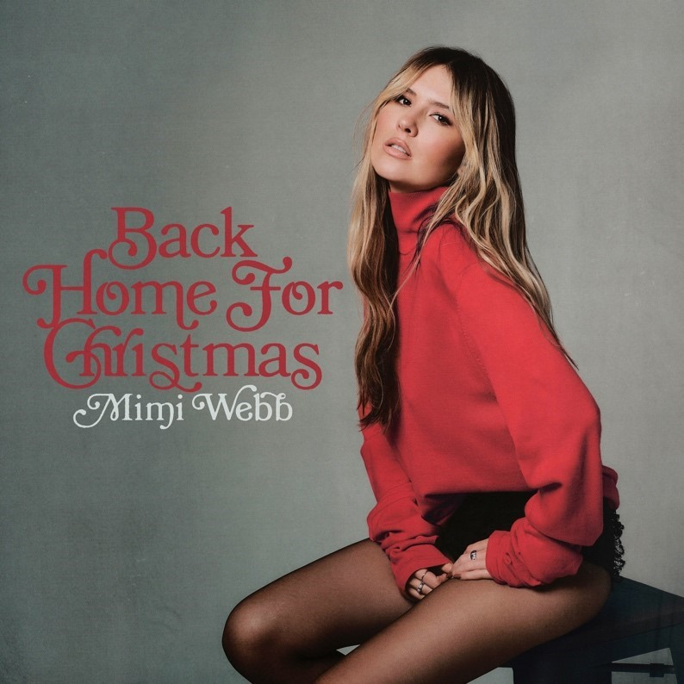

Today, rising singer-songwriter Mimi Webb unveils a brand new holiday single entitled “Back Home For Christmas” – listen HERE. It notably stands out as her very first Christmas original!

With “Back Home For Christmas,” she serves up a different kind of holiday anthem. Her stark vocals echo over bells as the momentum picks up, dashing towards a danceable chorus. Amplifying her buoyant and bold delivery, she urges, “Only one thing on my wish list, get my love back home for Christmas.” The song seamlessly jumps from moments of intimacy into an irresistible refrain.

Stay tuned for the premiere of a cinematic music video to accompany the track soon.

It lands on the heels of the fan favorite “Last Train To London (I Won’t Look Back),” which received updated production courtesy of Academy Award- and Grammy Award-winning musician, producer, and artist FINNEAS. Beyond generating 3.1 million Spotify streams, Rolling Stone touted it among “All The Songs You Need To Know This Week.” The original track, “Last Train To London,” was featured on Mimi’s debut album Amelia, which released this year.

The 12-track album expanded on her signature sound of breakup bops and sentimental ballads, showcased through upbeat anthems such as her latest smash hit “Red Flags,” and “Freezing,” and poignant tracks like “Roles Reversed.” Amelia garnered wide-spread critical acclaim with Rolling Stone praising it, “a vibrant, nostalgic record of her coming-of-age voyage to self-love,” and V Magazine applauding her, “a fiery vocalist setting the pop sphere on fire.”

In just two years the rising artist has racked up over 1 billion global streams, and multiple chart-topping tracks including “House on Fire,” “Good Without,” and most recently “Red Flags.” Mimi was nominated for Best New Artist at the 2023 BRIT Awards and has performed at the Queen’s Platinum Jubilee in London and on The Late Show with Stephen Colbert, The Tonight Show Starring Jimmy Fallon, The Graham Norton Show and ELLEN.

ABOUT MIMI WEBB
Mimi Webb projects a voice as magnetic, massive, and magical as her personality. As “the girl next door” with a hell of vocal range, she’s quick to laugh, will let you know precisely what’s on her mind, and isn’t afraid to be heard. Originally hailing from the UK town of Canterbury, the pop singer and songwriter turns up the volume on every emotion with skyscraping runs and open-heart honesty.

Inspired by the likes of Amy Winehouse, Emelie Sandé, and Sam Smith, she started writing songs of her own at 13-years-old in diaries before eventually learning guitar. Around the same time, she enrolled in The BRIT School—known for alumni such as Adele, Amy Winehouse, Jessie J, and more. Three years later, she left home, moved in with a host family, and attended the prestigious BIMM [British Institute of Modern Music]. In 2019, she landed management, and inked a deal with Epic Records, followed by the release of her debut single “Before I Go” in 2020.

In a whirlwind two years, Mimi released her debut EP Seven Shades of Heartbreak (October 2021), amassed an international following with multiple hit tracks such as “House on Fire,” and “Good Without,” and a Best New Artist nomination at the 2023 BRIT Awards. She has surpassed 1 billion global streams to date and toured across the world- performing at festivals such as Capital FM’s Summertime Ball, Isle of Wight Festival, and Montreux Jazz Festival, as well as her own headline tours. Mimi has garnered critical acclaim from the likes of British Vogue, Rolling Stone, Harper’s BAZAAR, and Billboard, and performed on The Late Show with Stephen Colbert, The Tonight Show Starring Jimmy Fallon, The Graham Norton Show, and ELLEN. Mimi’s debut album Amelia is out now.

CONNECT WITH MIMI:
TIKTOK // INSTAGRAM // YOUTUBE


Photocredit: Nick Walker

For more information and press enquiries please contact

Jenny Entwistle
Jenny@chuffmedia.com

