**MIMI WEBB REVEALS BRAND NEW SINGLE & OFFICIAL MUSIC VIDEO, “ERASE YOU” – OUT NOW**

**CONFIRMED TO SUPPORT THE JONAS BROTHERS FOR UK & EUROPEAN TOUR THIS FALL**

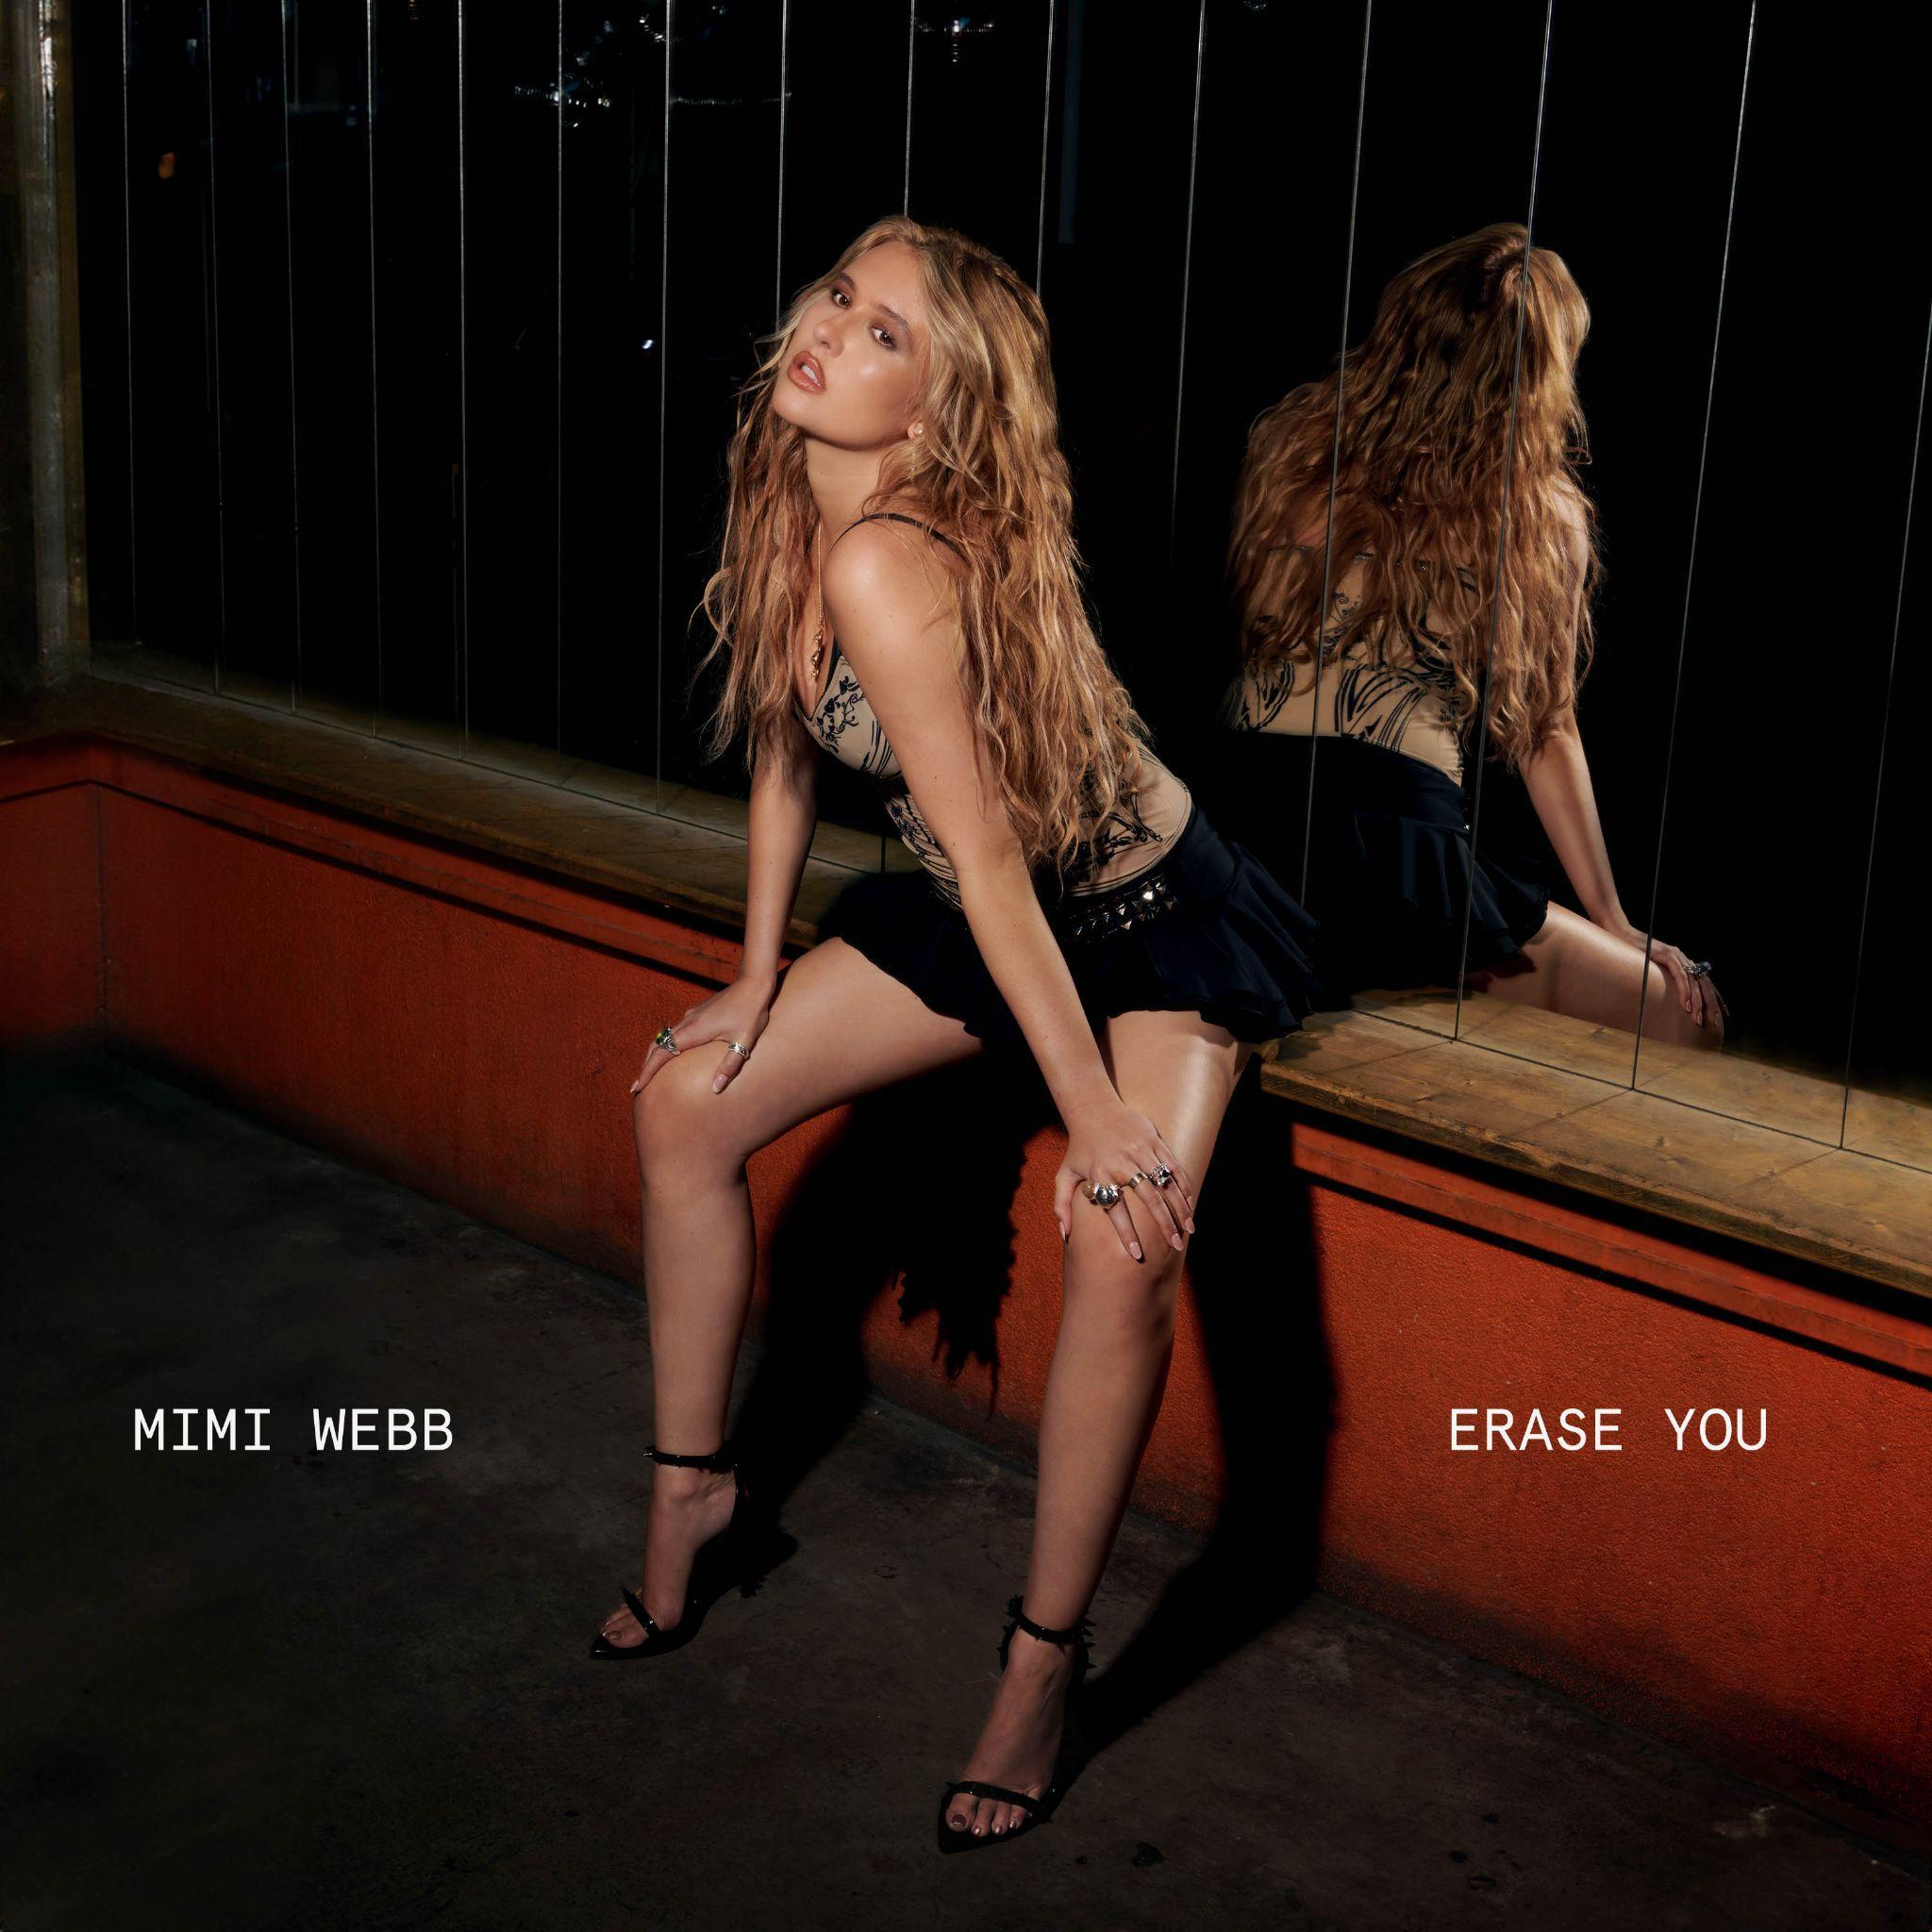

[**LISTEN**](https://mimiwebb.lnk.to/EraseYou)

**“ERASE YOU”**

Ahead of her upcoming performances this weekend at Osheaga in Montreal on August 2 and Lollapalooza this coming Sunday, August 4—British pop-songstress **Mimi Webb** returns with yet another stellar single, “**Erase You**”. Another collaboration with multiple GRAMMY® Award-winning songwriter and producer **Ryan Tedder**, who has worked with the likes of **Adele**, **Beyoncé**, and **Taylor Swift** throughout his career. ***Listen*** [***HERE***](https://mimiwebb.lnk.to/EraseYou)***.***

Speaking about “**Erase You**” **Mimi Webb** reveals, *“I have been playing ‘Erase You’ out on the road live since my last North American tour, and the reaction from the crowd is always so incredible. It’s such a perfect song for the summer. Carefree and fun, just like the music video! I’m so excited to finally be sharing it with the world."*

**“Erase You”** comes paired with a fun official music video, directed by **Colin Solal**.

In addition to scheduled festival sets this weekend at **Osheaga** and **Lollapalooza**, Mimi is slated to play **Outside Lands** in **San Francisco** **on Saturday, August 10**; a testament to her steadily growing profile and stardom. Next month, Mimi will join **The Jonas Brothers** on the UK & European legs of their ***FIVE ALBUMS: ONE NIGHT*** Tour, kicking off **September 9** in Belfast. She also recently concluded a massive North American tour with **Benson Boone**, her most expansive trek of live shows to date. For a full list of tour dates and to purchase tickets, please visit [www.mimiwebb.com](https://www.mimiwebb.com/).

**“Erase You”** serves as the follow-up to “**Mistake**,” out earlier this summer to vast critical and fan praise. ***Listen to “Mistake”*** [***HERE***](https://mimiwebb.lnk.to/mistake)***. Watch the official video*** [***HERE***](https://youtu.be/BaGOJi0xdj0?si=6Nobqa5oYQ47n4em)***.***

***“Erase You”, the new single from Mimi Webb is*** [***available everywhere***](https://mimiwebb.lnk.to/EraseYou) ***today.***

**NORTH AMERICAN FESTIVAL APPEARANCES**

08/02 – Osheaga Festival – Montreal, QC

08/04 – Lollapalooza – Chicago, IL

08/10 – Outside Lands – San Francisco, CA

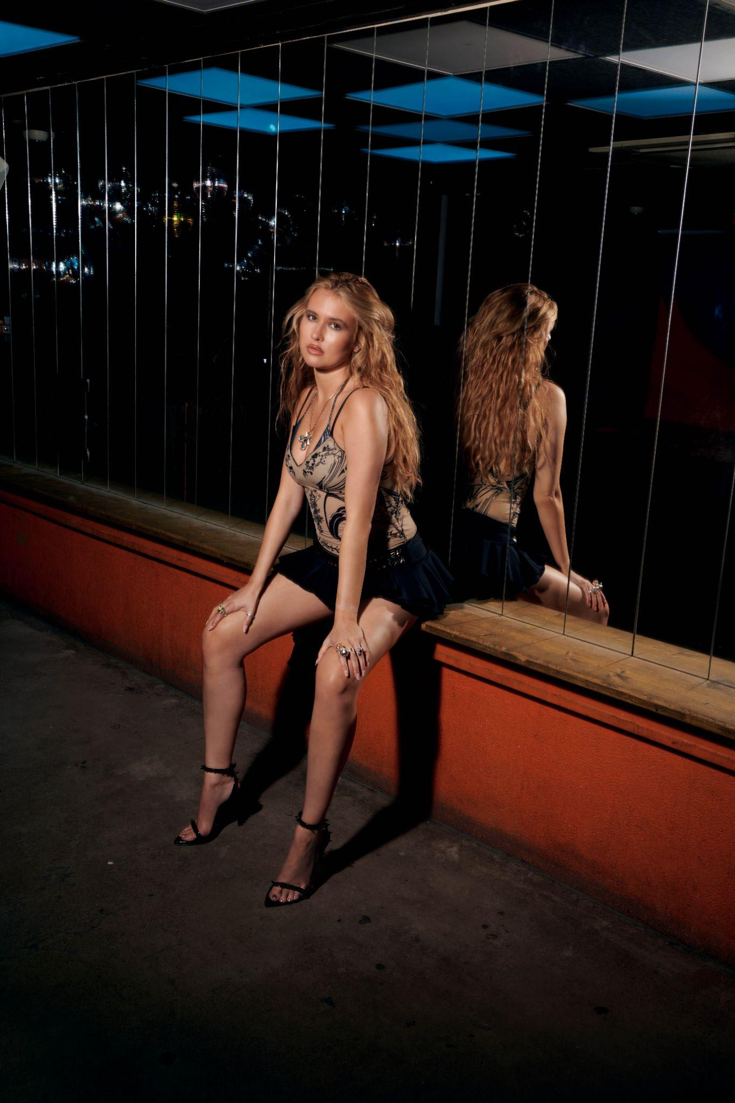

*Credit: Colin Solal Cardo*

**CONNECT WITH MIMI:**

[**TIKTOK**](https://www.tiktok.com/@mimiwebb_?lang=en) **//** [**INSTAGRAM**](https://www.instagram.com/mimiiiwebb/?hl=en) **//** [**YOUTUBE**](https://www.youtube.com/@MimiWebb)

**MORE ABOUT MIMI WEBB**

Mimi Webb signed to Epic Records in 2021 following an extraordinary come-up in her native UK that included over a quarter-billion streams and the admiration of global tastemakers, from *Wonderland* to *teen VOGUE*. Her debut EP with Epic, *Seven Shades of Heartbreak*, introduced her to a mainstream global audience, and gave fans a taste of her stardom, particularly with records like “Good Without” and “Dumb Love,” which earned Webb concurrent Top 15 placements on the UK Singles Chart, a feat that hadn’t been accomplished since Dua Lipa in 2017. Webb went on to play a sold-out trek of Australia before diving into the campaign for her debut full-length studio album, *Amelia*, released in April 2023. The album earned Webb a #4 peak on the UK Albums Chart, a career best, and sports the single “House On Fire,” which has become a smash hit, amassing over 115M Spotify streams and over 10M music video views on YouTube. The album also boasts the successful singles “Red Flags” and “Ghost Of You,” which Webb will perform as she supports Benson Boone on his sold-out international headlining tour, The Fireworks and Rollerblades Tour. She will also grace stages at this year’s Governors Ball in New York City (Jun. 7), the Osheaga Festival in Montreal, Canada (Aug. 2) and Chicago’s Lollapalooza (Aug. 4).

“[*Amelia*] gave me the opportunity to introduce Amelia [the person] to the world,” Webb says of her latest work. Despite her recent success, Webb plans on keeping her foot to the gas pedal while she tours with Boone, and will release a brand new single, “Mistake,” from the road. “When you listen to me, I hope you feel what I’m singing about,” Webb says. “Since I was a kid, I’ve wanted to get my story across and share what I feel and who I am. In my music, you’re going to get me.”

**For more information and press enquiries please contact**

**Jenny Entwistle**

[**Jenny@chuffmedia.com**](mailto:Jenny@chuffmedia.com)