mgk REFLECTS ON HIS CHILDHOOD
IN GRIPPING NEW VIDEO FOR ‘dont let me go’

WATCH HERE

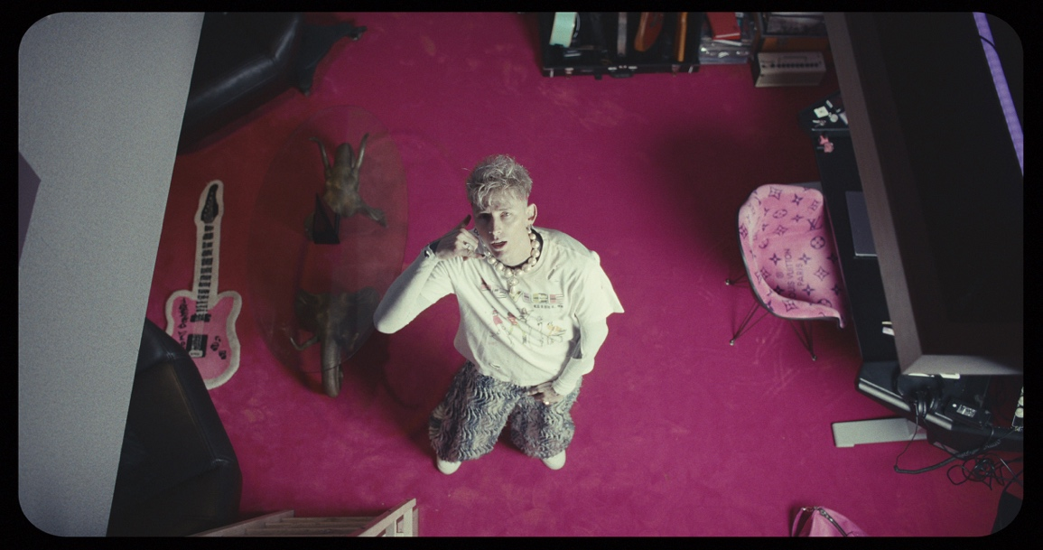
Renowned music sensation MGK transcends the boundaries of musical introspection with his latest release, "Don't Let Me Go." Unveiling a profound chapter in his storied career, the enigmatic artist delves into the depths of his soul, laying bare the scars of his tumultuous past and the shadows of a jaded childhood.
Directed by the visionary Sam Cahill, "Don't Let Me Go" is a visceral journey through MGK's poignant narrative. With unflinching honesty, the rockstar peels back the layers of his life, addressing the complexities of his rocky relationship with his family, the struggles of self-medication, and the relentless battles with depression that have shaped his artistic journey.
Seated before a piano, MGK vulnerably shares his truth, offering a raw and unfiltered glimpse into his world. In a moment of poignant revelation, he confesses, "I just called mom. Said I forgive her for not being there when I needed her."
"dont let me go" marks a new tale in the storybook career of mgk, as he retattooed his entire body. With his upper body tattooed in all black, the multi-hyphenate wrote on Instagram that the new picture of him is "for spiritual purposes only." mgk's transformation has caused an uproar amongst fans, as he also archived his Instagram and teased new music. Last week, mgk was a part of the historical NBA All-Star Weekend in Indianapolis, where he performed at the American Express Road Show.
For more information visit www.machinegunkelly.com

For more information and press enquiries please contact
Jenny Entwistle
Jenny@chuffmedia.com

