LOLA YOUNG ANNOUNCES NEW ALBUM
I’M ONLY FUCKING MYSELF
DUE SEPTEMBER 19TH
VIA ISLAND RECORDS
HEADLINE NORTH AMERICAN TOUR KICKS OFF THIS NOVEMBER
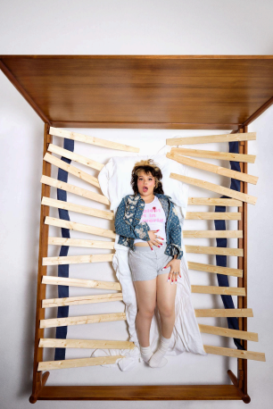
courtesy of Lola Young

What the press is saying about Lola Young:
“Young’s acrobatically tortured, increasingly raspy voice defines her”
The New York Times
“alt-pop heroine primed to make it even bigger this year”
Rolling Stone
“a rock sound and bolder lyrics that deal with the chaos of life”
Billboard
“unreal vocals and give-no-fucks attitude”
HommeGirls Magazine
I’m Only Fucking Myself
PRE-ORDER / SAVE: https://LolaYoung.lnk.to/IMFMPreOrder
(June 18, 2025) - Ivor Novello’s Rising Star Award winner and Brit-nominated South London singer / songwriter Lola Young announces her new album I’m Only Fucking Myself due September 19th via Island Records. The forthcoming album will also include the previously shared, head-bopping and dub grooved “One Thing,” which arrived with a Dave Meyers directed video, has accumulated millions of streams since its release and has been praised by Rolling Stone, PAPER, Billboard and more.
Following her major festival run this summer with performances at Glastonbury, Rosklide, Lollapalooza Paris, All Things Go Festival and more still on the horizon, Lola will embark on her headline North American tour this November and December. During the tour, the powerhouse vocalist will bring her show to Toronto, New York City, Washington D.C., Atlanta, Austin, Chicago, Vancouver and Seattle, before wrapping up in Los Angeles. Since the tour’s announcement, Lola has added additional shows in Toronto, New York City and Los Angeles due to demand. Tickets available HERE.
2025 has been nonstop for Lola. Earlier this month, Lola was direct support to Billie Eilish for her Paris shows at Accor Arena and performed at both Summertime Ball and Meltdown Festival in London. In May, Lola performed at BBC Radio 1’s Big Weekend following her debut performance at the iconic Coachella Valley Music and Arts Festival in April, where she premiered “One Thing.” Lola was also nominated for an American Music Award for Social Song of the Year for “Messy” and received 3 nominations at this year’s Ivor Novello awards, winning the Rising Star Award, which followed her “Best Pop Act” nomination at this year’s BRIT Awards. Lola was also named as a Future 25 artist with Rolling Stone, performed her track “Conceited” on Jimmy Kimmel Live!, spoke with NPR about her breakout and sat with The Los Angeles Times to discuss her rise and debut Coachella performance.
Boasting over 1 billion all-time streams globally across her catalog of releases, Lola Young continues to achieve tremendous success. Her platinum-certified #1 single “Messy,” which The New York Times described as “one of the most legitimately viral and popular songs of 2025” from her acclaimed 2024 album, This Wasn’t Meant For You Anyway, recently hit #1
on the Billboard Pop Airplay chart, #1 at Hot Adult Contemporary, #1 on the Alternative Rock Billboard chart as well as reaching the upper regions of the Billboard Hot 100. Lola Young is the first female artist to have a debut single go #1 at both Pop and Alternative since Lorde’s
“Royals.” “Messy” also held the top spot in the UK for four consecutive weeks, making Lola one of only two British female artists to reach #1 in the UK Singles Chart within the last year. Lola has collaborated with Tyler, The Creator (“Like Him”), and Lil Yachty (“Charlie”) and continues to make a global impact with her music and compelling personality.
Pre-order / save I’m Only Fucking Myself above, see full upcoming live dates below and stay tuned for more from Lola Young coming soon.
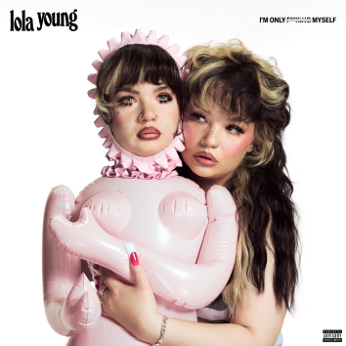I’m Only Fucking Myself album artwork
Lola Young
I’m Only Fucking Myself
September 19th, 2025
Island Records
Upcoming Live Dates
6/27 - Glastonbury @ Somerset, UK
7/3 - Open’er Festival @ Poland
7/4 - Rock Werchter @ Werchter, Belgium
7/5 - Roskilde Festival @ Roskilde, Denmark
7/17 - Gurtenfestival @ Bern, Switzerland
7/18 - Lollapalooza Paris @ Paris, France
8/7 - Øya Festival @ Oslo, Norway
8/9 - Way Out West Festival @ Gothenburg, Sweden
8/10 - Flow Festival @ Helsinki, Finland
8/14 - Paredes De Coura @ Paredes de Coura, Portugal
8/16 - MS Dockville @ Hamburg, Germany
8/17 - Lowlands Festival @ Biddinghuizen, The Netherlands
9/27 - All Things Go Festival @ Forest Hills, New York
9/28 - All Things Go Festival @ Columbia, MD
NORTH AMERICAN HEADLINE TOUR
11/01 - Toronto, ON @ HISTORY
11/02 - Toronto, ON @ HISTORY
11/04 - Boston, MA @ Roadrunner
11/05 - New York, NY @ Terminal 5
11/06 - New York, NY @ Terminal 5
11/08 - Philadelphia, PA @ The Met Philadelphia
11/09 - Washington, DC @ The Anthem
11/11 - Nashville, TN @ The Pinnacle
11/12 - Atlanta, GA @ Tabernacle
11/19 - Austin, TX @ Stubb's Waller Creek Amphitheater
11/21 - Dallas, TX @ The Bomb Factory
11/24 - Chicago, IL @ The Salt Shed
11/25 - St. Paul, MN @ Palace Theatre
11/28 - Denver, CO @ The Fillmore Auditorium
11/29 - Salt Lake City, UT @ The Union Event Center
12/01 - Vancouver, BC @ Doug Mitchell Thunderbird Sports Centre 12/02 - Seattle, WA @ WAMU Theater at Lumen Field
12/04 - San Francisco, CA @ Bill Graham Civic Auditorium
12/06 - Los Angeles, CA @ Hollywood Palladium
12/07 - Los Angeles, CA @ Hollywood Palladium
(Download hi-res assets HERE)
Connect with Lola Young:
Instagram | X (Twitter) | YouTube | TikTok | Website
For all Lola Young inquiries please contact warren@chuffmedia.com

