LOLA YOUNG

GRAMMY & BRIT AWARD-WINNING
ANNOUNCES UK HEADLINE TOUR FOR JUNE 2026

TICKETS ON GENERAL SALE NOW

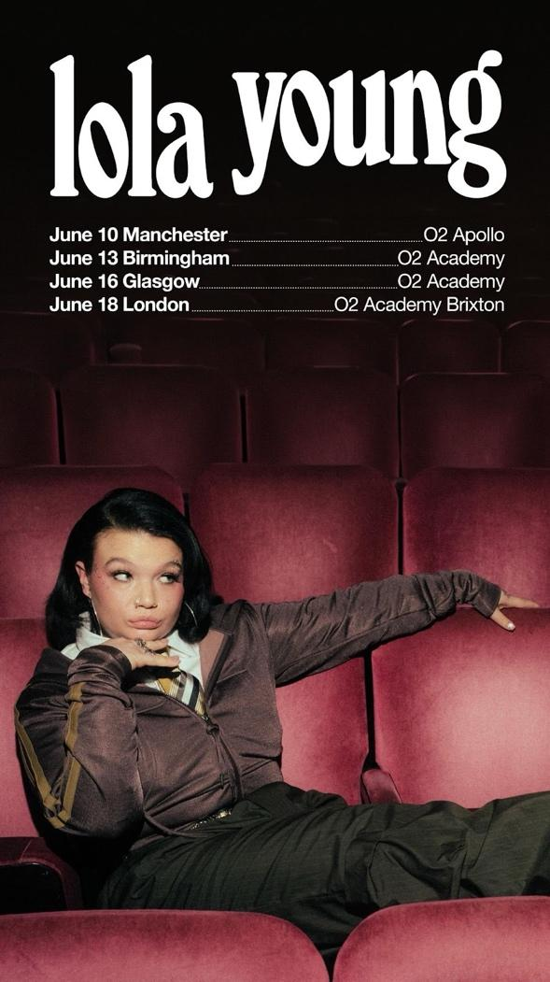

The London Standard 5* - "As Young’s noticeably stronger voice carried through the crowd, it became immediately clear that the audience was witnessing a landmark and unusually intimate moment in the young singer’s career."

The Times 4* - “From there, she came across as being in control of the situation: here was someone who can open up and bleed in song, but align that with a professionalism that brings its own form of protection."

Billboard UK - “This historic 2,200-seater venue requires a certain level of clout and personality, and Young has both in spades."

CLASH - "Young is back, looking completely at home and sounding stronger and sassier than ever."

GRAMMY® & BRIT award-winning British artist Lola Young announces her highly anticipated UK Headline Tour, taking place this June, following a landmark return to the stage with her sold-out performance at the iconic London Palladium earlier this week.

The tour begins at Manchester’s O2 Apollo on Wednesday 10th June, before heading to Birmingham and Glasgow and culminating in a hometown finale at O2 Academy Brixton on Thursday 18th June - full dates below. Fans can sign up to Lola’s mailing list for exclusive access to the artist pre-sale from today, with pre-sale opening on Tuesday 10th March at 10am GMT. Tickets go on general sale on Friday 13th March at 10am GMT.

“Coming back to performing live is everything to me. I felt so alive and connected to everyone at the show on Wednesday night.” says Lola. “I’m ready, prepared and grateful to anyone that wants to come to my show for a good cry, laugh or to shake your ass with me.”

Renowned for her raw lyricism, soulful delivery and fearless storytelling, Lola’s live performances have become synonymous with emotional intensity and magnetic stage presence. The tour announcement follows Lola’s stunning, stripped-back offering of ‘Messy’ at this year’s GRAMMY® Awards and her sold-out performance at The London Palladium earlier this week. This landmark moment saw the South London artist perform on her own terms in one of the capital’s most historic venues. The much-anticipated show saw Lola perform songs from her latest album, I’m Only F**king Myself, alongside fan favourites, in a setting that reflected the intimacy and vulnerability at the core of her work.

Lola’s UK headline tour announcement follows a remarkable run of milestones for the award-winning artist. At this year’s BRIT Awards, she won Breakthrough Artist and was one of the most nominated artists of the night, cementing her status as a vital voice in British music today. Across the Atlantic, Lola recently achieved her first GRAMMY® award, winning Best Pop Solo Performance for her global hit ‘Messy’. Later this month, Lola will also perform at Elton John’s AIDS Foundation Academy Awards Viewing Party, personally handpicked by Elton himself.

Lola Young - UK Headline Tour Dates 2026

Wednesday 10th June - O2 Apollo - Manchester
Saturday 13th June - O2 Academy - Birmingham
Tuesday 16th June - O2 Academy - Glasgow
Thursday 18th June - O2 Academy Brixton - London

About Lola Young

Lola Young is a South London–born artist whose raw, emotionally unfiltered songwriting and rock-tinged pop have made her one of the most compelling new voices in modern music. In 2025, she crossed fully into the global mainstream with her breakout single “Messy,” a 2× Platinum cultural moment that reached #14 on the Billboard US Hot 100 and #1 on Billboard’s US Pop Airplay chart in addition to spending 4 weeks at #1 on the UK Official Singles Chart. The track has also surpassed 1 billion streams on Spotify where she boasts tens of millions of listeners.

Lola's breakout year earned her a GRAMMY award for Best Pop Solo Performance ("Messy”) and nomination for Best New Artist, as well as being selected to perform live at the Grammy Awards Ceremony. She also received a BRIT Award for ‘Breakthrough Artist’ and was one of the most nominated artists at this year's ceremony. Already an Ivor Novello ‘Rising Star’ and following two MTV VMA nods for Best New Artist and Best Alternative Video, the momentum has cemented Young’s evolution from breakthrough artist to chart-topping force.

Lola Young’s latest studio album, I’m Only F**king Myself, further solidifies her reputation as a fearless storyteller. The album is a gut-punch of a record -- unflinchingly personal, full of grit, and loaded with anthems about self-sabotage, empowerment, and resilience. Through its uncompromising honesty, Lola continues to redefine what pop can sound and feel like.

FOLLOW LOLA YOUNG
TIKTOK | INSTAGRAM | X (TWITTER) | YOUTUBE

For all Lola Young inquiries please contact

Warren Higgins
warren@chuffmedia.com

