Unique, Bold & Scottish

THE LAFONTAINES

ANNOUNCE 5 INTIMATE SHOWS
IN CELEBRATION OF FORTHCOMING ALBUM
BUSINESS AS USUAL OUT 14TH JUNE VIA SO RECORDINGS
PRE-ORDER HERE

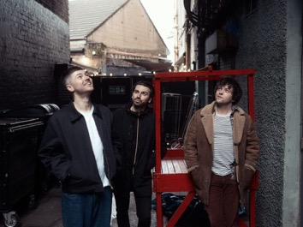
Credit: Euan Robertson
Press assets here

The LaFontaines today announce 5 intimate live shows and album signings to support the release of their upcoming album, Business As Usual out 14th June via So Recordings. They will kick off in their hometown of Glasgow at HMV on 15th June, and then make their way around Dundee, Aberdeen and Edinburgh, before wrapping things up at Kingston’s Banquet Record on 19th June. This will give fans a very special opportunity to see the band up close and personal, and performing the album tracks for the first time, at three tiny venues in Scotland. See full dates and details below. Business As Usual spans 10 tracks, including previously released singles, Where They Know My Name and the album’s title track, Business As Usual. Pre-order the highly-anticipated album here.

15th June - HMV Glasgow (Instore)
16th June - Church, Dundee (Outstore)
17th June - Tunnels, Aberdeen (Outstore)
18th June - Sneaky Pete’s, Edinburgh (Outstore)
19th June – Banquet Records (Instore)

Fifteen years since their inception in Motherwell Scotland, Kerr Okan (vocals), Jamie Keenan (drums, vocals) and Darren McCaughey (guitars, production) have long held a unique space within the UK music scene with The LaFontaines sound as instantly recognisable as singer Kerr’s vocals.

The bands personality, charm and charisma coupled with their unrivalled unique offering has earned them a dedicated, loyal fanbase who identify with the band through more than just the music. Connecting with their live audiences on a level that most acts never achieve, their live shows are their superpower.

Across their career, The LaFontaines have performed across the globe with festival highlights including TRNSMT in Scotland, VERY TV Festival in Bangkok, the Radio 1 Dance Tent at Reading & Leeds Festival in England and the NH7 Weekender in India. They have toured everywhere from New York to Paris with the likes of Linkin Park’s Mike Shinoda, Anderson .Paak, Don Broco, Deaf Havana and Example to name a few.

Their third studio album Junior was released via SO Recordings in June 2019 to critical acclaim. The album charted at number 33 in the UK Albums Chart, giving the band their first top 40 record.

The LaFontaines are Kerr Okan (vocals), Jamie Keenan (drums, vocals) and Darren McCaughey (guitars, production).

Follow The LaFontaines:
Instagram TikTok Facebook X Spotify YouTube Website

For all media enquiries please contact warren@chuffmedia.com



