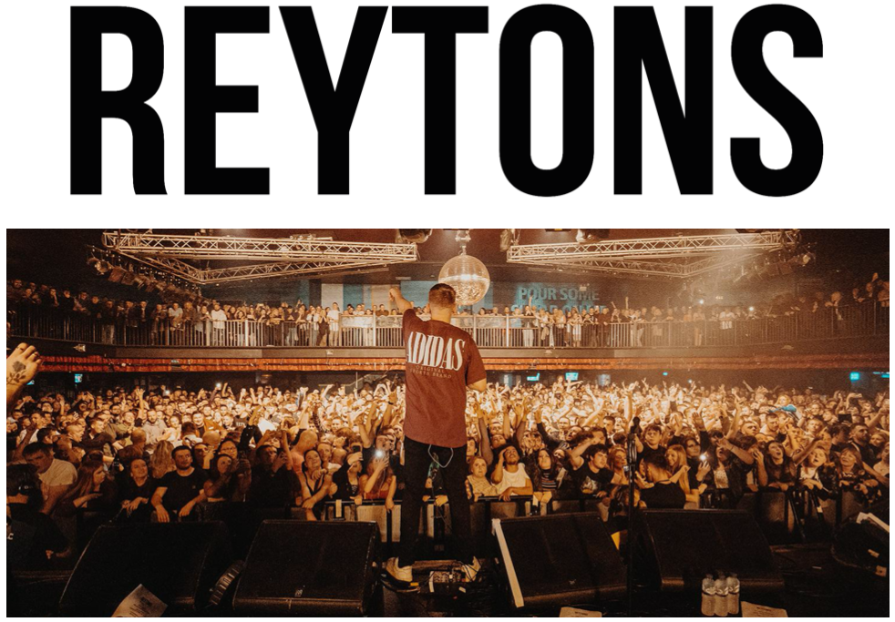

The Reytons have quickly risen from hometown heroes in South Yorkshire to one of the hottest new indie-rock bands in the UK. A word of mouth sensation, they continue to hit the country with sold out show after sold out show, and with an almost football-like tribalism amongst their fanbase the live shows are quickly becoming legend.

“Picture the scene: fans arm in arm singing back to a band they adore, faces gleaming because of how intensely perfect the atmosphere is. Biblical.” Exposed Magazine

The Reytons built on their Top 40 charting EP in February 2021 by smashing an 11th place finish with their debut album ‘Kids Off The Estate’ in November 2021, up against the likes of Abba, Ed Sheeran, Little Mix and Taylor Swift.

Frequent support has been received from the likes of BBC Radio 1 who have championed The Reytons with spot plays on Future Artists & The Indie Show (Jack Saunders), Future Sounds (Annie Mac), plus Radio X (John Kennedy) and more.

Recently dubbed as ‘a colossal live force’ by Clash, The Reytons are already infamous for their raucous live shows. After selling out every single show on their 2021 album tour, The Reytons went on to sell out Rotherham’s prestigious 4,500 capacity Magna in only 10 hours, before taking their trademarked live carnage the length of the UK, playing to thousands in Spring 2022.

After a summer of huge support slots and festival shows, including two massive slots with Gerry Cinnamon, The Reytons hit the academies, taking on huge rooms in each major UK city.

THE UNINVITED TOUR 2022

5-Nov-22 Stoke Keele SU
11-Nov-22 Nottingham Rock City
12-Nov-22 Norwich Waterfront
18-Nov-22 Coventry Kasbah
19-Nov-22 Cardiff Tramshed
24-Nov-22 Glasgow Barrowlands
25-Nov-22 Middlesbrough Empire
26-Nov-22 Leeds O2 Academy
1-Dec-22 Liverpool O2 Academy
2-Dec-22 Manchester O2 Ritz
3-Dec-22 Newcastle NX
9-Dec-22 Brighton Chalk
10-Dec-22 London Electric Ballroom

THE REYTONS ON SOCIALS
INSTAGRAM | TWITTER | FACEBOOK | OFFICIAL WEBSITE

For more information & media enquiries, please contact Warren
warren@chuffmedia.com

