JORDAN DAVIS TO RETURN TO UK/EUROPE FOR BIGGEST INTERNATIONAL HEADLINE TOUR TO DATE

Playing 7 Headline Shows in February/March 2026 including London’s OVO Arena Wembley
Tickets On Sale Friday, 15th August Alongside Brand New Album ‘Learn The Hard Way’

(Download hi-res here)

LONDON, UK. – (8th August 2025) – Multi-platinum award-winning singer/songwriter Jordan Davis has announced his return to the UK and Europe in February 2026 for his biggest international headline tour to date, the Ain’t Enough Road Tour, with special guests Avery Anna and Solon Holt. This run includes shows in Belfast, Glasgow, Manchester, Birmingham, Zurich and a major London date at OVO Arena, with two additional dates to be revealed soon. Full tour dates can be found below.

This news comes ahead of Davis’ highly anticipated new 17-track album Learn The Hard Way, set for release on Friday, 15th August, featuring the record-breaking 8-week #1 at UK Country Radio and RIAA Gold-certified ‘I Ain’t Sayin’’ and current single ‘Bar None’.
Tickets for the Ain’t Enough Road Tour will be on sale at 10am local time on Friday, 15th August, with pre-sale beginning on Wednesday, 13th August, available by pre-ordering Learn The Hard Way here.
UK/EU 2026 Tour Dates:
20th February - Belfast, Northern Ireland - SSE Arena
22nd February - Glasgow, Scotland - OVO Hydro
25th February - Manchester, England - O2 Apollo Manchester
26th February- Manchester, England - O2 Apollo Manchester
28th February - London, England - OVO Wembley Arena
1st March - Birmingham, England - O2 Academy

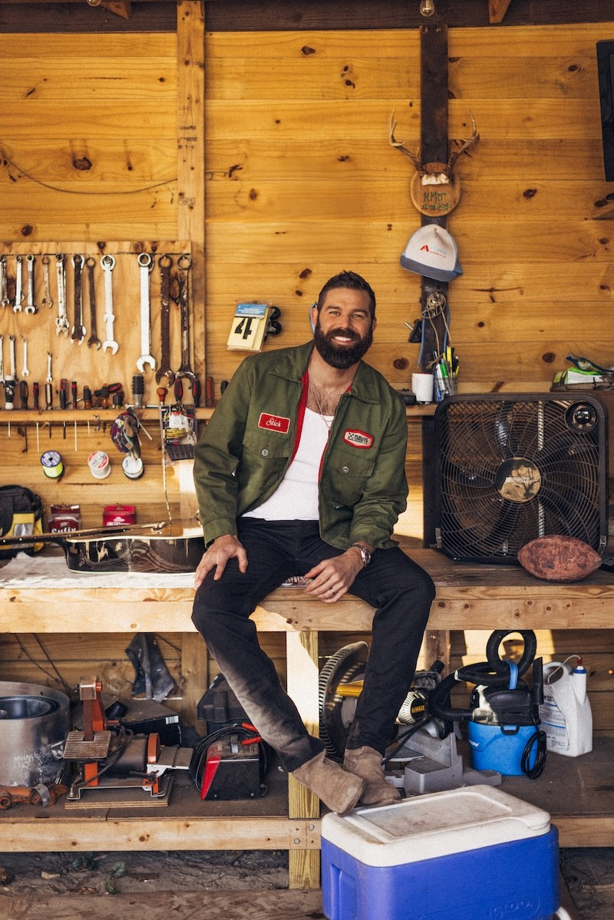
(Credit: Patrick Tracy)

To celebrate the tour announcement and album release, Davis, lauded as "one of the leading talents in a new wave of American country music” (BBC News) will also be playing three intimate sold-out shows in Kingston with Banquet Records on Tuesday, 19th August.

ABOUT JORDAN DAVIS:
Award-winning, multi-platinum singer/songwriter Jordan Davis’ highly-anticipated second full-length album, Bluebird Days, produced four consecutive No. 1’s and two “song of the year” award-winning titles including the 5X Platinum-selling hit 'Buy Dirt' (CMA Awards 2022, NSAI Awards 2023) and 3X Platinum-selling 'Next Thing You Know' (ACM Awards 2024). All penned by Davis, the Louisiana-born and raised star also released the chart-topping hit singles 'What My World Spins Around' and 'Tucson Too Late', in addition to 'Next Thing You Know' and 'Buy Dirt', earning numerous award nominations, including CMA, ACM, CMT, American Music Award, Billboard Music Award and iHeart Award nods as well as his second Platinum-Certified album, Bluebird Days. Davis previously notched four consecutive No. 1 hits-totaling eight No. 1s on Country radio - off of his Platinum-Certified debut album Home State including the 4x Platinum 'Singles You Up', and 2x Platinum-selling songs 'Take It From Me' and 'Slow Dance In A Parking Lot' along with his most recent No.1 single 'I Ain’t Sayin’' off his upcoming album Learn The Hard Way. In 2019, Davis was awarded Best New Country Artist at the iHeartRadio Music Awards, in addition to being a 2X nominee for ACM New Male Artist of the Year, and was named Billboard's Top New Country Artist of 2018. He’s appeared on Good Morning America, The Today Show, Late Night with Seth Meyers, The Tonight Show Starring Jimmy Fallon, Jimmy Kimmel Live, The Kelly Clarkson Show, Watch What Happens Live With Andy Cohen, CBS Mornings, College GameDay, and more. He has earned praise from Billboard, saying Davis is a “modern-day storyteller” with MusicRow noting, “this man never disappoints”. Starting 2025 off internationally, Davis served as direct support for Luke Combs’ stadium tour in New Zealand and Australia. Additionally, Davis was direct support for Luke on his 2024 Growin’ Up and Getting Old Tour and followed with his string of U.S. and international shows headlining his DAMN GOOD TIME TOUR in the fall of 2024. Davis announced his Ain’t Enough Road Tour for fall of 2025- the nationwide tour kicks off Thursday, September 11th in Greater Palm Springs, CA at Acrisure Arena, with additional stops in Los Angeles, New York, Phoenix, St. Louis, Rosemont, Savannah and more before wrapping up on Saturday, October 25th in Estero, FL at Hertz Arena. Davis’ highly anticipated upcoming album Learn The Hard Way is set to be released August 15th and includes certified Gold and 8th career No. 1 'I Ain’t Sayin’', alongside recent releases 'Turn This Truck Around', 'Bar None', 'In Case You Missed It', 'Know You Like That', 'Jesus Wouldn’t Do' and title track 'Learn The Hard Way'.

Website | Instagram | Facebook | X | YouTube | TikTok
For more information and press enquiries please contact

Jenny Entwistle
Jenny@chuffmedia.com

