SOUL II SOUL
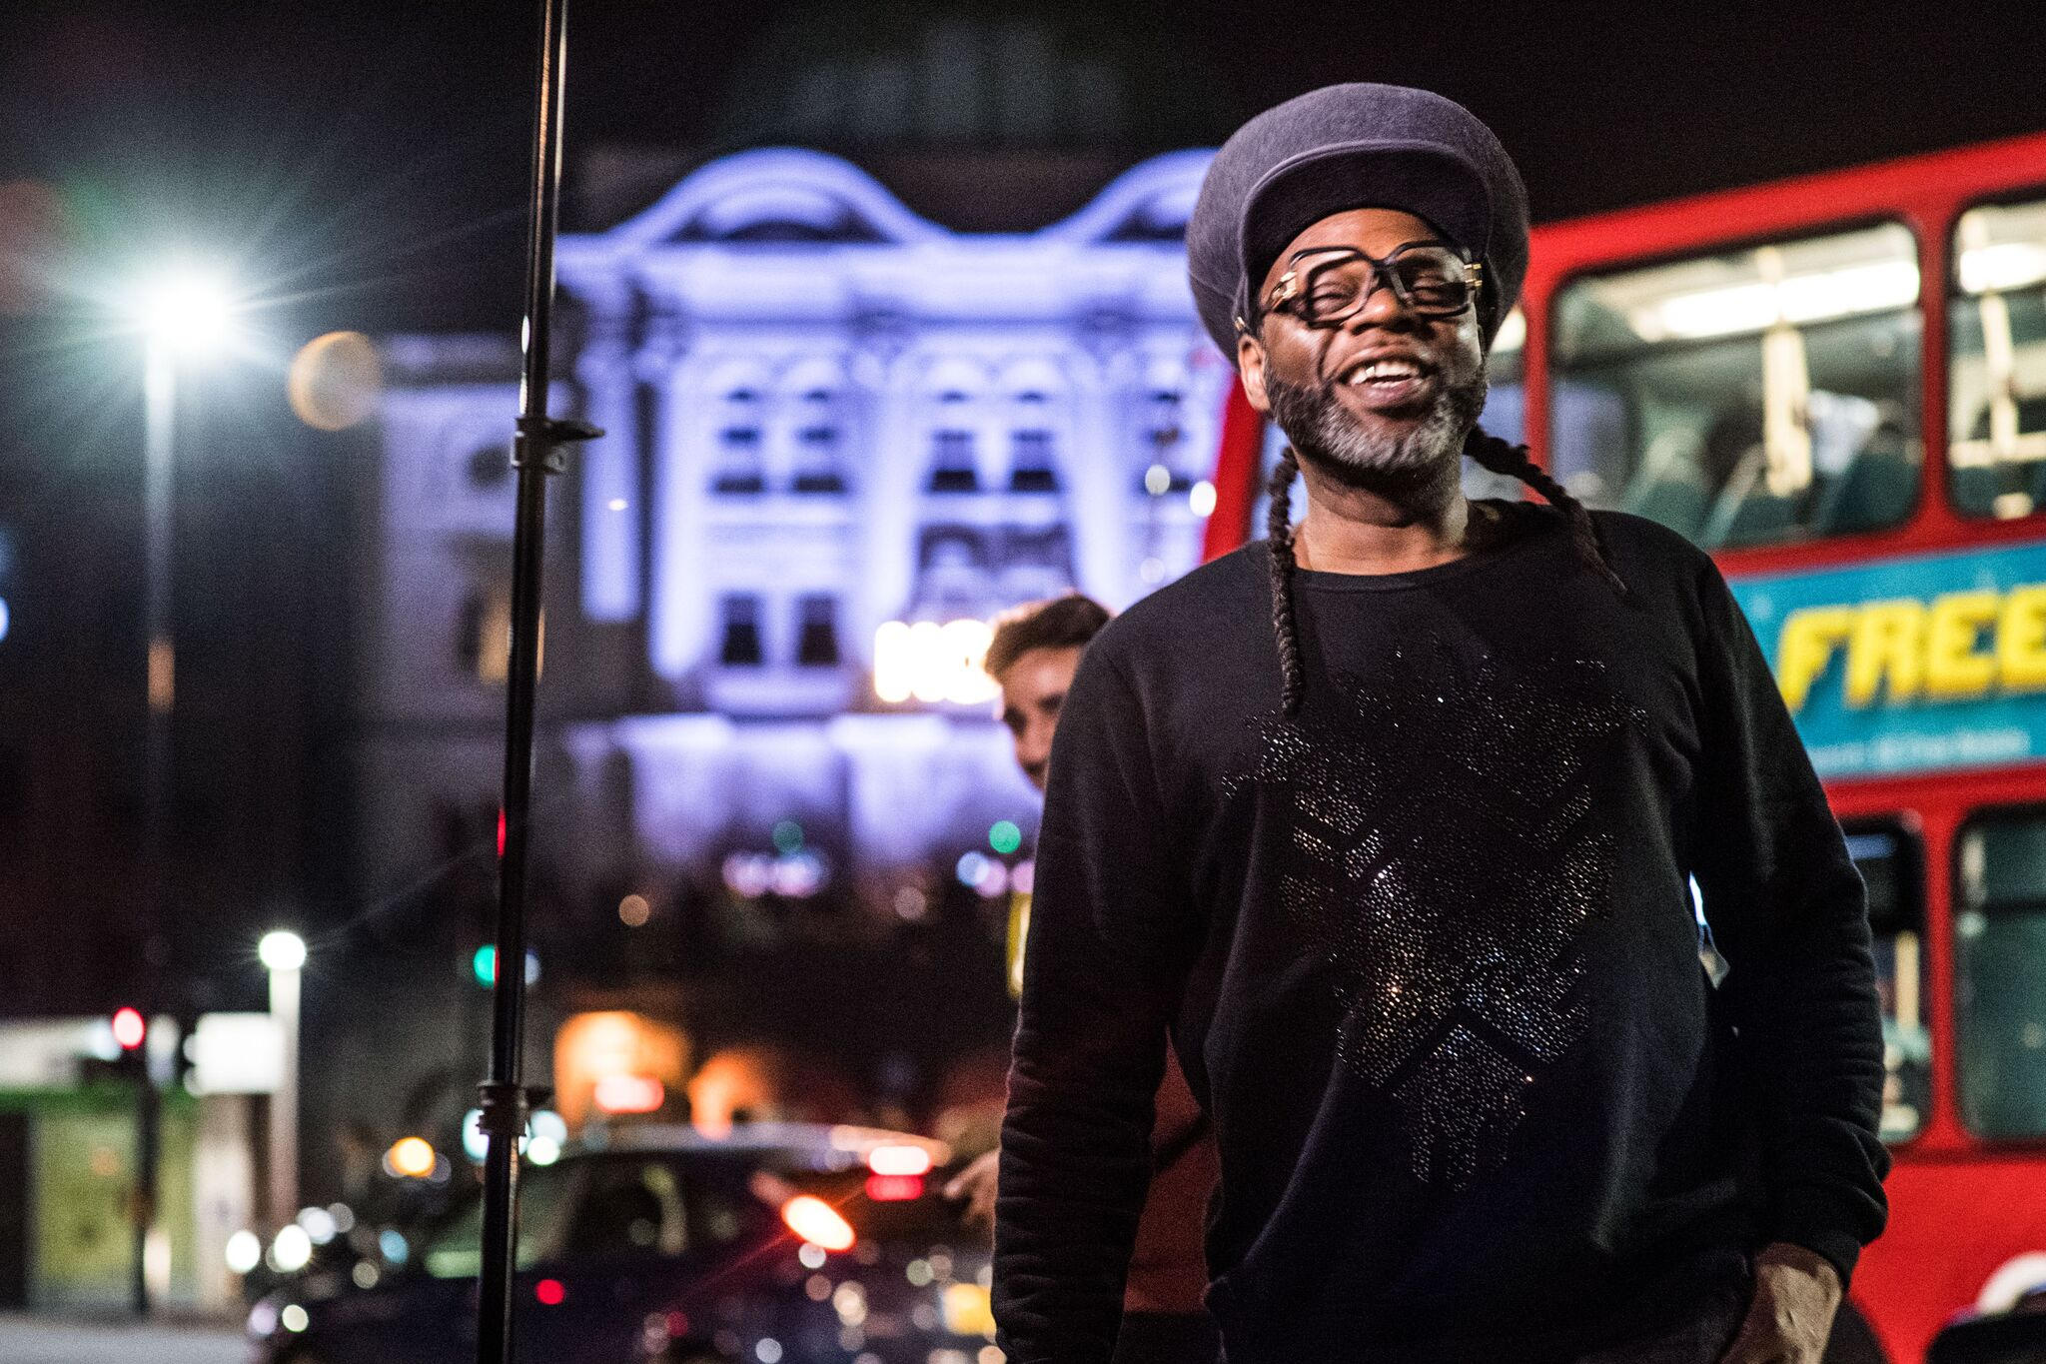

‘FEEL FREE’ UK TOUR
ANNOUNCED FOR NOVEMBER 2022

Including London Roundhouse on 16th December 2022

PRE-SALES - Fri 3rd September, 10am
GENERAL SALE - Mon 6th September, 10am
https://www.seetickets.com/tour/soul-ii-soul

Soul II Soul have announced their Feel Free tour for November 2022 starting at De Montfort Hall in Leicester and ending with a festive London headline show in December.

During the course of their stellar career the band have sold over 10 million albums worldwide and main man Jazzie B was awarded an OBE for services to music in 2008, as well as winning an Ivor Novello Award for Inspiration, as “the man who gave British black music a soul of its own”.

With huge hits including ‘Keep On Movin’ (which sold over a million copies in the US alone) and the UK number one single ‘Back To Life (However Do You Want Me)’, Soul II Soul progressed from being one of the leaders of the 1980s warehouse scene to pioneering British black music around the world, and securing commercial success for themselves and the huge amount of artists they have influenced.

10.11.22 Leicester, De Montfort Hall
11.11.22 Lincoln, Engine Shed
12.11.22 Sheffield, CIty Hall
13.11.22 Dartford, Orchard Theatre
18.11.22 Swindon, Meca
19.11.22 Stockport, Plaza Theatre
20.11.22 Stockton, Orchard Theatre
25.11.22 Bath, Bath Forum
26.11.22 Coventry, Empire
16.12.22 Roundhouse, London

For all media enquiries contact warren@chuffmedia.com on 07762 130510

