SNOOP DOGG
UK & IRELAND RESCHEDULED HEADLINE TOUR CONFIRMED FOR MARCH 2023

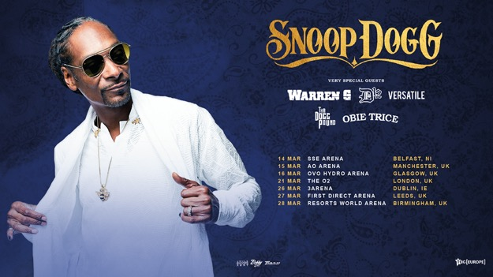

WARREN G, THA DOGG POUND,
OBIE TRICE, D12 & VERSATILE
TO PLAY ALL SHOWS

Celebrating over 25 years at the pinnacle of hip hop, it’s been a career that has seen the Doggfather cement his undisputed influence on music with chart-topping, multi-platinum records, while also solidifying his importance to wider culture as an actor, businessman and more across the board.

The tour sees Snoop Dogg enlist a selection of his key collaborators from the breadth of his iconic music career including further West Coast hip hop royalty; Warren G, Tha Dogg Pound, Obie Trice and D12. They will also be joined by the multi-million streamed Irish rap duo Versatile.

Snoop Dogg collaborator and platinum-selling rapper Xzibit will join the tour for the dates in Scotland and England.

Ticket presale 9am, 22nd December 2022 and general onsale 12pm via https://www.tegeurope.com/events/snoop-dogg

SNOOP DOGG UK & IRELAND TOUR MARCH 2023
14th – Belfast, SSE Arena
15th – Manchester, AO Arena
16th – Glasgow, SEC Hydro
21st – London, O2 Arena
26th – Dublin, 3Arena
27th – Leeds, First Direct Arena
28th – Birmingham, Resorts World Arena

For more information contact Warren@chuffmedia.com on 07762 130510

FURTHER INFORMATION ON SNOOP DOGG
West Coast rap legend Snoop Dogg has come a long way since being discovered by Dr. Dre in the early 1990. As impressive as he was when guesting on Dre’s The Chronic in 1992, few could have guessed he’d go on to global fame, tens of millions of record sales, and a career in movies and TV. And that’s only part of the story, from battles with the law to reinvention as a reggae artist.

He was born Cordozar Calvin Broadus Jr. in Long Beach, California, on October 20, 1971. His "Snoop Dogg" nickname came from his mother because she thought he looked like Snoopy from the Peanuts cartoon. He played piano and sang at his local Baptist church, before starting rap in sixth grade. After graduating high school, Snoop was arrested several times for drug possession and spent time in prison. He was also associated with the Rollin’ 20 Crips Gang. He started making music as a way out of his troubles and recorded early demos with his cousin Nate Dogg and friend Warren G as 213. A track on one of these came to the attention of Dr. Dre who invited Snoop — then rapping under the name Snoop Doggy Dogg — to audition. From there they collaborated on a song called "Deep Cover" for the soundtrack of the film for the same name; and Snoop became the key rapper on Dre’s hugely successful first solo album, The Chronic, in 1992.

Snoop's first album, the Dre-produced Doggystyle (1993), climbed its way to the No. 1 spot on Billboard's hip-hop and Top 200 charts, based in part on the success of the singles "Who Am I (What's My Name)?" and "Gin and Juice."

Next came a short film called Murder Was the Case, the soundtrack of which went double platinum. Snoop's next album, Tha Doggfather (1996), also reached the top of the charts, despite the absence of Dre, who had left Death Row over a contract dispute. Snoop then left Death Row himself, falling out with label mogul Suge Knight and moving to Master P’s No Limit Records. He scored the top slot on the hip-hop charts with his next two albums: Da Game Is to Be Sold, Not to Be Told (1998) and No Limit Top Dogg (1999). His last album for No Limit, The Last Meal, came in 2000 and sold over 2 million copies. By now his sound had become less "gangsta rap" and somewhat smoother.

Snoop continued to make music throughout the noughts, enjoying a big hit in 2004 with the chart-topping single "Drop It Like It's Hot," which sparked several fruitful collaborations with Pharrell Williams. He reunited with Warren G and Nate Dogg as 213 to drop the album The Hard Way in 2004. In 2007, Snoop became the first artist to release a track — "It's The DOG" — as a ringtone prior to its release as a single.
He also branched out into acting during the same period and appeared in several films, including Starsky & Hutch, The Wash and Training Day. He also made guest appearances on television shows, including The L Word and Weeds, and starred in his own E! reality show, Snoop Dogg's Father Hood, in 2007. He was part of a sketch show, Doggy Fizzle Televizzle, and participated in the Comedy Central Roast of the future president Donald Trump. He also uses his likeable laconic personality to good effect in a new venture for VH1, Martha & Snoop’s Potluck Dinner Party, where he and Martha Stewart host dinner parties for various celebrities.

Outside of music, Snoop has made investments in the burgeoning cannabis business. In November 2015 he launched Leafs By Snoop, becoming the first A-list celebrity to brand a line of cannabis products. That same year he also launched a new digital-media venture called Merry Jane, which focuses on the latest marijuana news. In May 2017 Snoop dropped his fifteenth studio album Neva Left. He also released a gospel album titled Bible of Love in March 2018.

He is held in high esteem and affection by hip-hop fans worldwide, and is one of the most recognizable faces and voices of the whole genre, even to those who don’t listen to his music. He has the distinction for having the most Grammy nominations of any music artist— 17 to date — without having won one. But as Snoop Dogg shows few signs of retiring, don’t write him off just yet.

