EMBARGOED UNTIL 9AM AUG 26TH

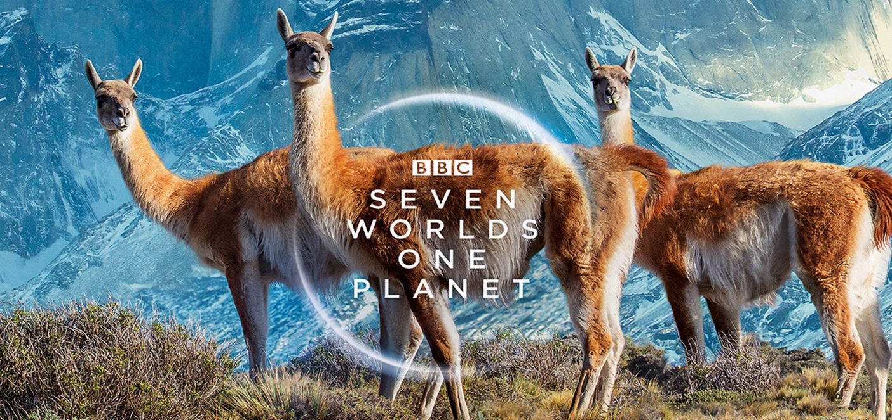

BBC SEVEN WORLDS ONE PLANET
LIVE IN CONCERT

BAFTA winning British Explorer, Naturalist and TV Presenter STEVE BACKSHALL to host special
UK Premiere at The O2 Arena, London

New UK Premiere Performance Date March 31st 2022

Stunning footage from the successful BBC Studios Natural History Unit television series
Music by Academy Oscar-winning composer Hans Zimmer and Jacob Shea
Featuring the original song ‘Out There’ by multi-award winning artist SIA
Performed by the Seven Worlds Symphonic Orchestra & Choir

All Previously Purchased Tickets Remain Valid
All Under 14’s tickets, 10% discount

BBC Studios and concert promoter FKP Scorpio UK have announced March 31st 2022 as the new rescheduled date for the highly anticipated UK concert premiere of Seven Worlds, One Planet.

The new date will be hosted by BAFTA winning British explorer, Naturalist and TV presenter, Steve Backshall accompanied by the very best hand picked musicians that make up the specially created Seven Worlds Symphonic Orchestra & Choir, conducted by Matthew Freeman.

Not only a TV presenter and acclaimed wildlife writer, Backshall is also a rock climber, mountaineer and endurance sports enthusiast who was recently appointed Member of the order of the British Empire (MBE) for service to charity and wildlife conservation.

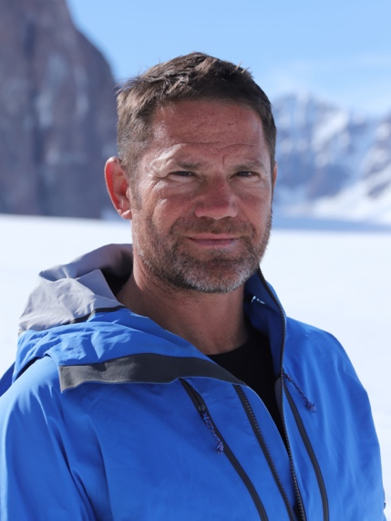
Says Backshall “When I was approached to host this premiere live concert, I was thrilled. As a naturalist I was fascinated by the television series which presented the incredible beauty and diversity of the seven continents that now make up our amazing planetary ecosystem. To bring those stunning visuals, stories and the live music score of Hans Zimmer to the arena stage is something to behold. It is going to be one of the highlights of 2022, a very special event for those who love the environment, our planet and something for all the family to really experience and enjoy!”

When this landmark television series, narrated by Sir David Attenborough, was first broadcast in the UK, it took viewers on an epic journey that not only celebrated the diversity of life on each of the seven continents, but also highlighted the many challenges faced by nature in a modern world dominated by humanity. It went on to become BBC One’s most-watched factual TV show of 2019 and will finally celebrate its UK premiere live concert performance at The O2 arena London in a very special one-off concert, presenting the very best footage and music from the highly acclaimed television series.

The live concert at the London O2 arena will present a selection of the most spectacular scenes from the television series displayed on a giant state of the art 4K Ultra HD LED screen. The series took a staggering 1,500 people over 4 years to make, including 92 film shoots across 41 countries.

Accompanying the footage on screen, the series hugely emotive score was composed by Academy Award winner Hans Zimmer and Jacob Shea for Bleeding Fingers Music, and features the captivating song ‘Out There’, produced specifically for the series by Zimmer and the multi-award winning artist SIA.

“Out of this World! Is this the Beeb’s best wildlife show ever? This will be the BBC’s most visually magnificent wildlife series yet.” ***** - The Daily Mail

“Breath-taking, moving, harrowing – David Attenborough and the BBC play us like pianos – and at this point in the evolution of natural history TV, they are maestros. Prepare to weep.” ***** - The Guardian

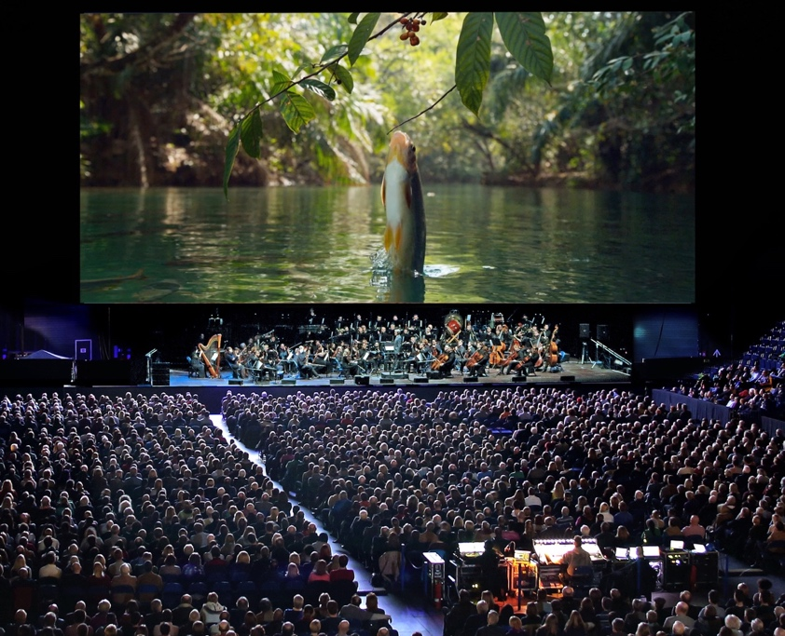

Zimmer said, “Following up Planet Earth II and Blue Planet II was no easy task, but the BBC have outdone themselves yet again with the magnificent Seven Worlds, One Planet. It was a true honour to return to the series to compose the theme with Jacob Shea for Bleeding Fingers Music, and a special pleasure to collaborate with Sia for 'Out There'!”

During the concert, the audience will be taken on a journey of discovery through the ‘seven worlds’ - from the colourful paradises of South America to Asia’s vast wilderness; from the unforgiving deep freeze of the Antarctic to the searing heat of Africa; from North America via Australia to wildlife closer to home in Europe.

The documentaries produced by BBC Studios Natural History Unit have inspired generations and helped shape people’s view of the planet, something which is now more important than ever. Featuring stunning, never-before-seen visuals, these programmes bring the miracles of the natural world to viewers all over the world, inspiring them to reflect on the power of our planet and have a positive, long-term influence on human behaviour.

The live concert format for these breathtaking television programmes has already proved hugely successful over the past number of years, with over half a million UK & European fans having already attended concerts for the outstanding Planet Earth II and Blue Planet II series.

All previously purchased tickets for the December 5th performance will remain valid for this March 31st 2022 performance.

Tickets available from www.seven-worlds-one-planet-live.co.uk and all usual ticket agents

Event: Seven Worlds, One Planet – Live in Concert
Venue: The O2 Arena
Address: Peninsula Square, Greenwich Peninsula, London, SE10 0DX
Date/Time: Thursday, March 31st 2022, 6.30pm doors, 7.45pm show.
Tickets: £65/£55/£45

Website/Box Office: www.theo2.co.uk / 0844 856 0202; www.axs.com; www.eventim.co.uk; www.ticketmaster.co.uk; www.seetickets.com

www.seven-worlds-one-planet-live.co.uk

For more information please contact warren@chuffmedia.com on 07762 130510

