MINISTRY OF SOUND
CLASSICAL
PRESENTS
THREE DECADES OF DANCE
WITH THE 50 PIECE LONDON CONCERT ORCHESTRA
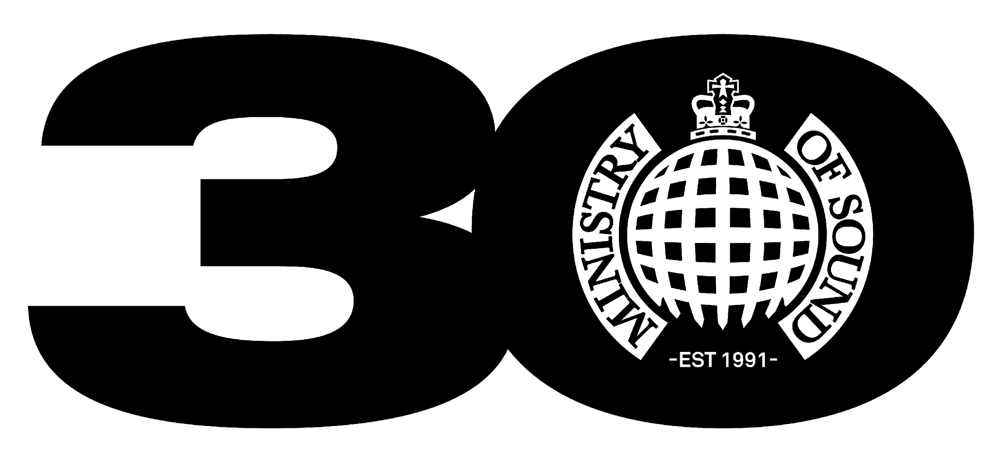

THE O2 ARENA, LONDON
SATURDAY NOV 13th 2021

FURTHER SPECIAL GUESTS ANNOUNCED
JUDGE JULES, BRANDON BLOCK, ALEX P & KELLI-LEIGH

ALSO INCLUDING SPECIAL GUEST DJ PAUL OAKENFOLD

TICKETS ON SALE NOW HERE

Ministry of Sound Classical have announced further special guests for the huge show at London’s The O2 arena on Saturday November 13th 2021 to celebrate the 30th anniversary of the world’s most iconic dance brand.

World-renowned DJs Judge Jules, Brandon Block, Alex P, and esteemed vocalist Kelli-Leigh, will all join the bill alongside the previously announced special guest DJ Paul Oakenfold. Ministry of Sound founder Justin Berkmann will also be DJing to open the show.

The special guests reflect the legendary history of Ministry of Sound, showcasing the longstanding innovative DJs and artists that have been imperative to the brand’s three decades of domination from the club’s opening in 1991 to sold out arena tours and topping charts around the world.

Ministry of Sound Classical is the evolution of their newly created classical arm, which launched in 2018 with the highly acclaimed The Annual Classical live show.

The Annual Classical celebrated the legendary dance music compilation The Annual, reimagining some of the biggest dance tracks from the 90s including the likes of The Chemical Brothers, Fatboy Slim and Dario G with a 50 piece classical orchestra. It sold out two shows at London’s Royal Festival Hall and its debut UK tour in 2019.

Ministry of Sound Classical builds on the success of its previous incarnation and offers an even broader reflection of Ministry of Sound, recreating classical forms of the music that has defined the brand with The London Concert Orchestra.

Ministry of Sound opened its doors at its Elephant & Castle site by co-founders James Palumbo and Justin Berkmann in 1991 and immediately made history as the first house music nightclub in the UK.

Ministry of Sound have always been at the forefront of dance music and in 1993 the label Ministry of Sound Recordings was launched, marking the birth of the first global electronic label. Swiftly after this in 1996, Ministry of Sound once again made history as The Annual II sold over a million copies making it the best-selling dance music compilation of all time.

Ministry of Sound have forever been a commanding force in London since its inception, which has been reflected across the city’s most iconic landmarks. In 1996 the Ministry of Sound logo was projected onto Buckingham Palace, and then again a year later on the Houses of Parliament. In 1998 Ministry of Sound bought the Royal Yacht Britannia and converted it into a rave ship. Despite the sense of anti-establishment the club was saved from closure from property developers by now Prime Minister Boris Johnson in 2014.

Ministry of Sound has reopened to rapturous welcome in 2021 following Covid-19 closure, the brand once again returns to The O2 arena for the largest classical show in its history. It is set to be another monumental moment in Ministry of Sound’s untouchable timeline of success.

Tickets for Ministry of Sound Classical promoted by FKP Scorpio by arrangement with Coalition Agency & Raymond Gubbay LTD at The O2 Arena on Saturday November 13th 2021 are priced in tiers of £55, £45, £37.50 and £30 available to purchase now via AXS, Eventim, SeeTickets and Ticketmaster.

For more information contact Warren@chuffmedia.com on 07762 130510

