MINISTRY OF SOUND
CLASSICAL

THREE DECADES OF DANCE
WITH THE 50 PIECE LONDON CONCERT ORCHESTRA
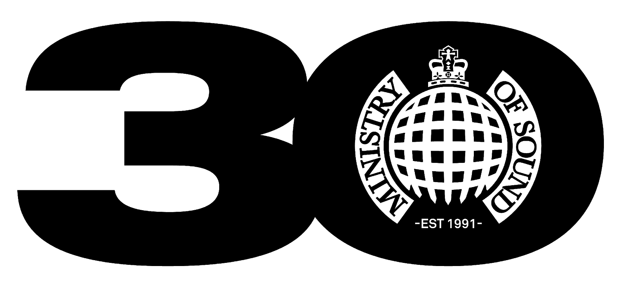

THE O2 ARENA, LONDON
SATURDAY NOV 13th 2021

PAUL OAKENFOLD ANNOUNCED AS SPECIAL GUEST DJ

TICKETS ON SALE 10AM FRIDAY MAY 28TH HERE

Ministry of Sound Classical and promoter FKP Scorpio have announced a huge show at London’s The O2 arena on Saturday November 13th 2021 to celebrate the 30th anniversary of the world’s most iconic dance brand. Tickets for the show, which is part of The O2’s full capacity Welcome Back Show series, go on sale on Friday May 28th at 10am here.

Special guest DJs will join Ministry of Sound at the landmark show for their 30th year including legendary DJ Paul Oakenfold, who played the opening night of the South London club in 1991 and has been a mainstay at Ministry of Sound ever since.

Regarding Ministry of Sound and the forthcoming show Paul Oakenfold says, “I've been a part of Ministry of Sound from the day it opened when I was the resident DJ every Friday. I also mixed one of their early compilations called The Sessions. And I still work there to this day. It's one of the greatest nightclubs in the world. It's one of my favourite places to play and I will always have fond memories of Ministry of Sound. I'm really looking forward to being part of their 30th birthday party at The O2. I've played for Ministry of Sound at The O2 before and it's always a wonderful experience.”

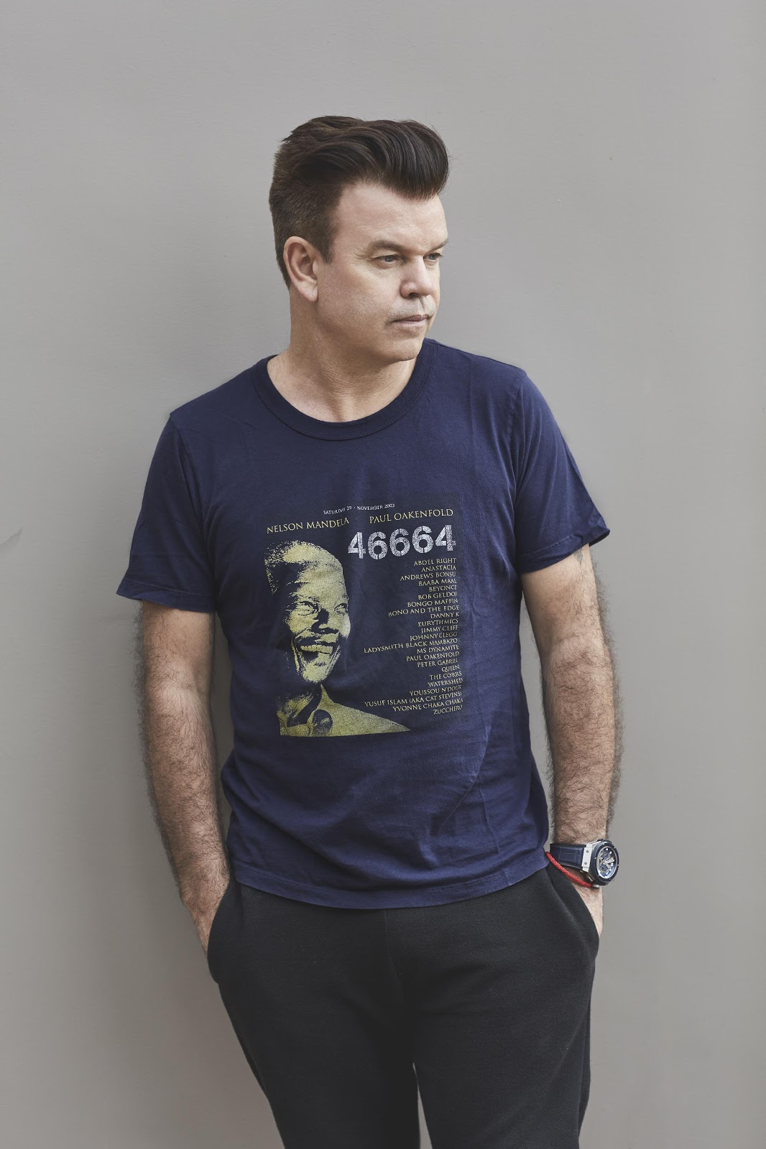

Ministry of Sound Classical is the evolution of their newly created classical arm, which launched in 2018 with the highly acclaimed The Annual Classical live show.

The Annual Classical celebrated the legendary dance music compilation The Annual, reimagining some of the biggest dance tracks from the 90s including the likes of The Chemical Brothers, Fatboy Slim and Dario G with a 50 piece classical orchestra. It sold out two shows at London’s Royal Festival Hall and its debut UK tour in 2019.

Ministry of Sound Classical builds on the success of its previous incarnation and offers an even broader reflection of Ministry of Sound, recreating classical forms of the music that has defined the brand across its three decades with The London Concert Orchestra.

Ministry of Sound opened its doors at its Elephant & Castle site by co-founders James Palumbo and Justin Berkmann in 1991 and immediately made history as the first house music nightclub in the UK.

Ministry of Sound chairman Lohan Presencer joins Palumbo and Berkmann in the brands running and development. Regarding the forthcoming show Presencer says, “Ministry of Sound have always been pioneers in London and dance music throughout our three decades. The phenomenal success of the newly launched Ministry of Sound Classical is continued proof of that. We’re delighted to be bringing the dance back to the capital following the pandemic and to be taking over The O2 arena for this very special occasion.”

Ministry of Sound have always been at the forefront of dance music and in 1993 the label Ministry of Sound Recordings was launched, marking the birth of the first global electronic label. Swiftly after this in 1996, Ministry of Sound once again made history as The Annual II sold over a million copies making it the best-selling dance music compilation of all time.

Ministry of Sound have forever been a commanding force in London since its inception, which has been reflected across the city’s most iconic landmarks. In 1996 the Ministry of Sound logo was projected onto Buckingham Palace, and then again a year later on the Houses of Parliament. In 1998 Ministry of Sound bought the Royal Yacht Britannia and converted it into a rave ship. Despite the sense of anti-establishment the club was saved from closure from property developers by now Prime Minister Boris Johnson in 2014.

As Ministry of Sound reopens to a rapturous welcome in 2021 following Covid-19 closure, the brand once again returns to The O2 arena for the largest classical show in its history. It is set to be another monumental moment in Ministry of Sound’s untouchable timeline of success.

The O2 Welcome Back Shows kick off in August and will feature a diverse line up of headline artists and performers showcasing the very best of British and International acts. The first event to be announced was Mo Gilligan + Friends and ‘The Black British Takeover’ which takes place on 8 December 2021 and more acts are soon to be announced.

Tickets for Ministry of Sound Classical at The O2 Arena on November 13th 2021 are priced in tiers of £55, £45, £37.50 and £30 available to purchase from May 28th at 10am via AXS, Eventim, SeeTickets and Ticketmaster.

For more information contact Warren@chuffmedia.com on 07762 130510
