Unique, Bold & Scottish

THE LAFONTAINES
PRESENT
MUSIC FOR GROWNUPS
SOFT PLAY FOR KIDS

LIVE SHOW AT INFLATA NATION, GLASGOW

IN CELEBRATION OF FORTHCOMING ALBUM
BUSINESS AS USUAL OUT 14TH JUNE VIA SO RECORDINGS
PRE-ORDER HERE

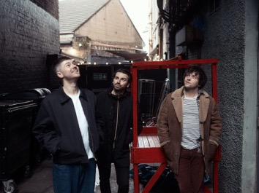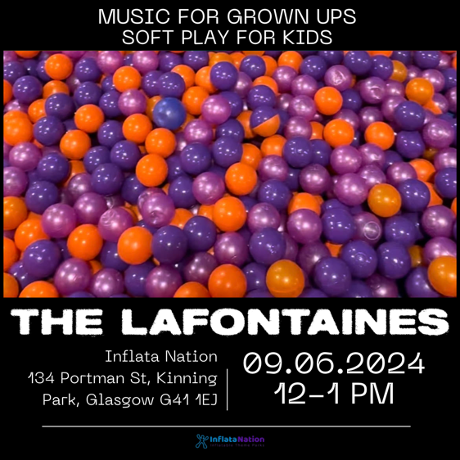
Credit: Euan Robertson
Press assets here

The LaFontaines today announce a family-friendly show at Glasgow’s Inflata Nation on the 9th June to celebrate their upcoming album release, Business As Usual out 14th June via So Recordings.

Over the past fifteen years as the band have grown older, lead singer Kerr Okan, like many of their fans, has become a parent with all the joys that that brings, but sometimes problems with childcare can mean catching your favourite band in an evening can be an issue. The LaFontaines have the solution; forgoing the usual concert venue they are putting on a lunchtime show at a kids soft play centre in Glasgow to keep the whole family happy – the kids can run amok and the parents can too!

Said Frontman Kerr Okan, “I’ll be honest, my knowledge of the soft play arena has grown massively over the last year so to get a headline slot at Inflata Nation feels like the first time we played the Barras - it’s a pretty big deal in my household. Since becoming a Dad myself, I’ve struggled to get to gigs and when we were planning our instores, I thought it would be a touch to do a gig for all those parents, like myself who would love to get to a Fonts gig but can’t because of the kids. At Inflata Nation
you can party during the day, whilst the kids play! What’s not to like about that, am I right? 😉”

Inflata Nation Glasgow is an inflatable theme park packed full of fun things to do, from bouncing and tumbling to climbing and sliding and now you can do all this to the sounds of The LaFontaines playing tracks from their new album along with some fan favourites. It’s a great way to keep the whole family active!

The LaFontaines at Inflata Nation is suitable for kids of all ages and adults and includes an area dedicated for under 4’s and a wider arena suitable for anyone aged over 4. The band will be playing in front of the arena during the 12pm-1pm session.

Booking The LaFontaines

◦ Go to Inflatanation.co.uk
◦ Pick location (Glasgow)
◦ Book a bounce
◦ Select how many people will be bouncing
◦ Go to Sunday 9th June
◦ Select the 12pm session marked La Fontaines X Inflatanation
◦ Proceed to payment and fill in the waiver form

Prices: Under 4 £6.99 / 4+ - adult £10.99

The band will be playing some more conventional shows kicking off in their hometown of Glasgow at HMV on 15th June, and then make their way around Dundee, Aberdeen and Edinburgh, before wrapping things up at Kingston’s Banquet Record on 19th June. This will give fans a very special opportunity to see the band up close and personal, and performing the album tracks for the first time, at intimate venues in Scotland. See full dates and details below. Business As Usual spans 10 tracks, including previously released singles, Where They Know My Name and the album’s title track, Business As Usual. Pre-order the highly-anticipated album here.

15th June - HMV Glasgow (Instore)
16th June - Church, Dundee (Outstore)
17th June - Tunnels, Aberdeen (Outstore)
18th June - Sneaky Pete’s, Edinburgh (Outstore)
19th June – Banquet Records (Instore)

Fifteen years since their inception in Motherwell Scotland, Kerr Okan (vocals), Jamie Keenan (drums, vocals) and Darren McCaughey (guitars, production) have long held a unique space within the UK music scene with The LaFontaines sound as instantly recognisable as singer Kerr’s vocals.

The bands personality, charm and charisma coupled with their unrivalled unique offering has earned them a dedicated, loyal fanbase who identify with the band through more than just the music. Connecting with their live audiences on a level that most acts never achieve, their live shows are their superpower.

Across their career, The LaFontaines have performed across the globe with festival highlights including TRNSMT in Scotland, VERY TV Festival in Bangkok, the Radio 1 Dance Tent at Reading & Leeds Festival in England and the NH7 Weekender in India. They have toured everywhere from New York to Paris with the likes of Linkin Park’s Mike Shinoda, Anderson .Paak, Don Broco, Deaf Havana and Example to name a few.

Their third studio album Junior was released via SO Recordings in June 2019 to critical acclaim. The album charted at number 33 in the UK Albums Chart, giving the band their first top 40 record.

The LaFontaines are Kerr Okan (vocals), Jamie Keenan (drums, vocals) and Darren McCaughey (guitars, production).

Follow The LaFontaines:
Instagram TikTok Facebook X Spotify YouTube Website

For all media enquiries please contact warren@chuffmedia.com

