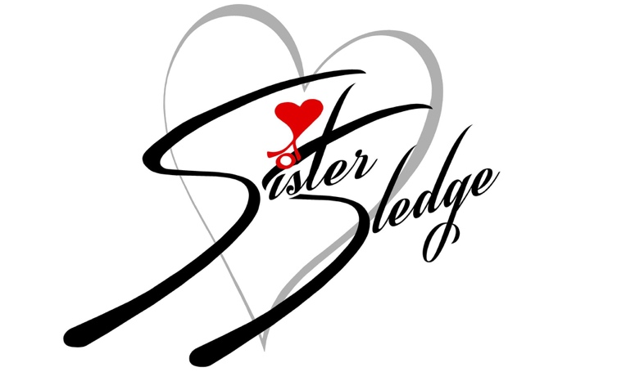

SISTER SLEDGE LIVE IN CONCERT
THE ULTIMATE 70’s DISCO SUMMER PARTY

ROYAL ALBERT HALL
THURSDAY 8TH JUNE 2023

“Glitter and indestructible pop anthems” The Times
Following their incredible and lauded sold-out headline of London’s Roundhouse in December, SISTER SLEDGE have announced their return to the capital for a blistering summer show. The one-night-only event will see the family band headline the iconic Royal Albert Hall for a not to be missed Sledgendary event!

Experience their greatest hits including ‘Lost In Music’, ‘Thinking Of You, ‘We Are Family’ and many more, as the renowned American vocal group transform the Royal Albert Hall into a true 70’s celebration. Since breaking through with ‘He’s The Greatest Dancer’, the Grammy nominated group have amassed a string of Gold and Platinum records and accumulated total sales of over 15million worldwide. Their albums, several of which were produced by the renowned Nile Rodgers, have received global recognition.

Joined by seventies hitmakers The Real Thing performing their No.1 Hit ‘You To Me Are Everything’ alongside ‘Can’t Get By Without You’ and ‘Can You Feel The Force’, audiences can expect an unforgettable evening at the world famous Royal Albert Hall. The line-up is completed by Dimitri from Paris and Twiggy Garcia.

Don’t miss out on this spectacular night as we host SISTER SLEDGE Live In Concert with a full eight-piece band.

Tickets are on sale now via RoyalAlbertHall.com and SeeTickets.com starting from £34.50. There will be hospitality packages available to suit all budgets.

FOLLOW SISTER SLEDGE
Instagram / Facebook
For more information and press enquiries please contact
Jenny@chuffmedia.com

