
EMBARGO: 9AM, TUESDAY 13TH JANUARY
LIVE MUSIC FOR EVERYONE CONTINUES AS READING FOUR-PIECE OPEN BRIXTON STAGE TO GRASSROOTS TALENT

BAND EXTEND £1 BRIXTON SHOW COMMITMENT OFFERING UNSIGNED UK BAND/ARTIST SUPPORT SLOT AT LANDMARK SHOW

BANDS/ARTIST TO ENTER HERE

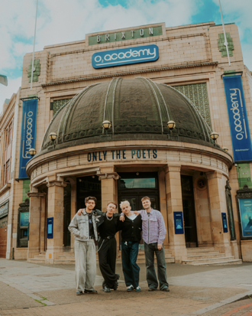

DEBUT ALBUM ‘AND I’D DO IT AGAIN’ OUT JANUARY 30TH
PREORDER HERE

Following the landmark announcement of their historic £1 headline show at O2 Academy Brixton, Only The Poets are taking their commitment to accessible live music one step further by offering one unsigned UK band/artist the chance to support them at their sold-out show on Monday 2nd February 2026.

Seven years on from charging £1 for entry to their first ever gig, the Reading four-piece will become the first band ever to headline O2 Academy Brixton for just £1 — a symbolic, sold-out celebration of live music as something everyone should be able to experience, regardless of background or income.

Now, with the Brixton show selling out in minutes, the band are turning their focus to the next generation — opening the door for an unsigned band/artist from anywhere in the UK to perform at one of the country’s most iconic venues.

With grassroots venues closing and opportunities for emerging artists becoming increasingly limited, Only The Poets want to offer a rare platform: a chance to share the stage and play to a sold-out crowd at a truly landmark moment in the band’s story.

To enter, unsigned bands/artists are invited to submit their details HERE. From all entries, five shortlisted acts will be personally selected by Only The Poets and invited to perform live at The Purple Turtle in Reading on 31st January 2026 — as part of a special all-day celebration marking the release of the band’s debut album, complete with signings and fan events.

Reading’s, The Purple Turtle holds deep significance for Only The Poets, having played a crucial role in their early journey through the small-venues circuit. The five shortlisted bands will perform in front of a packed room of Only The Poets fans, with the fans choosing one final winner on the night. The selected act will go on to support Only The Poets at O2 Academy Brixton on 2nd February 2026, all five acts will be paid a fee directly by the band.

“Without grassroots venues we won’t have the next big bands, and without bands & fans going to grassroots venues, they can’t keep the doors open.
Growing up playing in local venues gave us our first chance to get on stage and perform to people, and supporting other artists down the line changed everything for us, so we wanted to bring the two together.
We’re excited to support our favourite grassroots venue (The Purple Turtle) and invite five new artists to play to a packed-out room, showcasing the amazing new talent that’s out there.”

The Brixton show also supports The LIVE Trust, with an additional £1 per ticket donated to help protect and promote access to live music across the UK.

The announcement comes as Only The Poets kick of 2026 with the release of their much-anticipated debut album, And I’d Do It Again, out January 30th 2026 - a bold 14-track alt-pop statement packed with raw honesty, soaring hooks and widescreen ambition. The album title reflects the band’s seven-year journey — from DIY beginnings and manual labour jobs to relentless touring across the UK and Europe — building a devoted fanbase one gig at a time.

For frontman Tommy Longhurst, bassist Andrew “Roo” Burge, guitarist Clem Cherry and drummer Marcus Yates, the ethos behind both the £1 show and the unsigned-band opportunity is deeply personal.

As teenagers, live music was their lifeline — a place to connect, escape and protect their mental health. With fewer small venues, rising costs and diminishing club nights, opportunities for emerging artists are disappearing fast. This initiative is the band’s way of giving back — creating space, opening doors, and ensuring live music remains something to be shared.

Only The Poets have always been a band with a conscience. This moment — a sold-out Brixton, a debut album, and a platform for the next wave — is not just a celebration of how far they’ve come, but a statement of how inclusive live music can be.

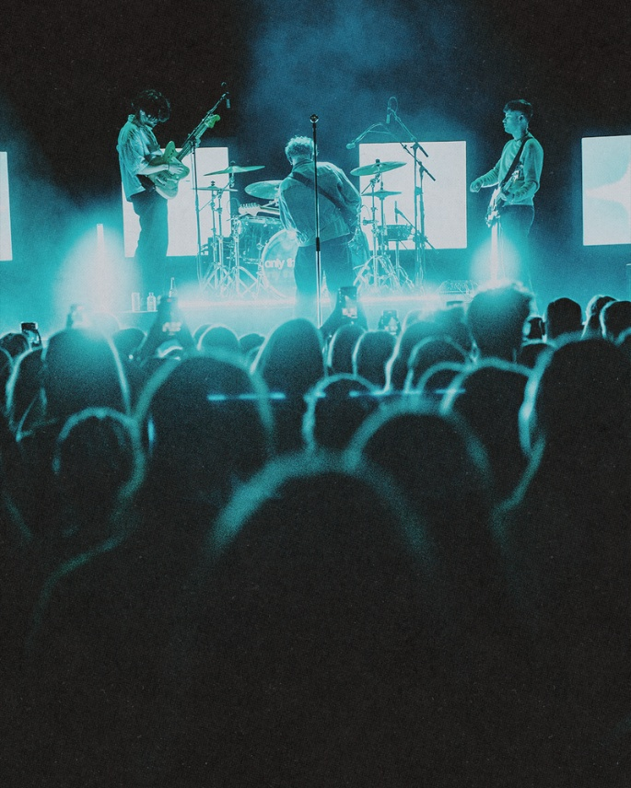

DON’T MISS A THING:
OTP // INSTA // X // FB

For more information and press enquiries please contact
Jenny Entwistle
Jenny@chuffmedia.com

About Only The Poets
Only The Poets are one of the UK’s most exciting rising alt-pop bands known for their honest and unfiltered, confessional songwriting and electrifying live shows. The Reading four piece— made up of frontman Tommy Longhurst, bassist Andy “Roo” Burge, guitarist Clem Cherry, and drummer Marcus Yates have built their following from the ground up, growing a devoted fanbase through relentless touring, grassroots connection, and a steady stream of powerful releases.

Their reputation as a must-see live act has been cemented through sold-out headline tours across Europe and the US, as well as high-profile support slots for artists including Lewis Capaldi, YUNGBLUD, Bastille, and more recently supporting The Wombats in the U.S last autumn. In 2025 alone, the band sold over 30,000 tickets across their European tours and made their US live debut with sold-out shows in New York, Los Angeles, and Boston. In London, the band have sold out shows at Camden Barfly, KOKO, Electric Ballroom, O2 Shepherd’s Bush Empire, and Brixton Academy, alongside several sold-out UK tours.

With songs that speak openly about love, loss, mental health, and emotional resilience, Only The Poets have become a voice for a generation unafraid to feel deeply. Their lyrics feel lived-in: not just stories, but shared experiences. It’s this emotional openness that’s helped them grow from cult favourites to a rising force without ever losing their grassroots spirit.

Only The Poets continue to carve their own path — not through trends, but through truth, connection, and unforgettable live moments.

