Yard Act Announce New UK Autumn Headline Dates

Leeds, Manchester, and London For November

+ 6Music Festival Show In Manchester This Friday

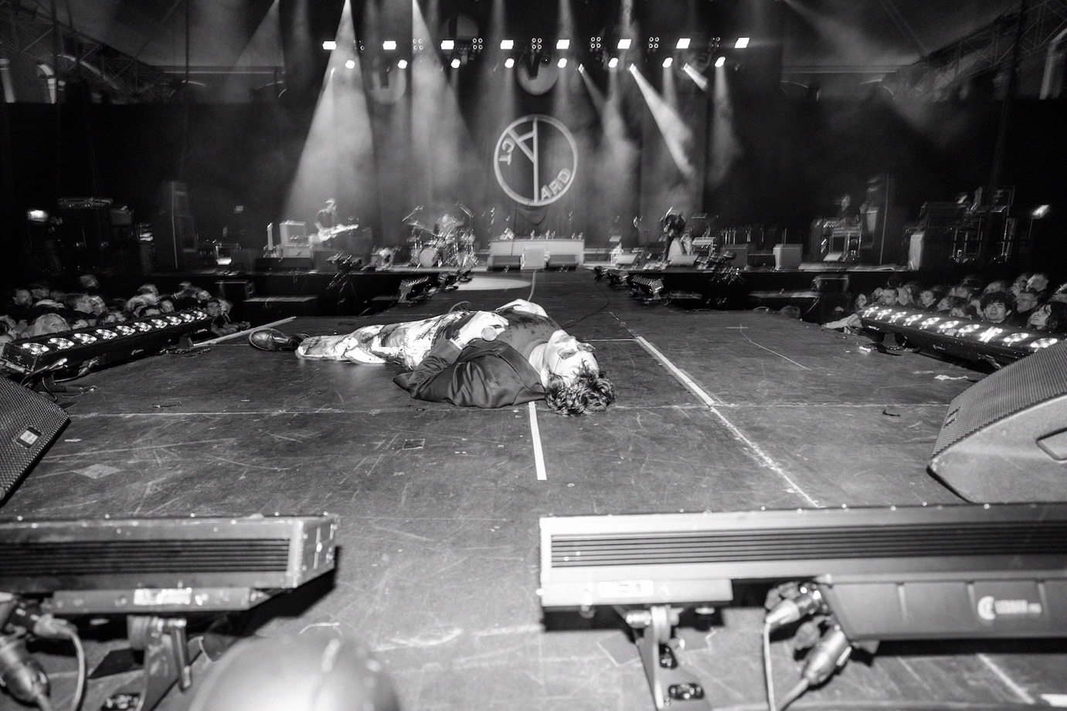
Credit: James Winstanley

Yard Act are pleased to announce details of their first proper UK headline dates since August 2024, with three new shows for later this year.

The Yorkshire band return to their hometown of Leeds on 6th November first a date at the O2 Academy, before shows at the O2 Victoria Warehouse in Manchester in 13th November, and O2 Academy Brixton on 26th November. These dates follow the band’s first show of the year at the 6Music Festival this Friday in Manchester.

Tickets go on artist presale from 10am on Wednesday 25th March before hitting general sale at 10am on Friday 27th March.

Yard Act completed the touring for their technicolour, critically acclaimed second album Where’s My Utopia? with a victory lap back home at the 5000 capacity Millennium Square in Leeds in August 2024. It was a record that brought a stark change of pace to the acerbic, post-punk of their debut, embracing something altogether more playful and bringing a different energy. It shifted the dynamic on stage too, with the addition of dancing backing singers and additional musicians and openly challenged listeners to reconsider who they thought Yard Act were.

Since then, the band have remained active, whether writing Where’s My Utopia’s follow-up on scratching the itch to get back on stage, heading out across the UK and Europe with The Hives, which was preceded by an intimate one-off show at Blackpool Tower last May.

Following a lengthy stint in the studio (with more on that very soon), the band now look to the Autumn for three big UK dates. Act III incoming.

Yard Act Live:
27th March – 6Music Festival at YES, Manchester
6th November – O2 Academy, Leeds
13th November – O2 Victoria Warehouse, Manchester
26th November – O2 Academy, Brixton

www.yardactors.com

For more info contact Warren warren@chuffmedia.com

