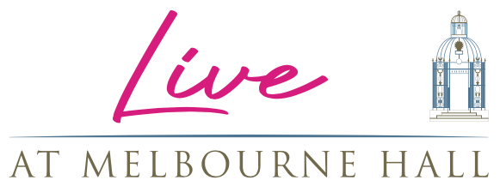

I’M A COMEDIAN, GET ME OUT OF HERE!!!!

JUST THE TONIC COMEDY SHINDIGS RETURN TO MELBOURNE HALL
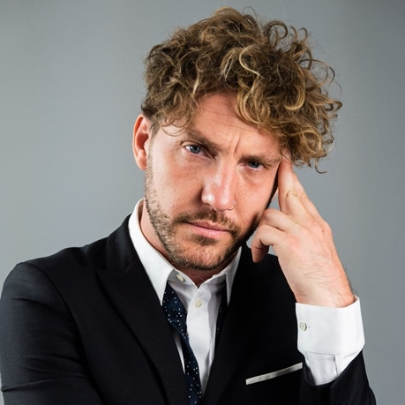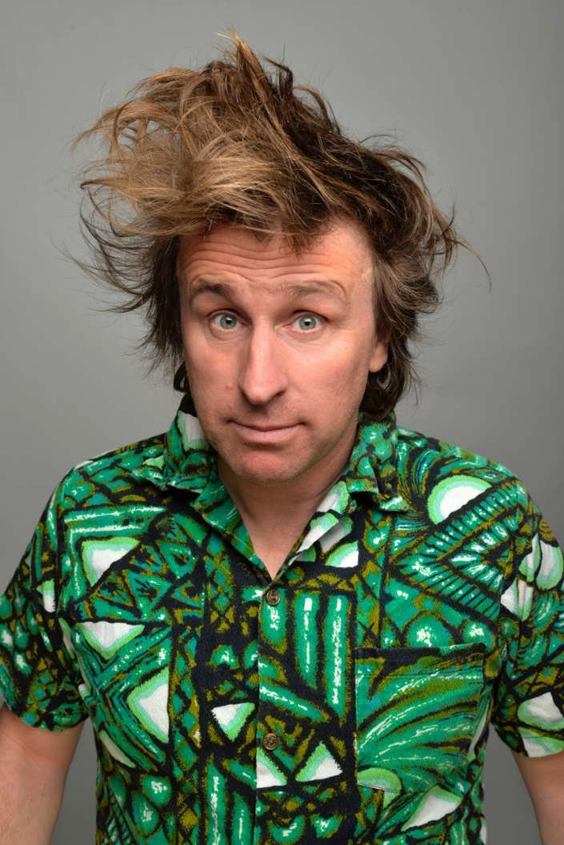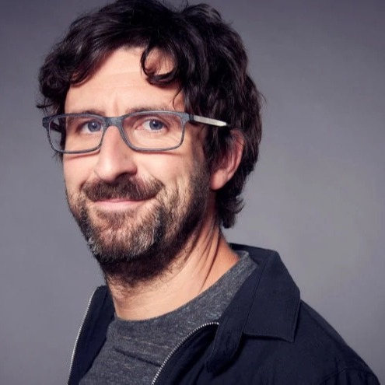

FRIDAY 19TH MAY
Seann Walsh, Connor Burns, Jake Lambert & Dave Longley
SATURDAY 20TH MAY
Milton Jones, Lindsey Santoro, Adam Bloom & Aurie Styla
SUNDAY 21ST MAY
Mark Watson, Dan Tiernan, Scott Bennett & Susie McCabe

Live At Melbourne Hall are pleased to announce the return of Just The Tonic Comedy Club who aim to bring the laughter from the jungle to the walled garden for what is quickly shaping up to be an amazing line up of regular weekend entertainment for South Derbyshire and beyond this summer.

Fresh from his stint in the Australian jungle with I’m A Celebrity Get Me Out Of Here, Seann Walsh is described as “the best observational comedian of his generation” (The Guardian). This Edinburgh Award nominee’s last UK tour show ‘After This One, I’m Going Home’ ended with standing ovations around the country. Seann has starred in Netflix’s Flinch, Live At The Apollo, Tonight at The London Palladium, Celebrity Juice, 8 Out of 10 Cats and is a regular guest on The Jonathan Ross Show.

Not just one of the countries funniest stand-up comedians, Seann can be seen acting in Jack Dee’s ITV sitcom Bad Move where he plays audience favourite, Grizzo. Seann also performs stand-up comedy in America and has appeared on the US chat show, Conan. His DVD, Seann To Be Wild, was recorded at Hammersmith Apollo.

Milton Jones was a regular on Mock the Week (BBC2), has appeared on Michael McIntyre’s Comedy Roadshow (BBC1), Live at the Apollo (BBC1) and has headlined Dave’s One Night Stand (DAVE). MIlton Jones’s tours have seen him play to hundreds of thousands across the UK. He is a previous Perrier Best Newcomer and Nominee, Sony Award winner and British Comedy Award nominee.
Mark Watson is Edinburgh Festival Award Winner and Time Out Critic’s Choice, Mark’s recent TV credits include QI (BBC2) Taskmaster (Dave) and Bear Grylls’ Celebrity Island (Channel 4). Mark has been the face of shows such as BBC Four’s We Need Answers and BBC Radio 4’s Mark Watson Makes The World Substantially Better. He has also appeared on Mock The Week, Celebrity Pointless, Have I Got News For You, Would I Lie To You?, Live At The Apollo and Channel 4’s Comedy Gala. Not only a stand-up, Mark has written seven novels.

With glamping, top comedians, music, food and more planned for 2023, the South Derbyshire stately home is quickly becoming a destination for more than just its iconic gardens.
Tickets are on sale now, available here.
Just The Tonic Comedy starting from £27.50 (weekend tickets £82.50)

LIVE AT MELBOURNE HALL:
Friday 19-May Just The Tonic presents Seann Walsh
Saturday 20-May Just The Tonic presents Milton Jones
Sunday 21-May Just The Tonic presents Mark Watson
Friday 23rd June BBC Radio 2: Sounds of the 80s w/ Gary Davies
Friday 1st September Jo Whiley’s 90s Anthems SOLD OUT
April – September Johnny Vegas’ Field of Dreams Glamping

Ticketing and more information at melbournehall.com/events

For all media enquiries please contact
Warren (warren@chuffmedia.com)
07762 130510

About Melbourne Hall
Melbourne Hall stands in an idyllic setting in Derbyshire and is home to one of the most treasured historical gardens in the country and is the best surviving early 18th century English garden in the manner of le Notre.

The house has a chequered and unusually well-documented history, and all centuries from the 16th to the 20th have left their mark on the fabric. This combined with the fact that Melbourne remains a lived-in family home for Lord and Lady Ralph Kerr (Lord Ralph being a direct descendant of Sir John Coke who made Melbourne his home in 1629) accounts for its warm, welcoming and comfortable atmosphere.

About Just The Tonic
Just The Tonic was launched in Nottingham over 256years ago and has played host to countless up-and-coming comics as well as the most established TV names. It is now one of the most respected live comedy brands across the UK with venues in Leicester, Birmingham, Nottingham, Reading and Watford. It also runs shows at leading festivals including the Leicester Comedy Festival and the Edinburgh Festival. Past and recent performers include the likes of Ricky Gervais, Al Murray, Bill Bailey, Stewart Lee, Simon Pegg, Noel Fielding, Dylan Moran, Ross Noble, Daniel Kitson and Johnny Vegas.

