SAM FENDER ANNOUNCES HUGE STADIUM SHOW

SET TO HEADLINE NEWCASTLE’S ST. JAMES’ PARK IN JUNE 2023

TICKETS ON GENERAL SALE FROM FRIDAY 9TH SEPTEMBER

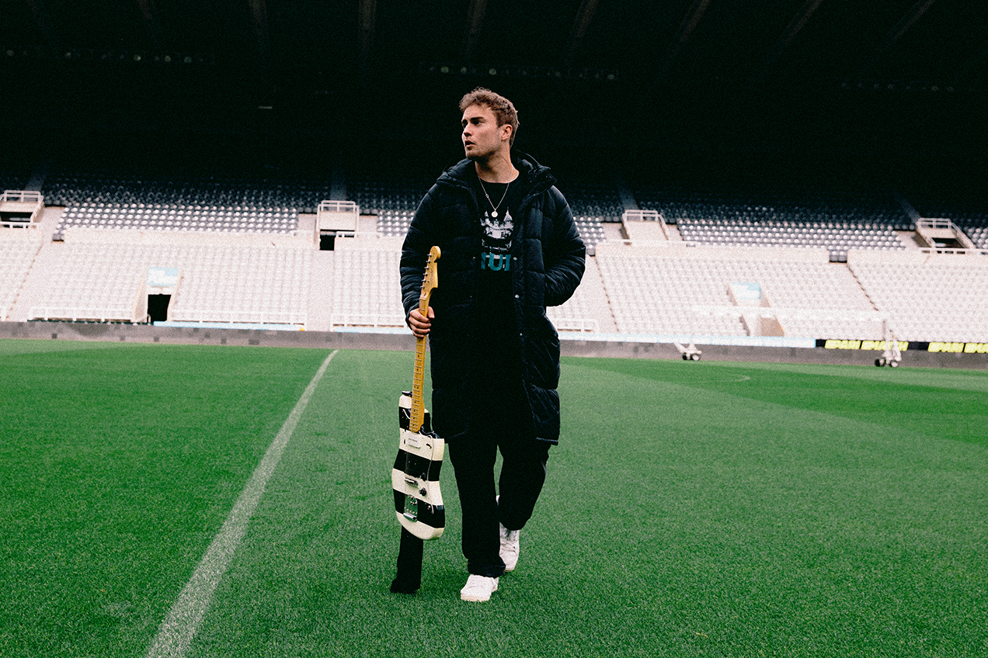
Credit: Niall Lea

Sam Fender is very excited to announce details of his first stadium headline show, and one of Summer 2023’s hottest tickets.

Fender headlines Newcastle’s St. James’ Park on the 9th June 2023, following in the footsteps of Bruce Springsteen and Bob Dylan, and becomes the first Geordie musician to headline the 55,000+ capacity stadium.

Sam Fender: “Ever since I started this band, I always used to joke with the boys that one day we might play St James' Park in Newcastle. It's a childhood dream come true, and we're actually gonna play it on the 9th June. This is literally gonna be the biggest show we've ever done - our first stadium show, which is so weird to say! I can't wait, it's gonna be absolutely lush and I hope to see yas all there.”

Support comes from Inhaler and Holly Humberstone.

Tickets go on general sale from 10am on 9th September via www.samfender.com/live and www.myticket.co.uk. Further official, trusted ticket outlets are listed at the bottom of this press release.

Pre-sale goes live at 10am on Wednesday 7th September. Fans can add their details here before 5pm on Tuesday 6th September to get early access (unless already signed up to the mailing list).

Over the past few months, Sam Fender has solidified himself as one of the most celebrated and successful British artists of his generation, pulling a huge crowd on the Pyramid Stage at Glastonbury ahead of his own 45,000 sell-out show at London’s Finsbury Park.

It’s been a huge 2022 so far for the North Shields hero, picking up a slew of BRIT, NME, and Ivor Novello Awards, and a first nomination for the prestigious Mercury Prize next week, for his second album, the critically acclaimed number 1 album, Seventeen Going Under. Ahead of a series of shows alongside Florence & The Machine in the US, and his first Australian shows since 2019, this latest announcement suggests 2023 will be Sam’s biggest year yet.

Additional St James’ Park official ticket outlets:
www.gigantic.com
www.ticketmaster.co.uk
www.seetickets.com
www.eventim.co.uk
https://www.eventtravel.com/

About Sam Fender..

If Sam Fender’s debut album, 2019’s “Hypersonic Missiles”, introduced a smart, street-wise British songwriter with a penchant for euphoric, hard-hitting guitar anthems, it was 2021’s peerless “Seventeen Going Under” that sent the Newcastle artist stratospheric. An acute observer, Fender turns the mirror not only on the streets he grew up walking, but on himself too. The record is a tough-talking but also tender account of Fender’s childhood and finding his feet in the North of England. It’s also a coming-of-age story, marrying relatable family themes and broken friendships with devastatingly colossal choruses.

“Seventeen Going Under” is also a record that has taken Sam right across the globe, playing to bigger rooms and wider stages, whilst reaping a clutch of awards too (including BRITs, NMEs, Ivor Novellos, and a first Mercury Prize nomination).

Having headlined his first festivals in the UK in the Summer of 2022, and sold out all 45,000 tickets of his most recent headline performance in London, Sam Fender has inadvertently become one of Britain’s most celebrated and successful musicians of a generation.

Sam Fender Live 2022:

12th September – Capital One Arena, Washington DC (w/ Florence & The Machine)
14th September – TD Garden, Boston (w/ Florence & The Machine)
16th September – Madison Square Garden, New York (w/ Florence & The Machine)
18th September – Life Is Beautiful Festival, Las Vegas
22nd September – Wonder Ballroom, Portland SOLD OUT
24th September – The Showbox, Seattle SOLD OUT
25th September – The Commodore Ballroom, Vancouver SOLD OUT
18th November – Palace Foreshore, Melbourne SOLD OUT
22nd November – Enmore Theatre, Sydney SOLD OUT
22nd November – Harvest Rock Festival, Adelaide
24th November – Fortitude Music Hall, Brisbane SOLD OUT
26th November – Hordern Pavilion, Sydney *New Date*

2023:

9th June – St. James’ Park, Newcastle *New Date*

For more information & enquiries please contact jenny@chuffmedia.com

