LEON THOMAS
GRAMMY® WINNER TO HEAD ON UK LEG OF
MUTTS DON’T HEEL WORLD TOUR
DELUXE EDITION OF CRITICALLY ACCLAIMED SOPHOMORE ALBUM MUTT; HEEL OUT NOW VIA EZMNY/MOTOWN RECORDS
LISTEN HERE

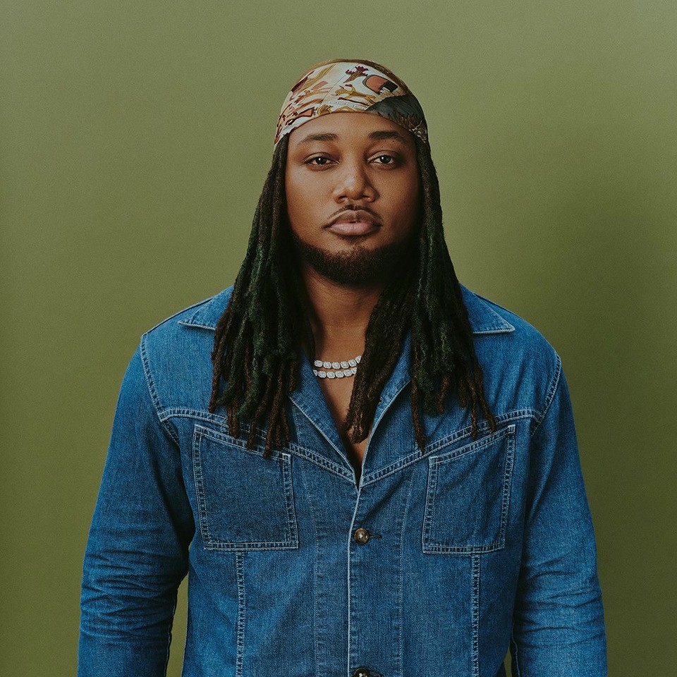

LEON THOMAS MUTT ALBUM PRESS PRAISE
“Through his thorough examination of romance in the social media age, singlehood, and the vast expanse of Black music, Leon Thomas’ Mutt stands as the most stunning R&B album of 2024.” – BILLBOARD
“Thomas not only pays homage to the musical influences of his childhood but also pushes the boundaries of modern Black music. It’s a daring and emotionally rich album that cements his place as one of R&B’s most exciting voices.” – ESSENCE
“MUTT authentically documents the hardships and complexities of love lost while balancing pain with insights into a lesson learned. It’s all wrapped up and laid out over one of the best R&B albums of the year.” – VIBE
“With ‘Mutt,’ Leon Thomas Becomes A Top Dog In R&B.” – HUFF POST
Following a landmark year that saw him top charts on both sides of the Atlantic, GRAMMY® Award-winning artist Leon Thomas is set to bring his critically acclaimed MUTTS DON’T HEEL World Tour to the UK this March and April. The shows form part of the global tour in support of MUTT Deluxe: HEEL, the expanded edition of Leon’s chart-dominating sophomore album MUTT, released via EZMNY/Motown Records.
Leon’s boldly introspective and highly acclaimed second studio album, MUTT, continues to push the boundaries of modern R&B, blending soulful melodies with rock influences and experimental production.
MUTT amassed over 1.1 billion global streams, with its platinum-certified title track becoming his first Billboard Hot 100 Top 40 hit and reaching No. 1 on Billboard’s Hot R&B Songs chart. In the UK, “MUTT” also hit No. 1 on the UK R&B Singles Chart, marking a major breakthrough moment for the artist in Britain.
Critics hailed the album as one of the most important R&B releases of 2024, with Billboard naming it the #1 R&B Album of the Year and praising Leon as “one of the hottest names in R&B.” The deluxe edition, HEEL, builds on that momentum with a bold fusion of psychedelic soul, rock textures and deeply introspective songwriting.
Leon continues to cement himself as a generational star. His NPR Tiny Desk performance went viral, peaking at #2 on YouTube and #5 on X, further iconizing his influence in music and culture. This year, he was named Billboard’s Chartbreaker and MTV PUSH’s Artist of the Month, in addition to making his TV debut on The Late Show with Stephen Colbert, an appearance on The Jennifer Hudson Show, and first cover with GUAP Magazine. Known for his electrifying stage presence and genre-blurring live arrangements, Leon has quickly established himself as one of R&B’s most compelling live performers.
UK TOUR DATES:
March 24 – Bristol, O2 Academy
March 26 – Birmingham, O2 Academy
March 27 – Manchester, Academy
March 29 – Glasgow, SWG3 Galvanisers
April 3 – London, Eventim Apollo

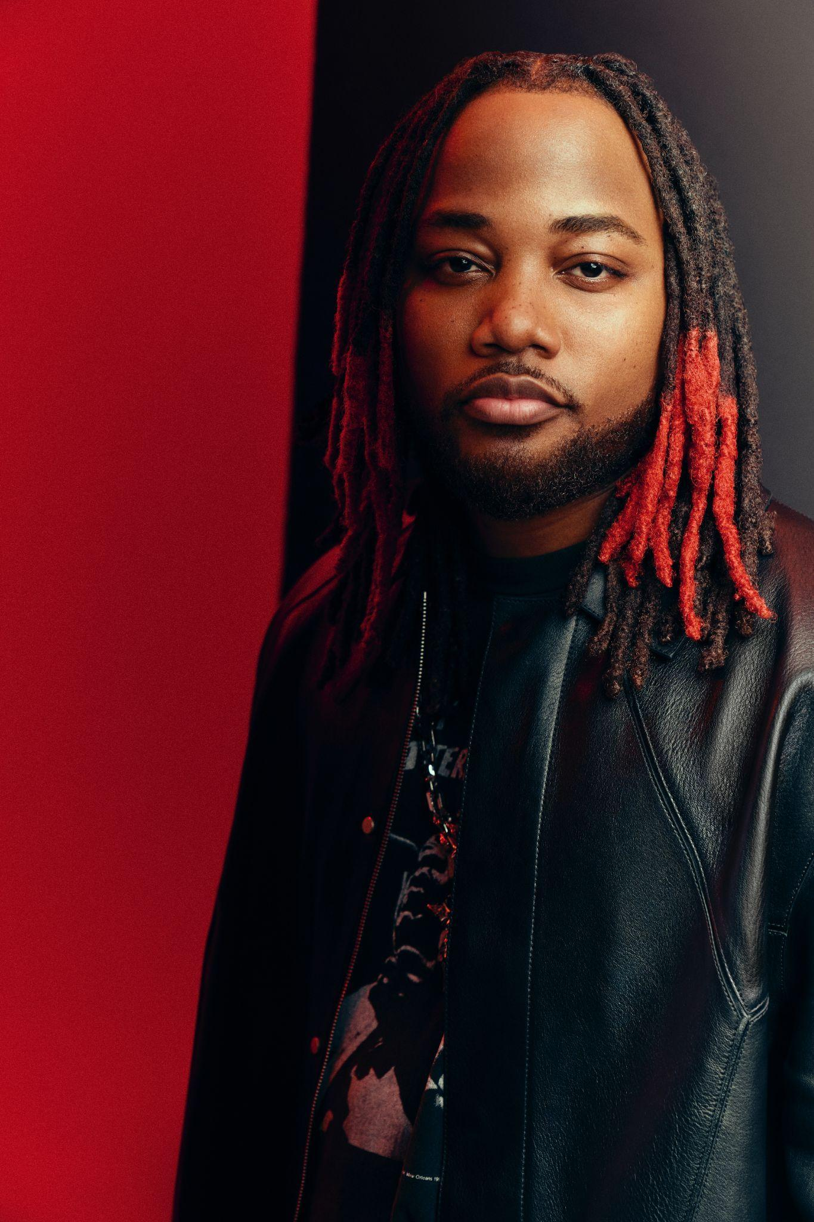
Download Hi-Res Press Image HERE // PC: Raymond Alva

FOLLOW LEON THOMAS
TikTok | Instagram | X | YouTube

For more information and press enquiries please contact

Warren Higgins
warren@chuffmedia.com

