*“Ensnaring combination of ethereal melodies, precise enunciation and haunting up-close vocals. For fans of Laura Marling, Kings of Convenience and early Joni Mitchell”* **- The Sunday Times**

**LILY LYONS**

**ANNOUNCES DEBUT EP *FABRIC***

**DUE FOR RELEASE APRIL 26**

**SHARES BRAND NEW SINGLE “**[**FABRIC**](https://lilylyons.lnk.to/FabricEM!UMGUK48480-1095928?vvsa_consumer_id=37839838&vvsa_tracking=_vvsa_TOTMlysl581196)**”**

**OUT NOW ON FICTION RECORDS**

**

[*Download assets*](https://drive.google.com/drive/folders/1uI7PMih-V_Tk7MxsSOcSy395JK4mHM_6)

**Lily Lyons** searches for truth in her music, exploring simple things that are easily forgotten - not revolutionary, but the everyday beauty and tragedy of relationships. Each track she writes is a beautiful vignette capturing her experiences of life so far, with intricate guitar work and perceptive lyrics delivered in a singular, dulcet voice that could easily sit among the greats. Today, Lily announces the release of her debut EP ***Fabric***, due out on **April 26th** via **Fiction Records**. With lyrics that read like poetry - ‘*Out of the ruins are seeds to sew, They come from the same bricks, You build and grow, They’re part of the fabric you can’t erase’* - Lily also today shares the EP’s title track, following the already released ‘[Spinning Sides](https://lilylyons.lnk.to/SpectreSR)’ and ‘[Spectre](https://lilylyons.lnk.to/SpectreSR)’ as the third single to be released from the project.

[Listen to “Fabric”](https://lilylyons.lnk.to/FabricEM!UMGUK48480-1095928?vvsa_consumer_id=37839838&vvsa_tracking=_vvsa_TOTMlysl581196)

**Lily says of the track:**

*“Fabric is about moving away from the idea that I can rewrite the past. That what has happened has happened and instead of fixating on what I can’t control, moving towards incorporating all those lessons, accepting my story as mine and seeing that all opportunity now lies here in my day-to-day choices.”*

After a standout performance at The Chapel at St. Barnabas, as well as festival slots at Mutations Festival, Golden Slippers, and Celtic Connections, Lily has spent the last month on the road with Dan Mangan for his extensive EU tour, following a run of UK support dates with Tiny Ruins late last year.

*Fabric* EP

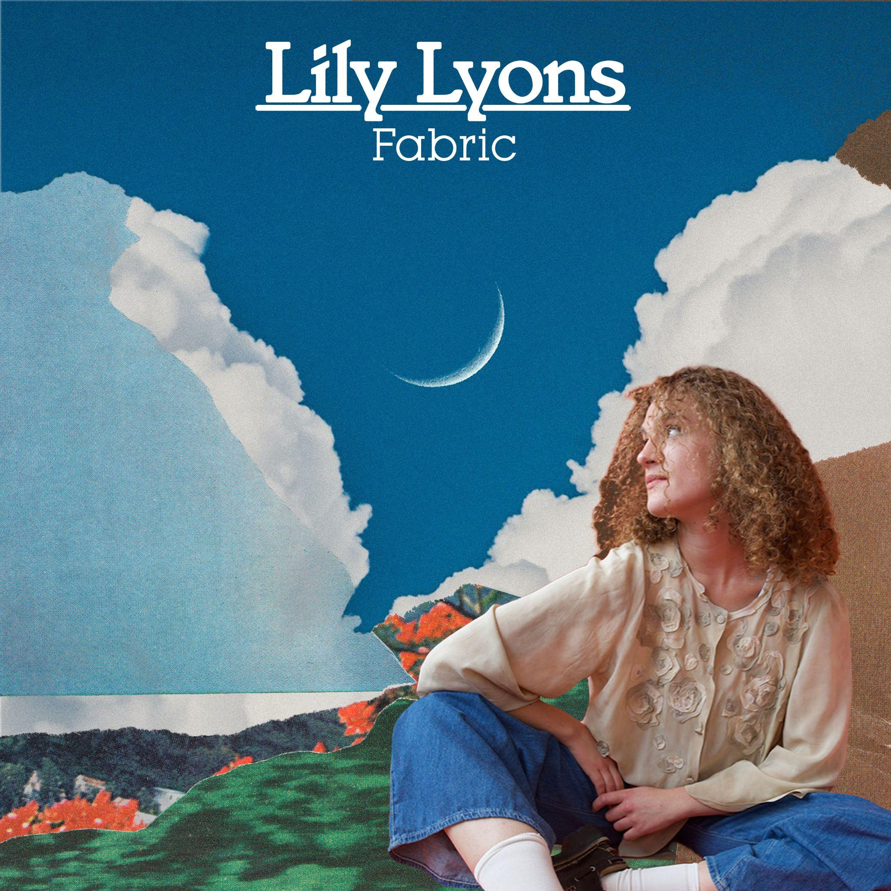

Tracklisting:

1. [Spectre](https://lilylyons.lnk.to/SpectreSR)
2. My Past, Your Luck
3. Fabric
4. [Spinning Sides](https://lilylyons.lnk.to/SpectreSR)

Raised in South London, Lily started singing aged two - influenced by her big band-loving granddad - but it wasn’t until she left London to study music in Cornwall that she was encouraged to sing, a gift she had kept quiet for many years. Moving from bustling London to the tranquil English coast meant leaving the world she’d always known, filled with loving chaos and fast-paced characters. “Growing up, it sometimes felt like I was in a scene from the Meyerowitz Stories. Surrounded by the buzz of London and some pretty hectic friends and family, miscommunications and massive personalities were all I knew.” However, this space gave Lily room to reflect, and find power in learning how to command a room, changing up her live sets in a way that didn’t give her audience any choice but to stay quiet and listen.

As she started gigging, turning up to open mics and small shows multiple times a week, Lily became more in tune with the things she wanted to say in her songs. Using her songwriting to figure out who she is and how she wants to live her life, Lyons hopes that, in turn, her listeners will find the encouragement to “reflect on themselves and feel positive about tomorrow”.

**Follow Lily Lyons**

[Spotify](https://open.spotify.com/artist/5YKAGYFz84gLEI7rAFpIpX?si=Di3evanETvmrtpdJrqDY6Q) | [Apple](https://music.apple.com/gb/artist/lily-lyons/1610727589) | [Instagram](https://www.instagram.com/lilylyonsmusic/?hl=en-gb) | [TikTok](https://www.tiktok.com/@lilylyonsmusic?lang=en)

**For more info contact Warren** [**warren@chuffmedia.com**](mailto:warren@chuffmedia.com)