GLOBAL POP SUPERSTAR KATY PERRY ANNOUNCES THE LIFETIMES TOUR UK ARENA SHOWS OCTOBER 2025
Katy Perry to donate £1 from every ticket to UK grassroots music venues.
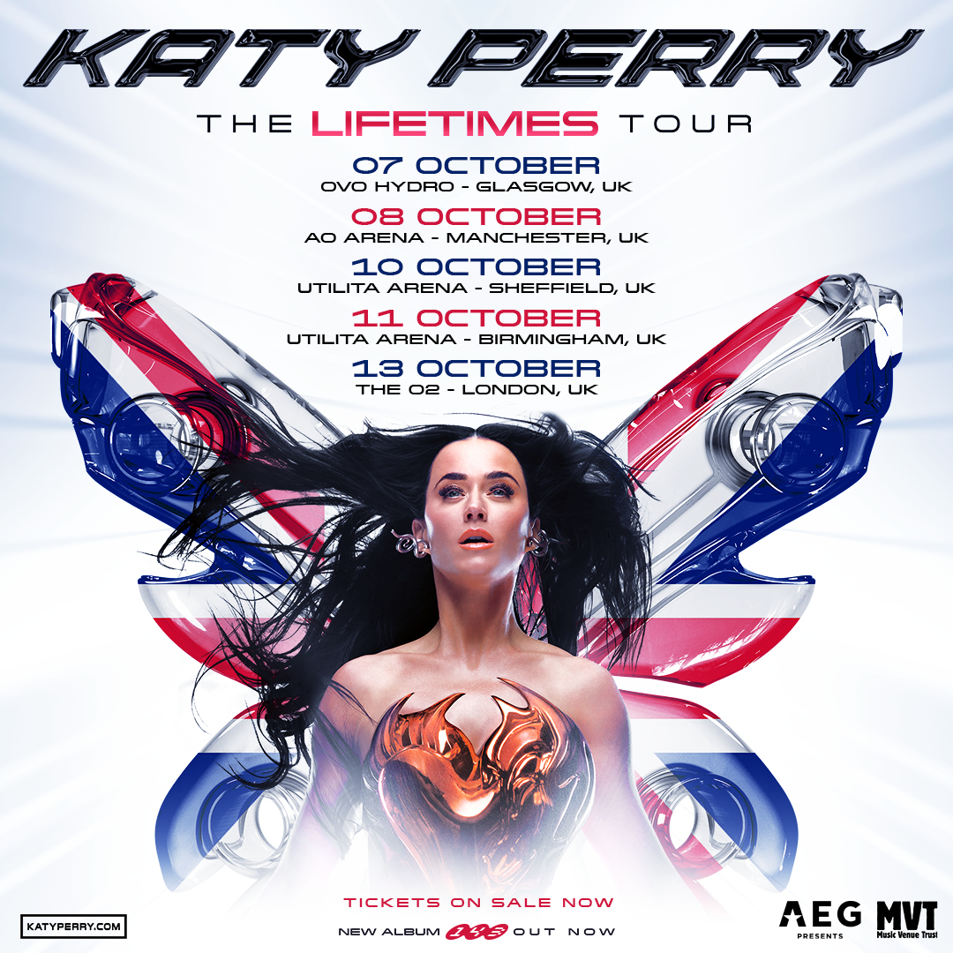

Ticket Pre-Sales Wednesday 20th November @ 10am
General On Sale Friday 22nd November @10am
Ticket link here
November 18 2024 – Today, one the best-selling music artists of all time, Katy Perry announces The Lifetimes Tour is coming to the UK in October 2025 - a spectacular career-spanning run of live shows, including all the hits from across her multi-million selling albums.
The Lifetimes Tour sees the global pop superstar perform in cities across the UK, opening in Glasgow on the 7th of October at the OVO Hydro continuing through to Manchester, Sheffield, Birmingham, and finally culminating with a date at London’s O2 Arena on 13th October.
The UK leg of the tour follows the announcement of additional shows in Australia due to overwhelming demand, with the original dates for June 2025 having sold out. In recent days, a further three shows were announced for Mexico in April 2025 after the first three sold out within an hour.
On returning to the UK for her first tour in over seven years Katy said, “I’m so incredibly chuffed to bring The Lifetimes Tour to the UK! I can’t wait to have a big sing along of all the songs you love and more! It’s going to be a giant dance party, and everyone’s invited!”
Having played her first UK show at Water Rats in Kings Cross in 2008 and at London’s Scala later that year, Katy today announces that £1 from every ticket sold will be donated to Music Venue Trust, the UK charity which acts to protect, secure and improve UK grassroots music venues. Every £1 received from this scheme will go directly into initiatives to support the UK grassroots music community, bringing more great new music to more towns and cities.
“I’m proud to donate £1 from every ticket on the UK leg of The Lifetimes Tour to Music Venue Trust so that venues like Water Rats and Scala, where I played my first UK shows, can continue to usher in the next generation of music talent” says Katy.

“We want to say a huge thank you to Katy and her team for stepping up to support grassroots music venues, artists and promoters. The contribution from these shows will keep venues open, get new and emerging artists out on tour, and enable promoters to bring the best in new music to our communities” says Mark Davyd, CEO Music Venue Trust.
Last month, Katy made an epic return to the MTV stage for the first time since 2017. The five-time VMA winner accepted the 2024 Video Vanguard Award and performed a show-stopping, career-spanning medley of her biggest hits. View HERE. The performance also features two tracks from Katy’s new album, 143, a record that’s jam-packed with the kind of celebratory and provocative pop anthems fans have come to love. Listen HERE
With a cumulative 115 billion streams alongside worldwide sales of over 70 million adjusted albums and 143 million tracks, Katy Perry is one of the best-selling musical artists of all time. She is one of only twelve artists in history to have surpassed 100 million certified units.
With The Lifetimes Tour, Katy announces an exciting new era in her record-breaking pop career, one UK fans will not want to miss!

THE LIFETIMES TOUR – UK TOUR DATES
Tue 7th October GLASGOW, OVO Hydro
Wed 8th October MANCHESTER, AO Arena
Fri 10th Oct SHEFFIELD, Utilita Arena
Sat 11th BIRMINGHAM, Utilita Arena
Mon 13th Oct LONDON, The O2

Photo credit: Louisa Meng

ABOUT KATY PERRY:
Since Katy Perry’s Capitol Records debut in 2008 with One of the Boys, she has racked up a cumulative 115 billion streams alongside worldwide sales of over 70 million adjusted albums and 143 million tracks. The biggest-selling female artist in Capitol history, Katy is one of only twelve artists in history to have surpassed 100 million certified units with their solo single releases – and the first-ever Capitol Records recording artist to achieve the elite status of having 10 million RIAA-certified units for a single in 2015. She was also the first artist in RIAA history to earn three RIAA Diamond singles – for “Firework,” “Dark Horse” and “Roar.” Since then, she’s added a few more to her collection with “California Gurls” (feat. Snoop Dogg), “E.T”, and both “Teenage Dream” the SINGLE AND ALBUM going DIAMOND. Katy now has six singles and one album for a total of SEVEN Diamond-certified titles.

Now certified 3x Platinum, One of the Boys contained the hits “I Kissed A Girl” (6x Platinum) and “Hot N Cold” (8x Platinum). Katy’s second studio album, Diamond-certified Teenage Dream (2010), produced massive hits “Firework” and “California Gurls,” in addition to “E.T.” and “Teenage Dream” (single), which have each reached Diamond (10x Platinum).

The 5x Platinum PRISM followed in 2013. When the official videos for “Dark Horse” and the 15x Platinum, “Roar” each surpassed three billion views, Katy became the first female artist to reach this milestone. ”Roar” has just crossed the four billion view mark, while “Dark Horse” recently crossed the one billion threshold on Spotify, where Katy boasts an impressive 57 million+ monthly listeners with over 30 million followers.

2017’s Witness contained the 2x Platinum “Chained to the Rhythm” (feat. Skip Marley) plus the Platinum hits “Bon Appétit” (feat. Migos) and “Swish Swish” (feat. Nicki Minaj). “Never Really Over,” off her latest album SMILE, is certified Platinum and was the biggest streaming launch of Katy’s musical career. The album also includes the Gold-certified singles “Daisies” and “Harleys in Hawaii.” SMILE has sold over 2.5 million adjusted albums, with over 4 billion combined streams to date.
Aside from being one of the best-selling musical artists of all time, Katy is an active advocate of many philanthropic causes. In 2013, Katy was appointed a UNICEF Goodwill Ambassador and has used her powerful voice to ensure every child’s right to health, education, equality, and protection. Katy has also been a champion for LGBTQ+ equality, and has received numerous awards for her work, including the Trevor Project's Hero Award in 2012, the Human Rights Campaign's National Equality Award in 2017, amfAR’s Award of Courage in 2018, and Variety’s Power of Women distinction in 2021 for her work with her own foundation, the Firework Foundation, whose mission is to empower children from underserved communities by igniting their inner light through the arts.
In 2023 Katy wrapped her critically acclaimed Las Vegas residency, PLAY. When “American Idol” returned to the air in 2018, Katy joined as a judge. She completed her seventh, and final, consecutive season on the show at the end of last year.
###
FOLLOW KATY PERRY
Website | Instagram | X | Facebook | YouTube | TikTok

About Music Venue Trust
Music Venue Trust is a registered charity, created in January 2014 to protect, secure and improve the UK live music network by securing the long-term future of iconic grassroots music venues such as Hull Adelphi, Exeter Cavern, Southampton Joiners, The 100 Club, Band on the Wall, Tunbridge Wells Forum etc. These venues have played a crucial role in the development of British music over the last 40 years, nurturing local talent, providing a platform for artists to build their careers and develop their music and their performance skills.
We work to gain recognition of the essential role these venues fulfil, not only for artist development but also for the cultural and music industries, the economy and local communities. We aim to preserve and improve venues, making them more efficient and improving the experience for performers and audiences. Long-term we plan to acquire the freeholds of as many of these vital venues as possible.
Music Venue Trust is a Charity registered with the Charity Commission of England and Wales, registration no: 1159846.
Music Venue Trust (Scotland) is a charity registered with the Office of the Scottish Charity
www.musicvenuetrust.com

About AEG Presents
Combining the power of the live event with a focus on true artist development, AEG Presents is a worldwide leader in the music and entertainment industries. Operating across five continents, the company has an unparalleled commitment to artistry, creativity, and community. The company’s tentpole festivals and multi-day music events, global tour promotion, vast network of clubs, theaters, arenas and stadiums, and renowned partner brands combine to create an unmatched infrastructure for artist development and audience reach, while continuing to set the bar for the live music experience. More information can be found at www.aegpresents.com.

For more information please contact
Warren Higgins
warren@chuffmedia.com

