**Kurt Vile Announces UK and European Tour Dates With The Violators**

**Headlines Camden’s Koko on Monday 12th June**

*“as lushly unselfconscious as any American stadium icon”* ***– MOJO***

*“one of America’s great modern songwriters”* ***– NME***

*“inimitable”* ***– The Line of Best Fit***

*“magical”* ***– The i***

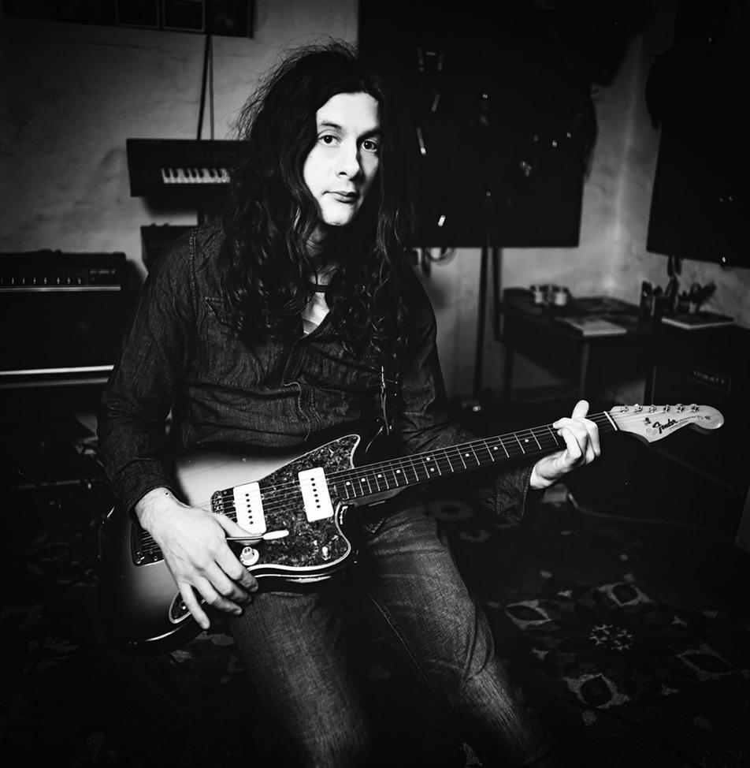

**Credit: Lance Bangs**

Today, acclaimed musician, songwriter and producer **Kurt Vile** **and his band The Violators** announces a headline tour of the UK and Europe, including an appearance at Black Deer Festival and London’s legendary Koko on Monday 12th June. The Koko show is Vile’s first headline show in London since 2019 and follows the release of his critically acclaimed ninth album [*(watch my moves)*](https://kurtvile.lnk.to/WatchMyMoves) released on Verve Records last year.

The tour will take in eight UK cities, including Manchester and Glasgow before Vile and The Violators head into Europe for a run of shows and festivals.

*(watch my moves)* was named an album of the year by Uncut, MOJO and The Observer, who described the 15 track collection as *“gently psychedelic tunes meandering to just the right places, where Vile’s preternatural serenity felt like a balm.”*

Produced by Vile himself with Rob Schnapf, the album features special guests Chastity Belt, Cate Le Bon and percussionists Stella Mozgawa (Warpaint, Courtney Barnett) and Sarah Jones (Hot Chip, Harry Styles). *(watch my moves)* featured the singles[*‘Like Exploding Stones’*](https://www.youtube.com/watch?v=Oz52D43VRSE)*, ‘*[*Hey Like A Child*](https://www.youtube.com/watch?v=qsj6MN9R1pk)*’, ‘*[*Mount Airy Hill*](https://www.youtube.com/watch?v=pMyGCw6li2c)*’* and [‘*Flyin’ (like a fast train’)*](https://www.youtube.com/watch?v=wxNGZOS4SuI)*.*

**Tickets go on sale 3rd March at 10am GMT.**

**Kurt Vile & The Violators play**

**\*with King Hannah**

**JUNE 2023**

11th Best Kept Secret, HILVARENBEEK, NL

12th Koko, LONDON, UK*

15th SWX, BRISTOL, UK*

16th Black Deer Festival, KENT, UK

18th Body & Soul Festival, WESTMEATH, IE

19th New Century, MANCHESTER, UK*

20th Boiler Shop, NEWCASTLE, UK*

21st Queens Hall, EDINBURGH, UK*

22nd The Level, NOTTINGHAM, UK*

23rd O2 Institute, BIRMINGHAM, UK*

25th Chalk, BRIGHTON, UK*

26th Le Grand Mix, TOURCOING, FR

27th Karlstorbahnhof, HEIDELBERG, DE

28th Muffathelle, MUNICH, DE

30th Spazio 211 Open Air, TURIN, IE

**JULY 2023**

1st Off Tune Festival, PRATO, IT

2nd Ferrera Comfort Festival, FERRARA, IT

3rd Kino Siska, LJUBLJANA, Slovenia

5th Rote Fabrik, ZURICH, CH

7th Pointu Festival, ILE DU GAOU/ SIX-FOURS, FR

9th Cactusfestival, BRUGGE, NL

10th Live at Amsterdamse Bos, AMSTERDAM, NL



**Keep up to date with Kurt Vile**

[**INSTAGRAM**](https://www.instagram.com/kurtvile/?hl=en) **//** [**SPOTIFY**](https://open.spotify.com/artist/5gspAQIAH8nJUrMYgXjCJ2?si=L3Nn6qV8RmqfEFOIMaXmTQ) **//** [**YOUTUBE**](https://www.youtube.com/channel/UC0e8FEoCtQIKW1B2eXnxm1w) **//** [**WEBSITE**](https://www.kurtvile.com)

[**TWITTER**](https://twitter.com/therealkurtvile) **//** [**FACEBOOK**](https://www.facebook.com/kurtvileofphilly/) **//** [**APPLE MUSIC**](https://itunes.apple.com/gb/artist/kurt-vile/274234314) **//** [**TIKTOK**](https://www.tiktok.com/discover/Kurt-Vile?lang=en)

**For more information and press enquiries please contact**

**Warren Higgins**

[**warren@chuffmedia.com**](mailto:warren@chuffmedia.com)