

**GLOBAL POP SUPERSTAR KATY PERRY LAUNCHES NEW ERA WITH “WOMAN’S WORLD,” THE FIRST SINGLE FROM HER NEW ALBUM**

**Single Out July 11 – Pre-Save / Pre-Order** [**HERE**](http://katy.to/SaveWomansWorldPR)

**Official Video Premieres July 12**

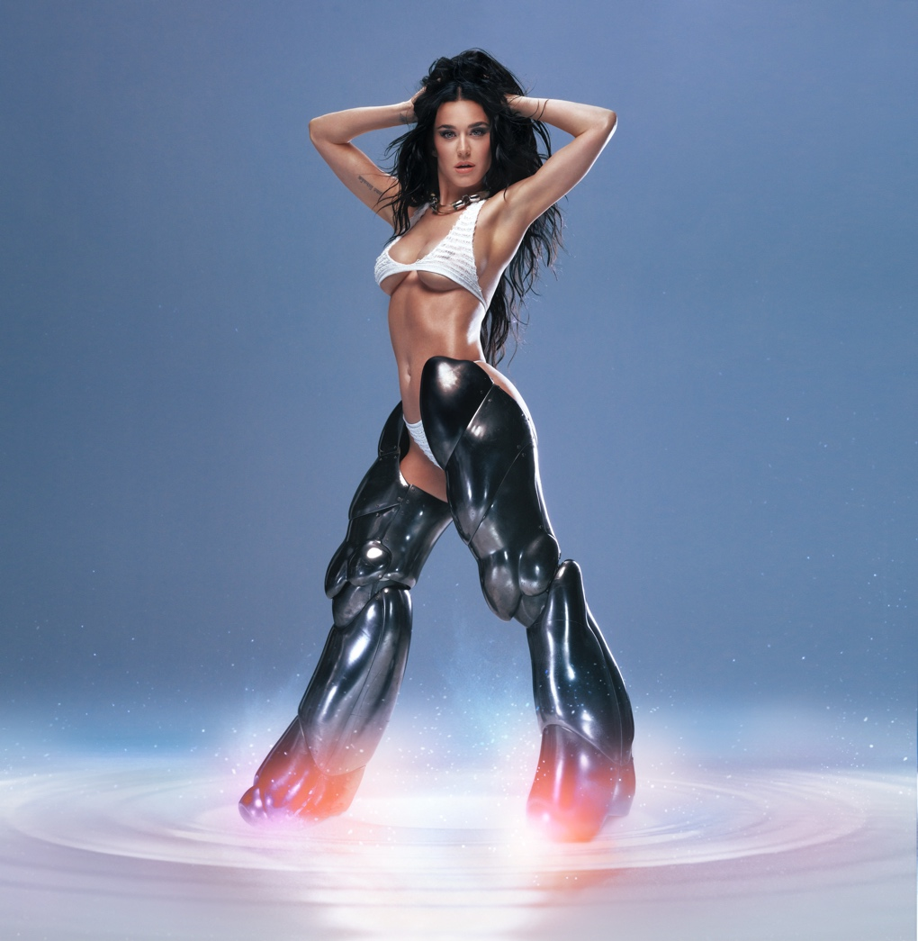

Katy Perry Photo Credit: Jack Bridgland

Hi-res artwork [here](https://umusic.box.com/s/h2m9zlqwgct4cxbljwf90fr625x7flvj)

**Katy Perry** will kick off an extraordinary new pop era this summer, beginning with the release of her new single, **“Woman’s World,”** on Thursday, July 11, at 7:00 PM ET/ 4:00 PM PT. The official video will premiere July 12. Today, the global pop superstar unveiled the single’s bold cover art, which was shot by acclaimed British photographer Jack Bridgland, and a snippet of the song on her social media. **“Woman’s World”** is the first single from **Katy’s** forthcoming album.

Fans can pre-save the single – and pre-order the CD single or 7-inch vinyl editions – [HERE](http://katy.to/WomansWorldPR). Check out the official sound for **“Woman’s World”** [HERE](http://katy.to/WWTTclip).

With a cumulative 115 billion streams alongside worldwide sales of over 70 million adjusted albums and 143 million tracks, **Katy** is one of the best-selling musical artists of all time. She’s one of only five recording artists in RIAA history to gain entry to the elite 100 Million Certified Songs club.

On Friday, September 20, **Katy** will headline the sold-out Rock in Rio in Brazil, marking her first performance at the Rio de Janeiro festival since 2015.

**ABOUT KATY PERRY:**

Since Katy Perry’s Capitol Records debut in 2008 with *One of the Boys*, she has racked up a cumulative 115 billion streams alongside worldwide sales of over 70 million adjusted albums and 143 million tracks. The biggest-selling female artist in Capitol history, Katy is one of only five artists in history to have surpassed 100 million certified units with their digital singles – and the first-ever Capitol Records recording artist to join the elite RIAA 100 Million Certified Songs club. She was the first artist in RIAA history to earn three RIAA Diamond Song Awards – for “Firework,” “Dark Horse” and “Roar.” “California Gurls” (feat. Snoop Dogg) recently brought Katy her fourth Diamond Song Award.

Now certified triple Platinum, *One of the Boys* contained the hits “I Kissed A Girl” (6x Platinum) and “Hot N Cold” (8x Platinum). Katy’s second studio album, *Teenage Dream* (2010), ushered in what the RIAA recognized as the highest-certified era of any artist ever. In addition to the massive hits “Firework” and “California Gurls,” the 9x Platinum album contained “E.T.” and “Teenage Dream” (single), which have each reached 10x Platinum Status.

The 5x Platinum *PRISM* followed in 2013. When the official videos for “Dark Horse” and the 15x Platinum, “Roar” each surpassed three billion views, Katy became the first female artist to reach this milestone. “Roar” has just crossed the four billion view mark, while “Dark Horse” recently crossed the one billion threshold on Spotify, where Katy boasts an impressive 57 million+ monthly listeners with over 30 million followers.

2017’s *Witness* contained the 2x Platinum “Chained to the Rhythm” (feat. Skip Marley) plus the Platinum hits “Bon Appétit” (feat. Migos) and “Swish Swish” (feat. Nicki Minaj). “Never Really Over,” off her latest album *SMILE*, is certified Platinum and was the biggest streaming launch of Katy’s musical career. The album also includes the Gold-certified singles “Daisies” and “Harleys in Hawaii.” *SMILE* has sold over 2.5 million adjusted albums, with over 4 billion combined streams to date.

Aside from being one of the best-selling musical artists of all time, Katy is an active advocate of many philanthropic causes. In 2013, Katy was appointed a UNICEF Goodwill Ambassador and has used her powerful voice to ensure every child’s right to health, education, equality, and protection. Katy has also been a champion for LGBTQ+ equality, and has received numerous awards for her work, including the Trevor Project's Hero Award in 2012, the Human Rights Campaign's National Equality Award in 2017, amfAR’s Award of Courage in 2018, and Variety’s Power of Women distinction in 2021 for her work with her own foundation, the Firework Foundation, whose mission is to empower children from underserved communities by igniting their inner light through the arts.  
  
Katy has similarly focused her entrepreneurial flair towards her eponymous shoe line, Katy Perry Collections, as well as for selective companies working to improve health and wellness. She sits on the Board of Bragg, makers of the celebrated Apple Cider Vinegar, has been an early backer of Impossible Foods, the plant-based meat producer, and is an active investor in Apeel Sciences, a company focused on plant-derived shelf-life extension technology for fresh produce that improves quality and reduces food waste, and Samsara, an enviro-tech company creating infinite recycling to end plastic pollution. Most recently, Katy co-founded De Soi, a line of sparkling ready-to-drink non-alcoholic apéritifs with natural adaptogens, in partnership with AMASS, maker of clean botanics.  
  
Katy has just wrapped her critically acclaimed Las Vegas residency, *PLAY*. When “American Idol” returned to the air in 2018, Katy joined as a judge. She just completed her seventh, and final, consecutive season on the show.

###

**FOLLOW KATY PERRY**

[Website](http://katyperry.com/) | [Instagram](http://instagram.com/katyperry) | [X](http://twitter.com/katyperry) | [Facebook](http://facebook.com/katyperry) | [YouTube](http://youtube.com/katyperry) | [TikTok](https://www.tiktok.com/@katyperry)

**For more information please contact**

**Warren Higgins** [**warren@chuffmedia.com**](mailto:warren@chuffmedia.com)