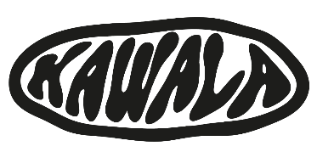
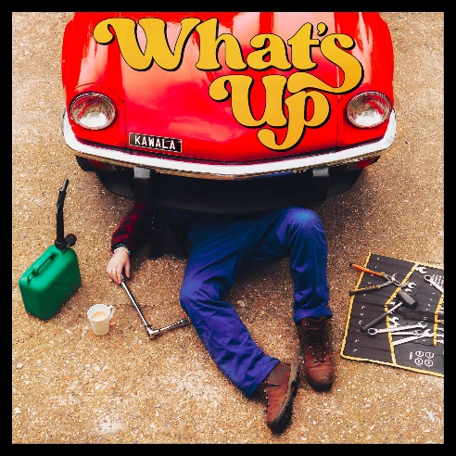
HI-RES IMAGE / ARTWORK
KAWALA SHARE NEW SINGLE ‘WHAT’S UP’
CURRENTLY ON TOUR THROUGHOUT EUROPE
HEADLINE UK SHOWS IN MAY - INCLUDES SOLD OUT LONDON SHOW ON MAY 22ND.
LISTEN HERE

Gearing up for what will be a stellar year, North London five-piece, KAWALA announce their infectious second single of 2024, ‘What’s Up’, an upbeat palliative offering that extends a gentle check-in to a close friend. The woozy sunshine-filled sonics unspool like a daydream - bigger, brighter and fuller than ever before.

KAWALA have always been connected to the summer, in sound and spirit. If their debut album Better With You was their sunrise, then this new era of music is their midday sun; a prism through which this unified beam of light is focused to divide into a far-reaching spectrum of colour, curiosity, and above all, confidence.

‘What’s Up’ follows the fan favourite track, ‘American Adrenaline’: a song that gleams on the surface, kissed by the California sun and melodies that fizz like sugar in champagne – but there is a duality to it, a world of substance beneath the surface. The track’s artwork, a cheeseburger stacked high, sticky with mustard and ketchup, might entice those with the hunger for it; look again, and in a different light, it’s nauseating, a tower of grease and greed. It’s this critical frame of thinking, to look beyond what we are spoon-fed.

This dazzling new direction in KAWALA’s music, has been welcomed by their fans with sell out shows in both London and Manchester at the end of last year. With a tour supporting Bombay Bicycle Club already done at the beginning of the year, alongside joining Giant Rooks across Europe, KAWALA are set to embark on a headline tour of their own in May including a sold-out date at in London @ Outernet on May 22nd – their biggest London show to date. See the full list of dates below and find tickets HERE.

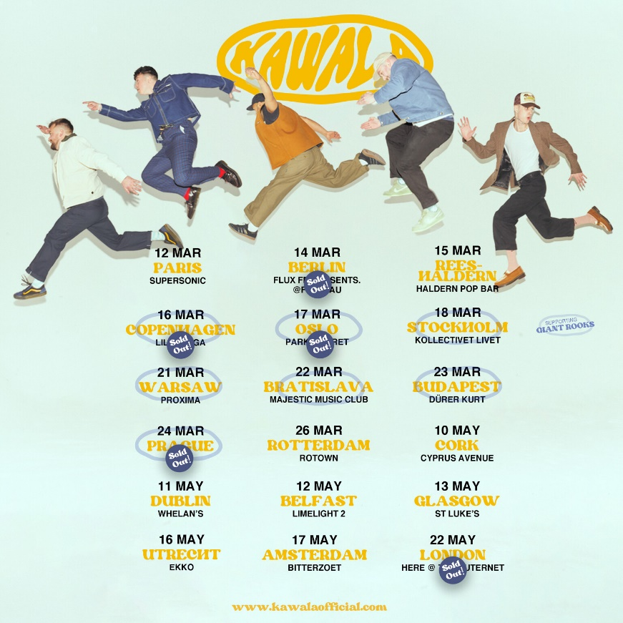

Follow KAWALA:
https://www.tiktok.com/@tiktokawala
https://www.instagram.com/kawalagram
https://twitter.com/KawalaOfficial
https://www.facebook.com/KawalaOfficial

For more information please contact warren@chuffmedia.com

