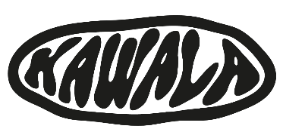

**KAWALA ANNOUNCE MINI ALBUM - ‘KAWALA COLLECTION’ ALONGSIDE BIGGEST EVER UK TOUR**

**INCLUDES HEADLINE LONDON SHOW AT SHEPHERD’S BUSH EMPIRE**

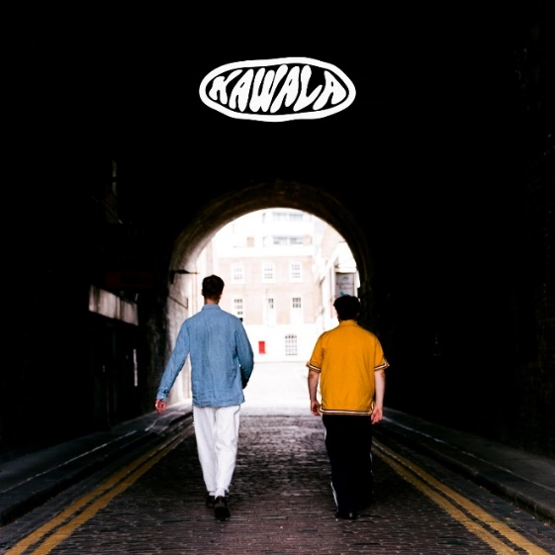

**LISTEN TO NEW SINGLE ‘OLD ME’** [**HERE**](https://kawala.lnk.to/oldme)

Today, North London five-piece **KAWALA** announce their upcoming project, the *Kawala Collection* landing January 24th, plus share new single ‘Old Me’ – listen [**HERE**](https://kawala.lnk.to/oldme).

Written with **Bombay Bicycle Club**'s Ed Nash, ‘Old Me’ is a heartfelt moment that sits within KAWALA’s fluorescent catalogue, an introspective ode to their older selves and a reflection on their lives so far, with high hopes and optimism for the future laying ahead.

*“We wrote a song for the people we’ll become. A reminder of who we were and a promise of who we’ll be.”* - **KAWALA**

The band also announce their brand-new mini album, the *Kawala Collection*, releasing January 24th. Consisting of 9 tracks portraying KAWALA’s diverse songwriting capabilities, from the sun-kissed ‘[American Adrenaline](https://kawala.lnk.to/AmericanAdrenaline)’, upbeat palliative fan-favourite ‘[What’s Up](https://kawala.lnk.to/WhatsUp)’, to the vibrant offerings of ‘[Time Slipping Away](https://kawala.lnk.to/TSA)’ and the soothing lyricism of ‘[Old Me](https://kawala.lnk.to/oldme)’, the *Kawala Collection* takes listeners on a sonic journey and showcases the band at their very best. Pre-order HERE.

KAWALA have always been connected to the summer, in sound and spirit. If their debut album *Better With You* was their sunrise, then this new era of music is their midday sun; a prism through which this unified beam of light is focused to divide into a far-reaching spectrum of colour, curiosity, and above all, confidence. 2024 has already seen the band play shows extensively around the UK and Europe, including incredible sets at **Colors**, **Electric Castle**, **Pukkelpop** plus a sold-out headline show at London’s **OUTERNET**. As they continue to build momentum, KAWALA prepare to embark on their biggest ever UK tour in 2025. Find dates below:

**UK Dates 2025**

February 1st – Engine Rooms, Southampton

February 3rd – Phoenix, Exeter

February 4th – Trinity Centre, Bristol

February 6th – O2 Institute, Birmingham

February 7th – Boiler Shop, Newcastle

February 8th – New Century Hall, Manchester

February 9th – SWG3, Glasgow

February 11th – Academy, Dublin

February 12th – The Wardrobe, Leeds

February 13th – Shepherd’s Bush Empire, London

**EU Dates 2025**

February 20th – Bahnhof Pauli, Hamburg

February 21st – Café V Lese, Prague

February 22nd – Cassiopeia, Berlin

February 23rd – Artheater, Cologne

February 25th – Melkweg OZ, Amsterdam

February 26th – Boule Noire, Paris

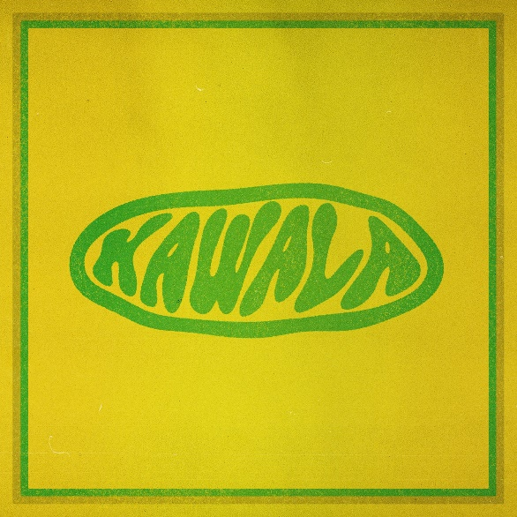

**Kawala Collection Tracklist**

Pre-order [HERE](https://lnk.bio/kawala)

Time Slipping Away

Good Morning

What’s Up?

Old Me

I Feel You

M.A.D

Honeycomb

American Adrenaline

**Follow KAWALA:** [**TIKTOK**](https://www.tiktok.com/@tiktokawala) **/** [**INSTAGRAM**](https://www.instagram.com/kawalagram) **/** [**TWITTER**](https://twitter.com/KawalaOfficial) **/** [**FACEBOOK**](https://www.facebook.com/KawalaOfficial)

**For more information please contact** [**warren@chuffmedia.com**](mailto:warren@chuffmedia.com)