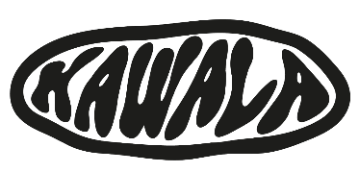

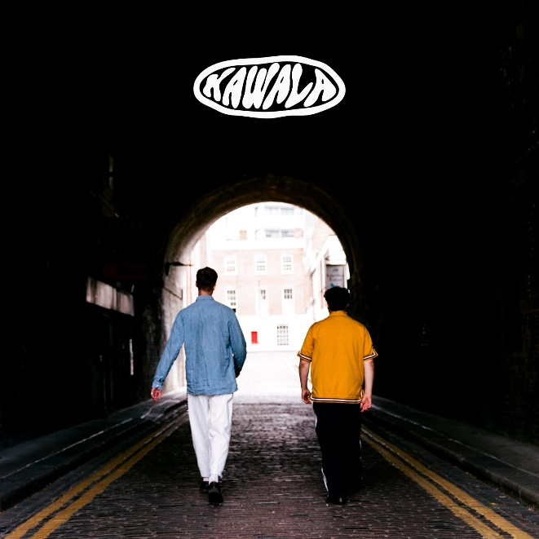

**[HI-RES IMAGE / ARTWORK](https://umusic.box.com/s/rdzjf1xalv2rpkl2kvgxsnewrtwevq2z)**

**KAWALA SHARE FINAL RELEASE, THE ‘KAWALA COLLECTION’ OUT NOW –** **LISTEN HERE**

**BIGGEST EVER UK TOUR KICKS OFF THIS WEEKEND – INCLUDES SHEPHERD’S BUSH EMPIRE ON 13TH FEBRUARY**

**WATCH “MAKE A DIFFERENCE” LIVE AT THE OUTNET** [**Here**](https://umusic.box.com/s/gf2vwmz7whaw6eb81vt9uji7hu9d45bx)

Today, **KAWALA** release the ***KAWALA Collection****,* the band’s final piece of music following the sad news they’ll be calling it a day after their forthcoming tour this February – [see here](https://www.instagram.com/p/DDeWPbsI-la/?hl=en&img_index=1). **The Farewell Tour** will be the last ever opportunity for fans in the UK and across Europe to see the band play live.

The ***KAWALA Collection***, out now consists of 9 tracks portraying KAWALA’s diverse songwriting capabilities, from the sun-kissed ‘[American Adrenaline](https://kawala.lnk.to/AmericanAdrenaline)’, upbeat palliative fan-favourite ‘[What’s Up](https://kawala.lnk.to/WhatsUp)’, to the vibrant offerings of ‘[Time Slipping Away](https://kawala.lnk.to/TSA)’ and the soothing lyricism of ‘[Old Me](https://kawala.lnk.to/oldme)’, the *KAWALA Collection* takes listeners on a sonic journey and showcases the band at their very best. **LISTEN HERE**

KAWALA have always been connected to the summer, in sound and spirit. If their debut album *Better With You* was their sunrise, then this new era of music is their midday sun; a prism through which this unified beam of light is focused to divide into a far-reaching spectrum of colour, curiosity, and above all, confidence.

**On The Farewell Tour,** KAWALA will be going out with a bang, “We’re hoping to make it, the biggest, most joyous send-off anyone could ask for!”. And as one of KAWALA’s biggest influences, they’ll be joined by a member of Bombay Bicycle Club on stage each night - Suren De Saram will be playing drums following the departure of KAWALA’s longtime drummer Ben Batten last year,

“As some of you know Bombay have always been our biggest influence and generally fave ever band, so to now have Suren on board for our special final shows feels wonderfully poetic, and the ultimate celebration of our journey. We are beyond buzzing to have him join us for the biggest send of party ever” - KAWALA

Join the band on the following dates for a fun, sunshine filled send off! …

**UK Dates 2025**

February 1st – Engine Rooms, Southampton

February 3rd – Phoenix, Exeter

February 4th – Trinity Centre, Bristol

February 6th – O2 Institute, Birmingham

February 7th – Boiler Shop, Newcastle

February 8th – New Century Hall, Manchester

February 9th – SWG3, Glasgow

February 11th – Academy, Dublin

February 12th – The Wardrobe, Leeds

February 13th – Shepherd’s Bush Empire, London

**EU Dates 2025**

February 20th – Bahnhof Pauli, Hamburg

February 21st – Café V Lese, Prague

February 22nd – Cassiopeia, Berlin

February 23rd – Artheater, Cologne

February 25th – Melkweg OZ, Amsterdam

February 26th – Boule Noire, Paris

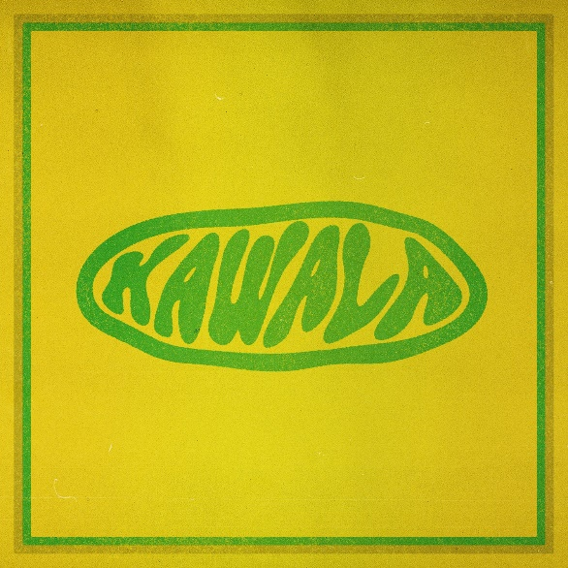

**Kawala Collection Tracklist**

Pre-order [**HERE**](https://kawala.lnk.to/Collection)

Time Slipping Away

Good Morning

What’s Up?

Old Me

I Feel You

M.A.D

Honeycomb

American Adrenaline

**Follow KAWALA:**

[**TIKTOK**](https://www.tiktok.com/@tiktokawala) **/** [**INSTAGRAM**](https://www.instagram.com/kawalagram) **/** [**TWITTER**](https://twitter.com/KawalaOfficial) **/** [**FACEBOOK**](https://www.facebook.com/KawalaOfficial)

**For more information please contact** [**warren@chuffmedia.com**](mailto:warren@chuffmedia.com)