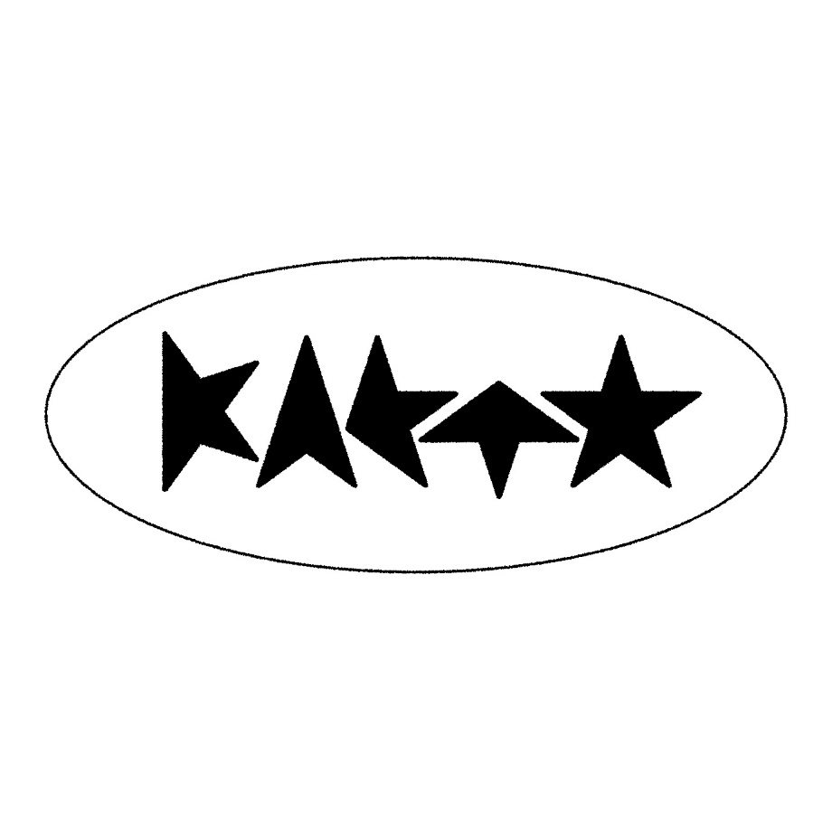
KAETO shares new single
‘HERO’
LISTEN HERE
ARTWORK
Announced as support for Last Dinner Party UK tour

DOWNLOAD ARTWORK
KAETO today (May 8th) shares her new single ‘HERO’ via Polydor Records. A meld of spectral synths, chiming guitars and shuffling trip-hop beats that spiral around Kaeto’s mesmeric vocals, ‘HERO’ is another astounding leap forward for an artist on the cusp of a big breakthrough. It is released tonight in line with a premiere on 6 Music Huw Stephens show.
‘HERO’ comes with an accompanying video – watch HERE – which Kaeto made with her friends, demonstrating the hands-on approach she takes with all her visuals. “I made the video with my long-time collaborators and best friends: Kyle McCarthy, Maisy Banks and Reuben Davies Lindley,” she explains. “We also made the Good Morning video and the Little Me music video. Maisy and I actually made the spikes for the Don’t Ask music video so we were super happy that they found a home in this video.”
‘HERO’ is the follow up to ‘Don’t Ask’ which was released in February and added to the A list at 6 Music as well as receiving plays at Radio 1.
KAETO has been captivating audiences with her mesmerising live performances, opening as special guest for Haim, Lauren Mayberry, Eliza and Bleachers. She has just been announced as support for The Last Dinner Party on their UK tour in October.
About KAETO
The emerging London-based artist is fast carving a space for herself with her unique genre-spanning sound that blends elements of trip-hop, dance and electronic music with punk, alt-pop and more.
KAETO first attracted attention with her startling debut ‘Good Morning’. After signing with Polydor last summer, she released ‘No Body’, which i-D declared “the most commanding artist statement we’ve heard all year”. CLASH remarked “word is already out on this pop voyager, a daring voice carving out her own niche”, while DIY described her as “absolutely melting with confidence and style”. Following it up with the hypnotic “Little Me”, THE FORTY-FIVE recently tipped KAETO for big things, saying “The London-based artist has crafted a sound that is distinctly her own”.
It was back in 2019 that Kaeto first entered the studio with outside producers and began building a sound that would be all her own, but the route she’s taken since is a mark of her maverick and inventive approach to music. One such diversion was enrolling in Clown School, a move designed to throw herself into something creative and spontaneous and shake off the mundanity of modern life. It's why Kaeto’s music has such a free-spirited, loose-limbed sense of adventure about it. “I’m so unashamed of myself,” she says, “but music is where I go to explore these things.”
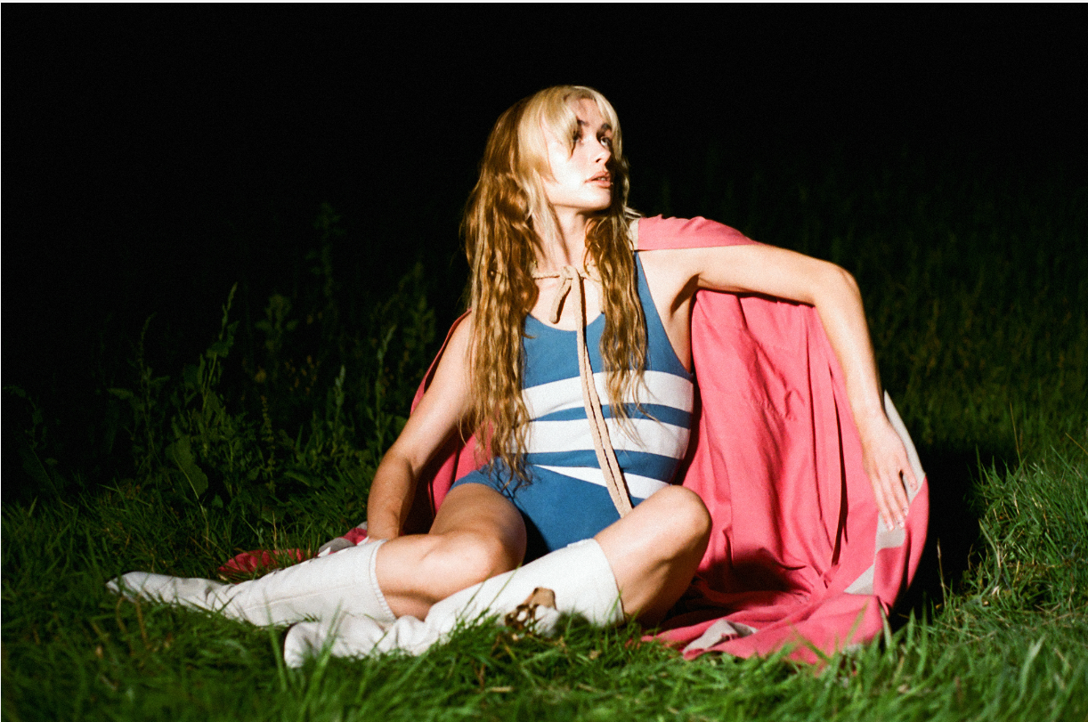
LEAD PRESS PHOTO
(credit: Maisy Banks)

FOLLOW KAETO
Instagram | Youtube |TikTok

For more on info contact warren@chuffmedia.com

