Jacob Alon

Announces Special "In The Round" Performance At London's Roundhouse + New Headline Shows In Bristol in April.

BRITs Week x War Child Show At Edinburgh Assembly Rooms On Sale Now

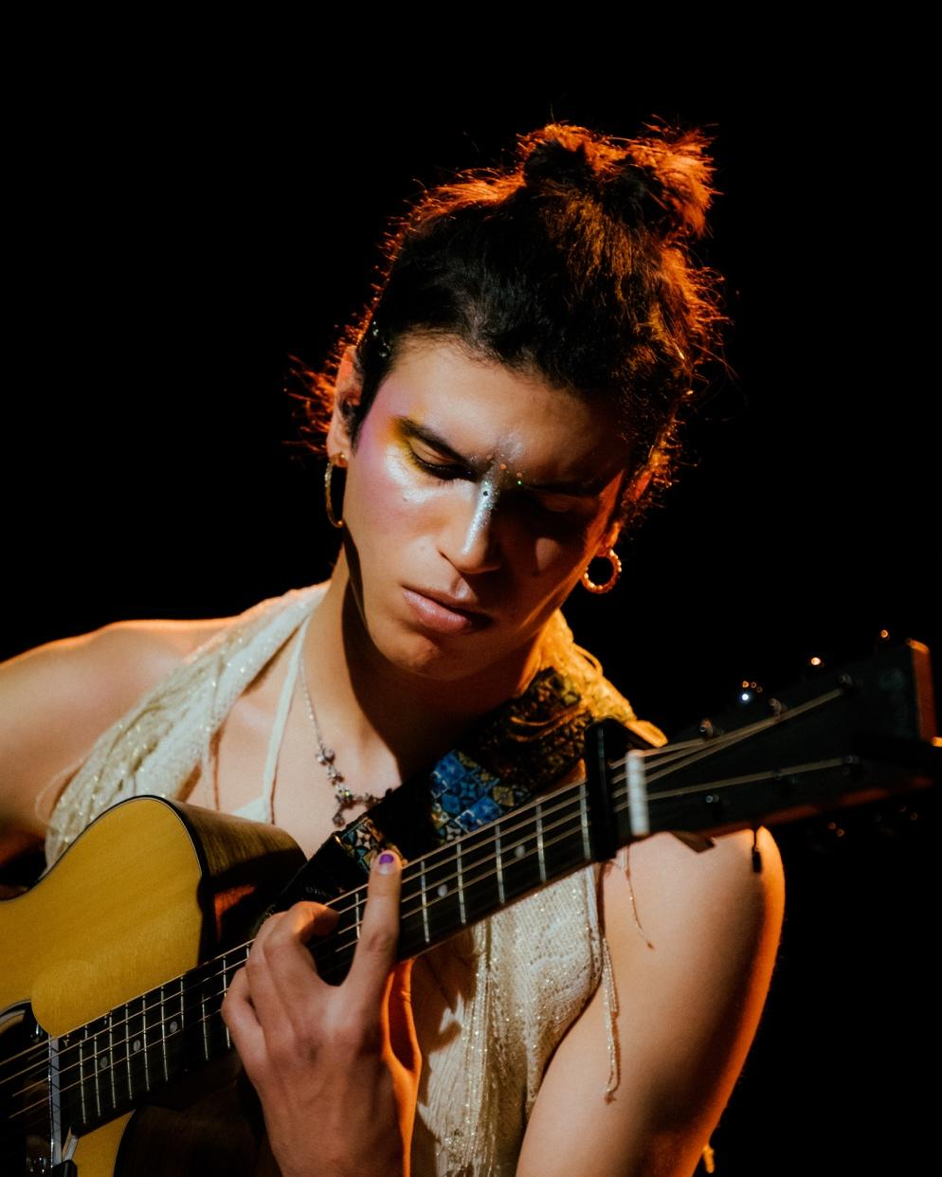
Credit: Zachariah Mahrouche

Jacob Alon is excited to share news of three new headline dates for the Spring.

The acclaimed Brit Award winner plays a special one-off show at London’s Roundhouse on 18th April, performing ‘in the round’ as part of the venue’s annual Three Sixty Festival. The London date is preceded by new shows in Dublin and Bristol.

Tickets for the new shows go on general sale from Friday 6th February at 10am GMT. A fan presale for Bristol and London only will be accessible from Thursday 5th February at 10am GMT.

As previously announced, Jacob headlines one of the BRITs Week headline series of shows in association with War Child. Remaining tickets are now on general sale for the Edinburgh Assembly Rooms date on 27th February.

It’s been an incredible twelve months for the young folk artist from Fife, achieving almost unanimous acclaim for their Mercury Prize nominated debut album In Limerence, before becoming the first Scottish artist to be awarded the BBC Introducing Award, and then commencing 2026 being heralded with the BRITs Critics’ Choice award.

Jacob Alon Live:

27th February – Assembly Rooms, Edinburgh (BRITs Week x War Child)
15th April – Button Factory, Dublin
16th April – Trinity Centre, Bristol
18th April – Roundhouse, London (Three Sixty Festival)

For further information about Jacob Alon:
INSTAGRAM | FACEBOOK | TIKTOK | WEBSITE

For more information and press enquiries please contact

Warren & Harry
@chuffmedia.com

