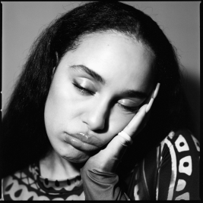
JORJA SMITH RELEASES ‘FALLING OR FLYING (REIMAGINED)’ PROJECT
A COLLECTION OF RE-WORKED TRACKS TAKEN FROM HER LATEST, CRITICALLY ACCLAIMED ALBUM ‘FALLING OR FLYING’
ARTWORK HERE / PRESS SHOT HERE
May 2nd 2024 - British singer Jorja Smith has today released ‘falling or flying (reimagined)’. The project - recorded with her long-time band in London - is a collection of re-worked, stripped back tracks taken from her critically acclaimed 2023 album ‘falling or flying’.
The existing ‘falling or flying’ album is a sonically vast record – sometimes sleek and shiny R&B, elsewhere intense and raw alternative – but above all, it is a record which found Jorja stepping into a new chapter; acknowledging the ever-whirring cogs of her brain but also moving through it, in turn growing and learning to love and respect herself. After its release in September 2023, the album quickly became one of the most critically acclaimed records of that year, subsequently earning Jorja a BRIT Nomination within the ‘Best R&B’ category at the 2024 ceremony.
Of the many British voices in music today, Jorja is among the most commanding, writing at a pitch of intensity and urgency that few can match. Over the past six years, since the release of her critically acclaimed debut album ‘Lost & Found’, she has been celebrated unanimously across the world for her evocative song-writing, powerful delivery, pure emotion and unbridled talent as a young woman navigating her way through life. It was in 2021 that Jorja’s hiatus from music was broken - enter ‘Be Right Back’, the holding space between the sensation that was ‘Lost & Found’, and her next project. ‘Be Right Back’ was born from playing, jamming, freestyling, and sounding out what Jorja had been on the edge of expressing all her life. It was a project entirely for her fans. “Be Right Back did exactly what I wanted it to do. It was a little waiting room so people knew I was coming back.”
And come back she did - entering a chapter of her return to music that’s certain to draw in and intoxicate Jorja’s fans and new listeners alike. And what has changed for her, in the six years since ‘Lost & Found’ dominated the charts and the soundscape, “I like this world that I've just come into. And I’m still figuring things out. Always
figuring things out.” Jorja says. “This is the first time I’m putting stuff out there that I can connect with right now.” Over the last few years, it’s been a reflective and transformative transition into her mid twenties for her. She’s been able to step into herself and evolve as a songwriter and a woman despite an ever-changing musical landscape.
On ‘falling or flying (reimagined) ’, Jorja Smith is reminding herself (and us), that whether things are up or down, she’s very much in control. In fact, as she grows and holds herself, she’s fully thriving.
‘falling or flying - (reimagined)’ - Tracklist:
1. Greatest Gift
2. Little Things
3. Feelings
4. GO GO GO
5. Falling or flying
6. Broken is the man
7. Backwards
8. Try Me
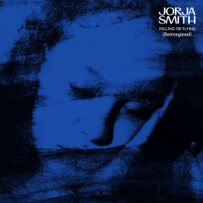
FOLLOW JORJA SMITH ONLINE:
INSTAGRAM / FACEBOOK / TWITTER

For more information please contact warren@chuffmedia.com on 07762 130510

