Announces three intimate UK shows
New album Dance Fever set for release on May 13th on
Polydor Records

(Dance Fever Artwork by Autumn de Wilde)

Florence + the Machine has announced details of three intimate UK shows for April in anticipation of her new album Dance Fever. Florence will perform for fans ahead of the album release at O2 City Hall in Newcastle on Friday 15th, King Georges in Blackburn on Saturday 16th and amidst the grand surroundings of The Theatre Royal Drury Lane in London on Tuesday, April 19th.

On announcement of her 5th studio album Dance Fever last week, Florence shared her new single ‘My Love’ which followed the recently released ‘King’ and ‘Heaven is Here’, all of which launched with videos by Autumn de Wilde, choreographed by Ryan Heffington.

Dance Fever was recorded predominately in London over the course of the pandemic in anticipation of the world’s reopening. It conjures up what Florence missed most in the midst of lockdown -clubs, dancing at festivals, being in the whirl of movement and togetherness -and the hope of reunions to come. It’s an album that sees Florence at the peak of her powers, coming into a fully realised self-knowledge, poking sly fun at her own self-created persona, playing with ideas of identity, masculine and feminine, redemptive, celebratory, stepping fully into her place in the iconic pantheon.

Produced by Florence Welch, Jack Antonoff and Dave Bayley, Dance Fever is the album that brings back the very best of Florence – the festival headlining Boudicca, wielding anthems like a flaming sword and these very first shows are set to capture everything we’ve missed with such intimate and unifying live performances.

Fans can pre-order the new album here before 8pm tonight to get access to tomorrow morning’s pre-sale on tickets. General on-sale will be on Thursday March 17th at 9am GMT.

UK show dates:

15th April - O2 City Hall, Newcastle
16th April - King Georges, Blackburn
19th April - Theatre Royal Drury Lane, London

Pre-order album pre-sale Wednesday 16th March @ 9am GMT / On-sale Thursday 17th March @ 9am GMT HERE

Pre-order ‘Dance Fever’ HERE

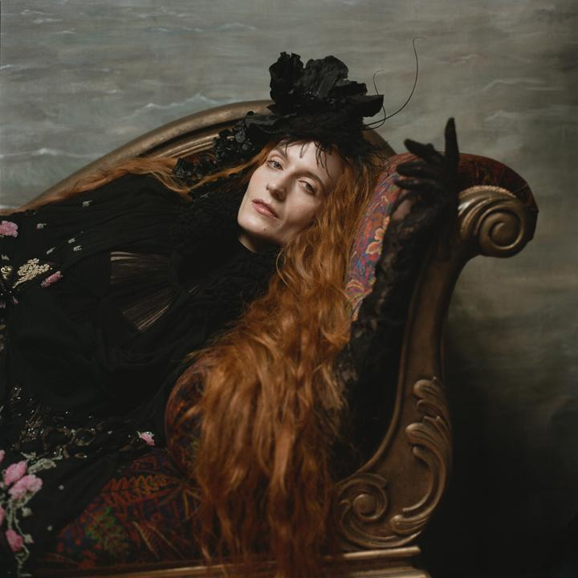
(Image by Autumn de Wilde)

For more information and press enquiries please contact
Jenny Entwistle / Jenny@chuffmedia.com

