ANNOUNCE RETURN WITH NEW SINGLE+ VIDEO **‘YOUR HOUSE’**

LISTEN[**HERE**](https://inhaler.lnk.to/YourHouse)

WATCH [**HERE**](https://inhaler.lnk.to/YourHouseVid)

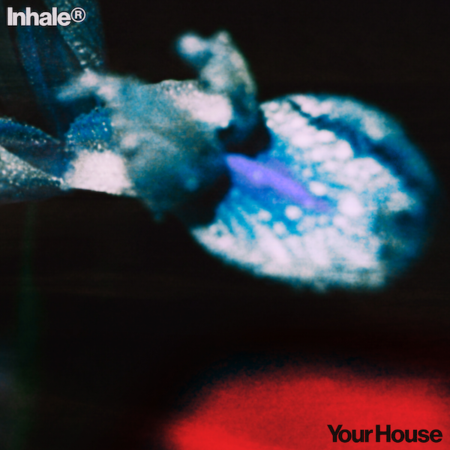

**INHALER** have today announced their return with the release of new single **‘Your House’**. A 70’s rock inspired anthem with a big group chorus**, ‘Your House’** was recorded with producer Kid Harpoon and features backing vocals from the House Gospel Choir. It marks a giant leap forward for the band and is released today in line with its premiere as Hottest Record In The World on Radio 1.

“We’re an ambitious band that wants to create anthemic music, particularly when things feel so destructive,” says Inhaler frontman **Elijah Hewson**. “’Your House’ is about belonging to someone or something that’s bad for you,” he continues. “The verse is blasé but the chorus feels spiritual. I love that contrast.”

Since their career launched in 2018, they’ve been among the biggest new names in guitar music, achieving commercial success with roaring chart positions. To date, they’ve sold over a quarter of a million records globally and garnered 500 million streams. Their debut album, *It Won’t Always Be Like This*, hit #1 in the UK and Ireland, while their 2023 follow-up, *Cuts & Bruises*, topped the Irish charts and reached #2 in the UK. To maintain this momentum, bandmates and childhood friends Hewson, Robert Keating, Ryan McMahon, and Josh Jenkinson have spent the past few whirlwind years on a relentless world tour, supporting acts like Arctic Monkeys, Pearl Jam, Harry Styles, and Kings of Leon, as well as headlining their own shows, including a sold out 13,000-capacity homecoming show at the Dublin 3Arena last year, their biggest headline show to date.

Beginning work on their third album early this year, the band were encouraged to challenge themselves and step out of their comfort zone. Listening to a wide range of genres during writing - from techno to Nick Cave – inspired them to experiment with a brighter, timeless sound, adding texture to the record. Recording in London with producer Kid Harpoon (Harry Styles/Florence and the Machine) pushed them to take more creative control which they relished.

**INHALER** are currently on a 4 week tour of North America where they have been debuting songs from their soon to be announced new album to the delight of their fans. Watch this space for further news.

[LEAD PRESS PHOTO](https://www.dropbox.com/scl/fi/excxd8uiz99p88erb8ky6/INHALER32579.jpg?rlkey=6032rwecfixesjsmwn68ij7v8&st=3zsz1bdn&dl=0) (credit: Lewis Evans)

CONNECT WITH INHALER

[Instagram](https://www.instagram.com/inhalerdublin/) | [TikTok](https://www.tiktok.com/@inhaler_on_tik) | [X](https://x.com/InhalerDublin)

**For more information and press enquiries please contact**

**Jenny Entwistle**

[**Jenny@chuffmedia.com**](mailto:Jenny@chuffmedia.com)