HORRIBLE HISTORIES - LIVE ON STAGE

HORRIBLE CHRISTMAS

VISITING BIRMINGHAM, MANCHESTER AND LONDON THIS DECEMBER

The story of how Christmas came to be what it is today - in Horrible Histories style!

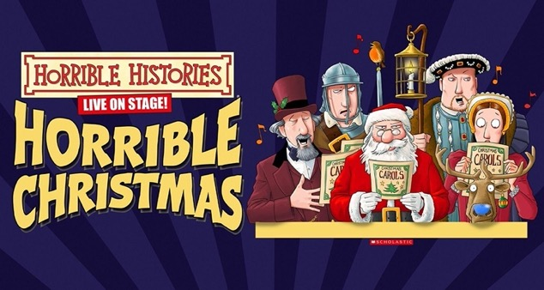

When you think of Christmas, many things usually come to mind - family, joy, goodwill, presents… - but how about Oliver Cromwell (fact)? Or Henry VIII (fact)?

When Christmas comes under threat from a jolly man dressed in red, it’s up to one young courageous boy to save the day – but can he save Christmas? From Victorian villains to Medieval monks, Puritan parties to Tudor treats, join us on a hair-raising adventure through the history of Christmas in the company of Charles Dickens, Oliver Cromwell, King Henry VIII and St Nicholas as they all join forces to save the festive season!

Bring the whole family to enjoy this festive adventure as Horrible Histories presents the terrific tale of Christmas. It's a celebration in the most wonderful, funny and moving way you'll ever see!

‘A flash, bang, wallop of a production!’ British Theatre Guide
‘That rare gem of a family show that genuinely appeals to all ages from four years old upwards. If you think you know about Christmas, this show will make you think again!’ Manchester Theatre Awards

‘Jam packed with brilliant, catchy tunes, hilarious jokes and lots of audience participation. I went with children aged between 7 and 12 and they loved it!’ Cambridge Edition

VENUES & DATES

11th December Birmingham Symphony Hall, 11.30am & 2.30pm
Tickets from £14.50-£33.50
https://bmusic.co.uk/events/horrible-christmas

20th December Manchester The Bridgewater Hall, 11.30am & 2.30pm
Tickets from £20-£33.50
https://tickets.bridgewater-hall.co.uk/45508/45509

27-30th December London Barbican Hall, 2pm
Tickets from £16.50-£30.00
https://www.barbican.org.uk/whats-on/2022/event/horrible-histories-horrible-christmas

MEDIA ASSETS HERE

For all media enquiries please contact
warren@chuffmedia.com 07762 130510

