The Birmingham Stage Company presents

HORRIBLE HISTORIES - LIVE ON STAGE

HORRIBLE CHRISTMAS

AT LONDON’S ALEXANDRA PALACE THEATRE
12TH DECEMBER 2024 TO 4TH JANUARY 2025

Press performances: Saturday 14th & Sunday 15th December at 2.30pm

The story of how Christmas came to be what it is today - in Horrible Histories style!

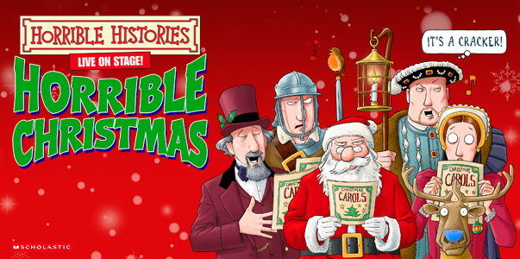

MEDIA ASSETS HERE
Horrible Histories Live on Stage is back, bringing holiday cheer with a fabulous twist in their fan-favourite show, Horrible Christmas! Kicking off December 12th and running until January 4th, this extended version of the hit show takes the stage at the beautifully restored Victorian gem, Alexandra Palace Theatre, London N22.
Have you ever wondered why you get together with your family - or put up a Christmas tree - or send a Christmas card - or buy presents - or eat a turkey? Horrible Christmas goes on an amazing journey to discover the answers in a fabulous adventure for the whole family!
Expect sing-a-longs, “behind you!” moments, and plenty of laughter – but don’t mistake this for your typical panto! When Christmas comes under threat from a mysterious man in red, it’s up to a brave young boy to save the day. But can he pull it off?
Join us on a wild, time-traveling escapade from Medieval monks to Tudor feasts, with appearances by Charles Dickens, King Henry VIII, and St. Nicholas himself. Together, they’ll do whatever it takes to save Christmas from being lost to history.
Neal Foster, director and star of Horrible Christmas (and recently seen in Terrible Tudors and David Walliams’ Awful Auntie), shares his excitement: “We were thrilled to be the first Christmas show at the newly refurbished Alexandra Palace Theatre and we’re even more excited to return with our biggest Horrible Histories production yet! Ally Pally is the perfect place for families to enjoy a uniquely hilarious and heart-warming holiday show.”
Don’t miss out on this hilariously fun holiday event! Grab the kids, bring your sense of adventure, and get ready to celebrate Christmas like never before with Horrible Christmas – it’s history with all the trimmings!
‘That rare gem of a family show that genuinely appeals to all ages from four years old upwards. If you think you know about Christmas, this show will make you think again!’ Manchester Theatre Awards

‘A flash, bang, wallop of a production!’ British Theatre Guide
‘Jam packed with brilliant, catchy tunes, hilarious jokes and lots of audience participation. I went with children aged between 7 and 12 and they loved it!’ Cambridge Edition

VENUE & DATES

Alexandra Palace Theatre
Alexandra Palace Way
London
N22 7AY

DATE DOORS START END
12 DEC 2024 18:00 19:00 21:00
13 DEC 2024 18:00 19:00 21:00
14 DEC 2024 13:30 14:30 16:30 *PRESS PERFORMANCE
14 DEC 2024 18:00 19:00 21:00
15 DEC 2024 13:30 14:30 16:30 *PRESS PERFORMANCE
15 DEC 2024 18:00 19:00 21:00
18 DEC 2024 18:00 19:00 21:00
19 DEC 2024 18:00 19:00 21:00
20 DEC 2024 18:00 19:00 21:00
21 DEC 2024 13:30 14:30 16:30
21 DEC 2024 18:00 19:00 21:00
22 DEC 2024 13:30 14:30 16:30
22 DEC 2024 18:00 19:00 21:00
23 DEC 2024 13:30 14:30 18:30
23 DEC 2024 18:00 19:00 21:00
24 DEC 2024 10:30 11:30 13:30
24 DEC 2024 13:30 14:30 16:30
27 DEC 2024 13:30 14:30 16:30
27 DEC 2024 18:00 19:00 21:00
28 DEC 2024 13:30 14:30 16:30
28 DEC 2024 18:00 19:00 21:00
29 DEC 2024 13:30 14:30 16:30
29 DEC 2024 18:00 19:00 21:00
30 DEC 2024 13:30 14:30 16:30
30 DEC 2024 18:00 19:00 21:00
1 JAN 2025 13:30 14:30 16:30
1 JAN 2025 18:00 19:00 21:00
2 JAN 2025 13:30 14:30 16:30
2 JAN 2025 18:00 19:00 21:00
3 JAN 2025 13:30 14:30 16:30
3 JAN 2025 18:00 19:00 21:00
4 JAN 2025 13:30 14:30 16:30
4 JAN 2025 18:00 19:00 21:00

For all media enquiries please contact warren@chuffmedia.com 07762 130510

