PETE TONG’S IBIZA CLASSICS
with THE ESSENTIAL ORCHESTRA

HEADLINE HAYDOCK PARK NIGHTS
FRIDAY 7TH AUGUST – HAYDOCK PARK RACECOURSE

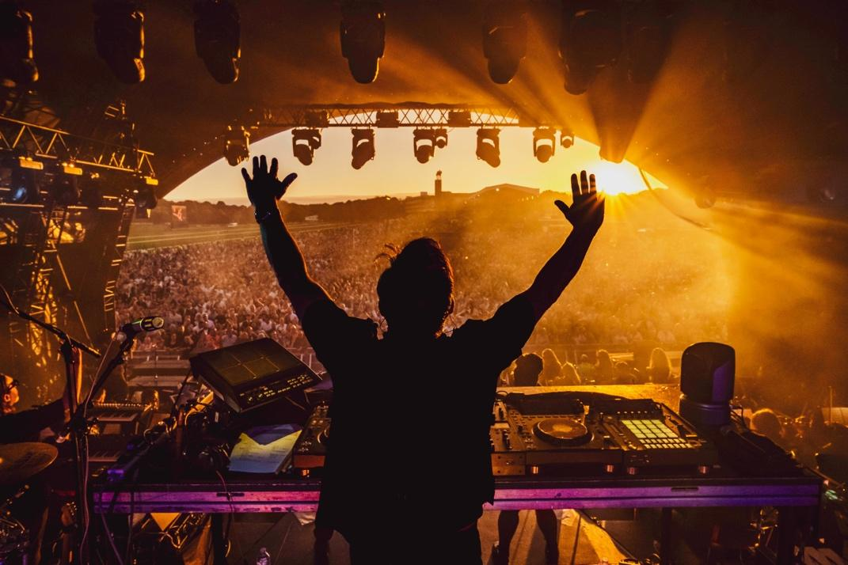
DOWNLOAD MEDIA ASSETS HERE

Haydock Park Nights is thrilled to welcome the return of PETE TONG’S IBIZA CLASSICS with THE ESSENTIAL ORCHESTRA to the summer music line-up, headlining on Friday 7th August.

It all began in 2015, when BBC Radio 1 united legendary DJ Pete Tong and visionary conductor Jules Buckley to fuse electronic and orchestral music at the Royal Albert Hall. Their debut performance, featuring a 65-piece orchestra reimagining Ibiza’s iconic dance anthems, became the most-watched BBC Prom on YouTube with over 8 million views and captivating fans around the world.

What started as a one-off show soon evolved into a full-blown musical phenomenon: Pete Tong’s Ibiza Classics. In the years that followed, the live show would tour internationally, taking over world-renowned venues such as The Hollywood Bowl in Los Angeles, and multiple sold-out nights at London’s O2 Arena. Now, a decade later, Pete Tong’s Ibiza Classics with The Essential Orchestra has become a fixture on the UK’s live music calendar. With over 750,000 fans attending shows across the years, Ibiza Classics has redefined what live dance music can be.

Simon Tonge, General Manager of Haydock Park Racecourse said, “Pete Tong’s Ibiza Classics with The Essential Orchestra is one of the most requested shows to return to Haydock Park Nights, and we couldn’t be more excited. Our 2026 summer line-up has something for everyone: the pop anthems of Tom Grennan, the legendary hits of Madness, and the sun-soaked sounds of Ibiza Classics. It’s the perfect chance for fans to enjoy top-tier racing, live music, and delicious food, all in one unforgettable day.”

The Haydock Park Nights series continues to set the standard for value-packed entertainment in the North West, combining thrilling afternoon racing with full headline performances from some of the nation’s biggest music stars. With a single ticket granting access to both world-class racing and live music, fans enjoy an unforgettable afternoon (and night out) at exceptional value. The experience is further enhanced by a diverse range of food options, from vibrant street food offerings to Haydock Park’s renowned selection of outstanding restaurants.

Tickets for PETE TONG’S IBIZA CLASSICS with THE ESSENTIAL ORCHESTRA will be on sale at 10am on Friday 30th January via thejockeyclub.co.uk/haydock, priced starting from £45. There will be a presale at 10am on Thursday 29th January for those on the Haydock Park Racecourse mailing list, register here.

Tickets for all shows in the Haydock Park Nights season are now on sale.

2026 Haydock Park Nights Season
Saturday 20th June – TOM GRENNAN
Saturday 18th July – MADNESS
Friday 7th August – PETE TONG’S IBIZA CLASSICS with THE ESSENTIAL ORCHESTRA

FOR MORE INFORMATION AND ALL MEDIA ENQUIRIES FOR
HAYDOCK PARK NIGHTS, PLEASE CONTACT

Jenny Entwistle at Chuff Media
jenny@chuffmedia.com

TOM GRENNAN – SATURDAY 20TH JUNE
With three number one albums under his belt alongside multiple Brit and Ivor Novello nominations, countless airplay smashes, sold-out arena tours and an MTV Award for Best UK Act, Tom Grennan is one of the country’s biggest artists. His 2025 album Everywhere I Went Led Me To Where I Didn't Want To Be is a state-of-the-art pop record which further showcases the thrilling evolution of one of UK’s most exciting talents at his creative best. It is a stunning addition to Tom Grennan’s already-impressive discography, which has seen him accumulate over 1.5 million album sales and 2.5 billion streams across his gold-selling debut Lighting Matches (2018), his first UK Number One album Evering Road (2021) and What Ifs & Maybes (2023), another Number One and Tom’s third gold-selling album in a row.

MADNESS – SATURDAY 18TH JULY
Madness’s energetic blend of ska, pop and reggae had made them one of the UK’s defining bands. With a rich catalogue of classics including “Our House,” “Baggy Trousers,” “It Must Be Love” and “House of Fun,” the band have amassed more than three decades of chart success, with 12 UK Top 10 albums and numerous singles that remain staples of British music culture. In recent years, they released a career-spanning hits compilation Hit Parade, hit UK No.1 with studio album Theatre Of The Absurd Presents C’est la Vie, and continue to perform live to thousands of fans, bringing their spirited shows to arenas and outdoor festivals across the UK.

PETE TONG’S IBIZA CLASSICS with THE ESSENTIAL ORCHESTRA – FRIDAY 7TH AUGUST
It all began in 2015, when BBC Radio 1 united legendary DJ Pete Tong and visionary conductor Jules Buckley to fuse electronic and orchestral music at the Royal Albert Hall. Their debut performance, featuring a 65-piece orchestra reimagining Ibiza’s iconic dance anthems, became the most-watched BBC Prom on YouTube with over 8 million views and captivating fans around the world.
What started as a one-off show soon evolved into a full-blown musical phenomenon: Pete Tong’s Ibiza Classics. In the years that followed, the live show would tour internationally, taking over world-renowned venues such as The Hollywood Bowl in Los Angeles, and multiple sold-out nights at London’s O2 Arena. Now, a decade later, Pete Tong’s Ibiza Classics with The Essential Orchestra has become a fixture on the UK’s live music calendar. With over 750,000 fans attending shows across the years, Ibiza Classics has redefined what live dance music can be.

ABOUT THE JOCKEY CLUB
Founded in 1750 The Jockey Club is today the largest employer and commercial organisation in British horseracing and one of the leading sports businesses operating in the UK.

The Jockey Club is governed by Royal charter, ensuring all profits are reinvested back into racing, which is Britain’s second biggest spectator sport.

The Jockey Club runs 15 of the UK’s racecourses – large and local – and is charged with looking after some of the nation’s biggest events, including the Randox Grand National Festival at Aintree, The Cheltenham Festival, The Betfred Derby Festival at Epsom Downs and the Betfred Guineas Festival at Newmarket.

Thousands of racehorses also use The Jockey Club’s training centres in Newmarket, Lambourn and Epsom every year, while the organisation also runs The National Stud in Newmarket and the charity, Racing Welfare, which makes help available to everyone in racing.

The Jockey Club’s joint Patrons are His Majesty The King and Her Majesty The Queen.

For more information, please visit thejockeyclub.co.uk

ABOUT HAYDOCK PARK
Haydock Park is often advertised as being conveniently situated at equal distances from both Manchester and Liverpool and yet in spite of this close proximity to industry, the actual course is in a setting of woodland and tree-lined avenues. Indeed, it still retains much of the atmosphere of a park, a reminder of the days when it was in possession of the Leghs, a great Lancashire family, who on elevation to peerage took the name of Newton from their local connections and later moved to Cheshire, where they did much to enrich the story of the neighbouring County Palatine.

The true Lancastrian has always been fond of horses and there is a definite link between Haydock Park and a series of meetings first instituted at Newton-le-Willows, two and a half miles away, in 1752.

The Newton meetings, which apart from a break about the 1820’s, continued until 1898, seems in its initial stages to have been mainly sponsored and patronised by members of the Newton Hunt, one of the may Lancashire Hunts that thrived in the days before so much of the Southern part of the Country was given over to industry.

For some years, the Newton race meetings, which were held on an extensive stretch of common known as Golborne Heath, were similar to those in many other parts of the country. Although mainly supported by hunting folk, the racing seems to have been open to all who cared to come along and enjoy the sport. The arrival of industry in the area appears to have given a boost to the organisers and even 100 years ago the pattern of the present Haydock Park meeting as a gathered ground for the sporting folk of the county, apart from hunting interests, was being moulded.

Haydock Park must be one of the most used racecourses in the country with racing on 32 days a year, combining both the very best of Flat and Jump Racing. The Old Newton Cup is the last tangible surviving link between the original course and Haydock Park.

Owned and operated by The Jockey Club, Haydock Park has become the scene of some of the most popular and attended events in the Northern racing calendar, including the Grand National Trial in February, The Temple Stakes in May, the Old Newton Cup and Lancashire Oaks in July, the Sprint Cup in September and the Betfair Chase in November.

With a choice of four grandstands and 33 private viewing suites, restaurants, bars and leading conference facilities, Haydock Park is as well-known for world-class racing as it is for hosting spectacular events, attracting visitors in their thousands each year.

