HAMISH HAWK ANNOUNCES NEW ALBUM "A FIRMER HAND" OUT AUGUST 16TH ON SO RECORDINGS
LISTEN TO NEW SINGLE "BIG CAT TATTOOS" HERE

Photo Credit: Michaela Simpson | Download Hi-Res HERE
Support for Hamish Hawk's "Angel Numbers":
"An album of remarkable scope and vivid, romantic lyricism."
***** - The Skinny
"Restless but never overwrought, flamboyant but without a trace of flippancy, Hawk is a welcome antidote for the mundanity of modern living."
9/10 - The Line Of Best Fit
"All human life is here."
**** - Mojo
"A shimmering curtain of prime pop jangle."
8/10 - Uncut
"Come for the triumphant arena anthems and stay for the mouth-wateringly arch lyricism. His star will undoubtedly only rise from here."
**** - Record Collector
"Hawk's new album is his best yet."
Breaking Act - The Sunday Times
Edinburgh's Hamish Hawk returns today with the news of his signing to So Recordings and that a new album "A Firmer Hand" will follow on August 16th.
Hamish also shares the first single from the record in the form of the playful, propulsive and searingly honest "Big Cat Tattoos". It's one that Hamish had the following to say for:
"Big Cat Tattoos is just one of the great unsaids that make up the new record, and it's the birthplace of the album's title: A Firmer Hand. Unknowingly I'd been building up an ugly arsenal of great unsaids over the past few years, and the album became a place I could offload them, and with any luck put them to rest.
I tried to avoid cleaning things up at the time of writing, I cornered myself into a warts-and-all approach. But don't be fooled, Big Cat Tattoos is all talk. Our hero gets a few barbs in nice and early, and lands a couple of clumsy jabs, but in the end we're witness to nothing more than a petty diatribe. It's embittered, unbecoming and wholly embarrassing. It does have a certain get-up-and-go, though."
LISTEN TO "BIG CAT TATTOOS" HERE
PRE-ORDER "A FIRMER HAND" HERE
Hawk's new album follows 2021's breakthrough LP "Heavy Elevator" and 2023's critically-acclaimed "Angel Numbers", both sublime and literate records that saw significant plaudits at both press and radio, including - no mean feat for an artist previously self-releasing in the current climate - six singles playlisted at BBC 6 Music.

Of his new album, Hamish says: “Writing this album, I opened up my closet, and a skeleton came out. The thing that links all of the songs is a sense of the unsaid, whether out of guilt, shame, repression, embarrassment, coyness, whatever it might have been. I realised: I am going to say these things, and not all of them are going to make me look good. The album made so many demands, and I just gave myself over to it.”

"Once I'd given myself over to the idea, I thought, I have to stick to this. I can’t hide anything from it. I can’t clean it all up for consumption. It felt uncomfortable for me – and that’s exactly how it should feel. That’s a really strong position.”

Through the writing of ‘Machiavelli’s Room’, followed by the arrival of songs such as ‘Milk An Ending’ and ‘Juliet As Epithet’, A Firmer Hand came into focus as an album directed towards Hawk’s relationships with men: friends, lovers, family, colleagues.
“I thought, this is the body of the record.
The fact that it makes me nervous tells me it was the right thing to do.”

It takes only a couple of listens to be sure that it was a risk worth taking. And just a couple more to determine that "A Firmer Hand" is the best and boldest record Hamish Hawk has delivered to date. “It’s a bit of a coming-of-age record,” he says.
And a record for the ages.
Read full bio HERE
---
Rich of voice and even richer of imagination, Hawk creates musical pen-portraits, chamber pop songs that have swallowed both a dictionary and a compendium of modern urban (and island) fairy tales. And Hawk does all this with considerable wit, inspired by artists like Leonard Cohen, Jarvis Cocker, Randy Newman and Stephin Merritt of Magnetic Fields.
Hamish Hawk will be playing a number of dates across the year in support of the new record, solo and with his band, including a run of shows with Villagers and a recently announced support for Elbow in the summer.
Catch Hamish live on the following dates:
May
4 EDINBURGH Stag & Dagger Festival Tickets
5 GLASGOW Stag & Dagger Festival Tickets
27 BRUSSELS Ancienne Belgique (Solo w/ Villagers)
28 AMSTERDAM Paradiso (Solo w/ Villagers)
29 ROTTERDAM LantarenVenster (Solo w/ Villagers)
30 HAMBURG Pop Seasons - Christiankirche (Solo w/ Villagers)
June
1 BERLIN Passionkirche (Solo w/ Villagers)
2 COLOGNE Luxor (Solo w/ Villagers)
3 PARIS La Maroquinerie (Solo w/ Villagers)
5 NEWCASTLE Wylam Brewery (Solo w/ Villagers)
6 LEEDS Irish Centre (Solo w/ Villagers)
8 LONDON Royal Festival Hall (Solo w/ Villagers)
27 INVERNESS Belladrum Festival
July
21 READING Englefield Estate (w/ Elbow & Villagers)
August
4 BARNSLEY Underneath The Stars Festival
23 KETTERING Green Belt Festival
24 BIRKENHEAD Future Now Weekender

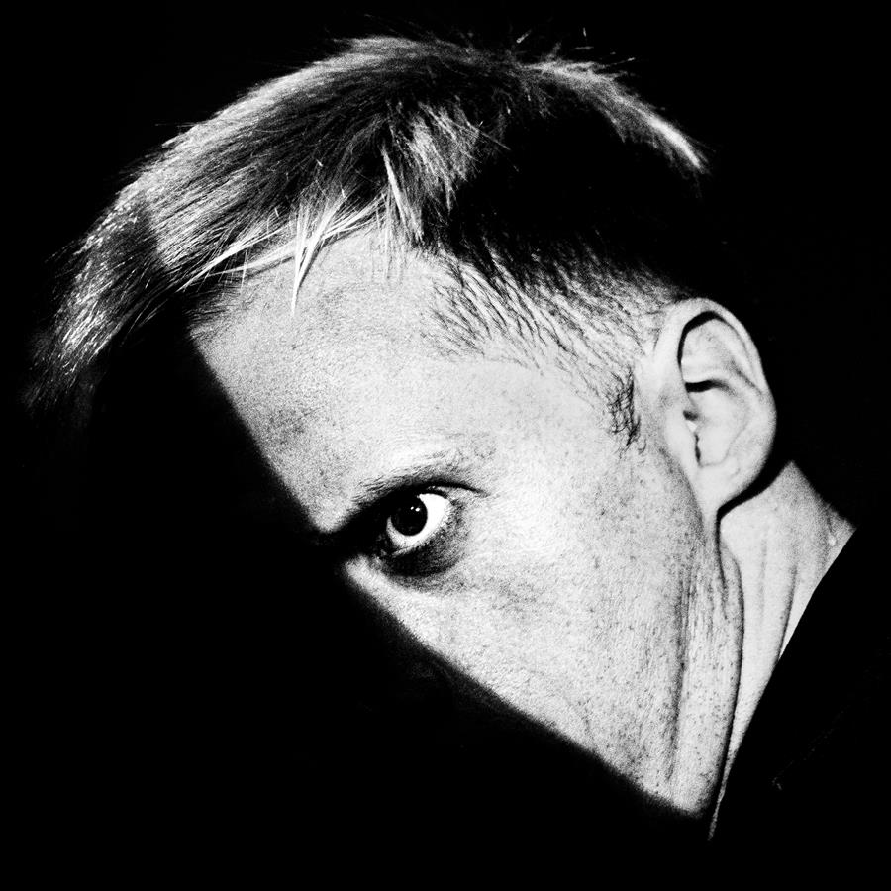

Hamish Hawk
A Firmer Hand
Out August 16th
via So Recordings
Tracklisting:
- Juliet as Epithet
- Machiavelli's Room
- Big Cat Tattoos
- Nancy Dearest
- Autobiography of Spy
- You Can Film Me
- Christopher St.
- Men Like Wire
- Questionable Hit
- Disingenuous
- Milk an Ending
- The Hard Won
For more on info contact warren@chuffmedia.com

